Skip to main content

Global Knowledge

Top of Form

Bottom of Form

Screenshots

Module 4: Implementing Storage Spaces and Data Deduplication

Lab A: Implementing Storage Spaces

**Scenario**

Adatum corporation has purchased a number of hard disk drives and SSDs and you have been tasked with creating a storage solution that can utilize these new devices to the fullest. With mixed requirements in Adatum for data access and redundancy, you must ensure that you have a redundancy solution for critical data that does not require fast disk read and write access. You also must create a solution for data that does require fast read and write access. You decide to use Storage Spaces and storage tiering to meet the requirements.

You will also implement and test Storage Spaces Direct using the Windows Admin Center in Lab C.

Exercise 1: Creating a Storage Space

**Scenario**

Your server does not have a hardware-based RAID card, but you have been asked to configure redundant storage. To support this feature, you must create a storage pool.

After creating the storage pool, you must create a redundant virtual disk. Because the data is critical, the request for redundant storage specifies that you must use a three-way mirrored volume. Shortly after the volume is in use, a disk fails, and you have to replace it by adding another disk to the storage pool.

Task 1: Create a storage pool from six disks that are attached to the server

1. Switch to [**LON-HOST1**](urn:gd:lg:a:select-vm)
2. Send the [**CTRL+ALT+DEL**](urn:gd:lg:a:send-vm-key-combo) command and login on as [**Administrator**](urn:gd:lg:a:send-vm-keys) with the password [**Pa55w.rd**](urn:gd:lg:a:send-vm-keys)

**Note**: The **LON-HOST1** machine is running Hyper-V and has the **LON-STOR1** virtual machine hosed on it for this lab. This enables you to simulate a disk removal during the storage spaces lab.

1. Open **Hyper-V Manager** from the taskbar.

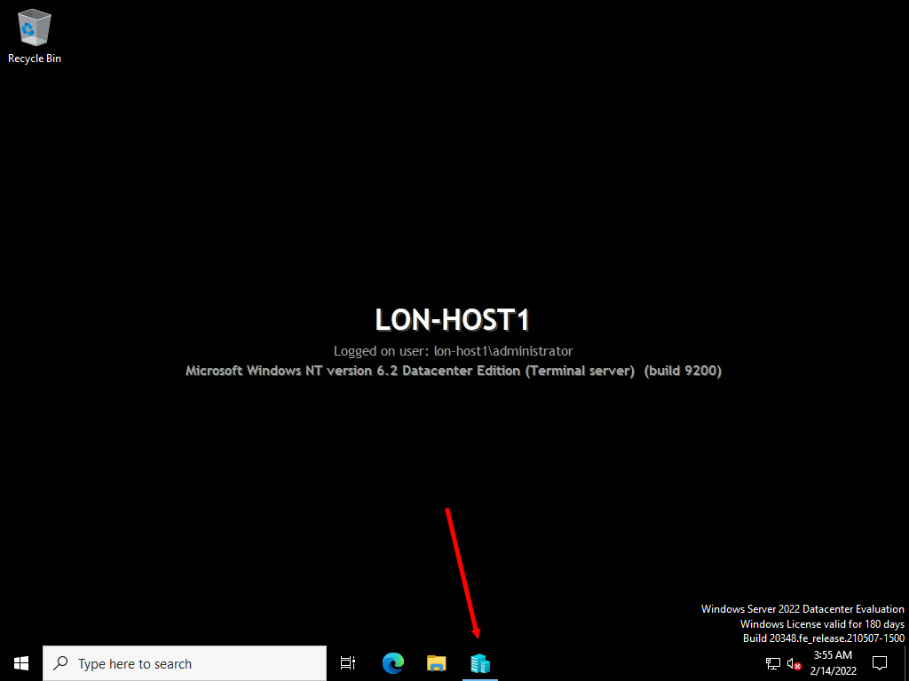

1. Right click **LON-STOR1** and click **Connect**.

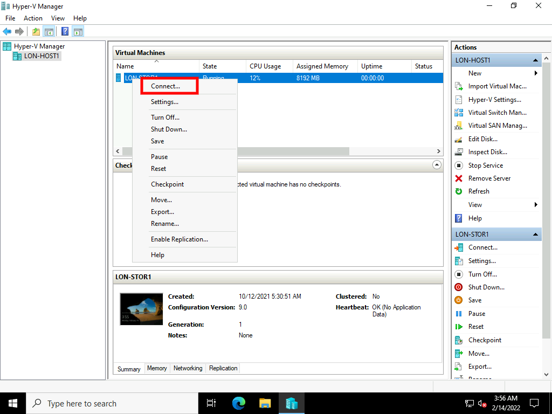

1. Send the [**CTRL+ALT+DEL**](urn:gd:lg:a:send-vm-key-combo) command and login as **[Adatum\AdatumAdmin](urn:gd:lg:a:send-vm-keys" \o "Paste text into VM)** with the password [**Pa55w.rd**](urn:gd:lg:a:send-vm-keys).

**Note** Use the **Ctrl+Alt+Delete** under **Action** in the **LON-STOR1** Virtual Machine.

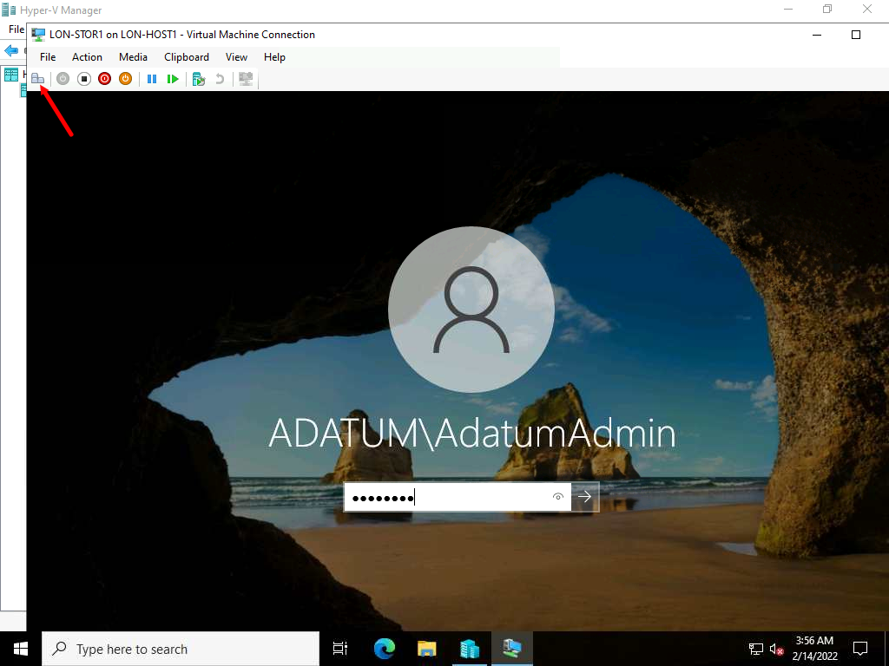

1. To enable you to see the virtual machine in full screen move, click the **View** menu then select **Full Screen Mode**.

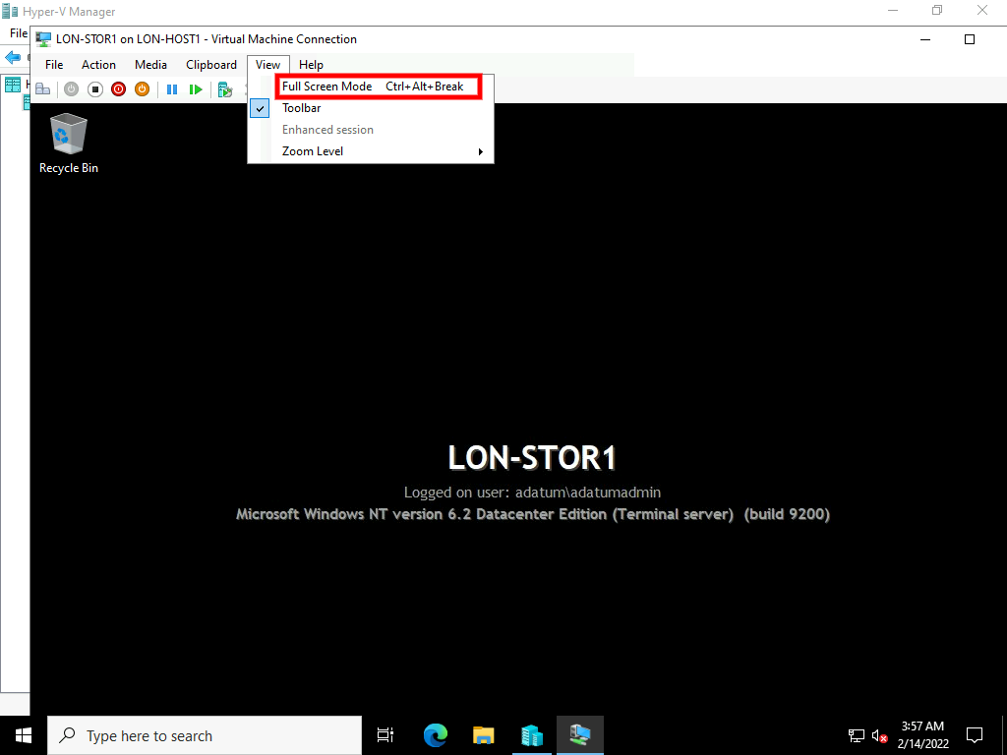

1. You can use the minimize button at any time to view to **LON-HOST1** machine.

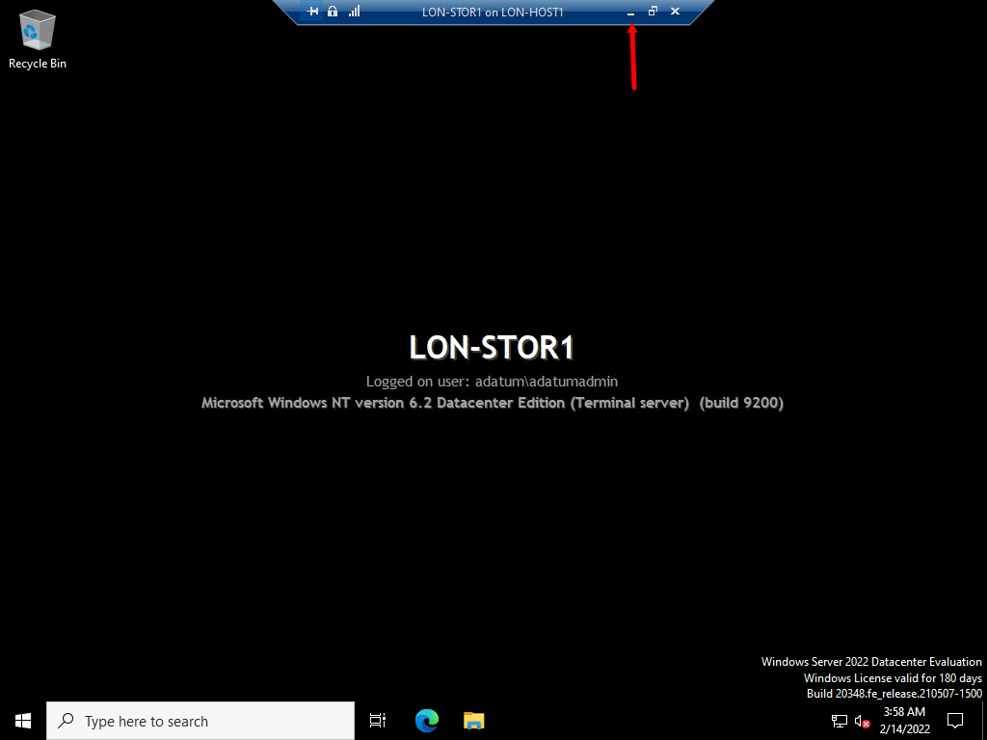

1. Click **Start**, and then click **Server Manager**.

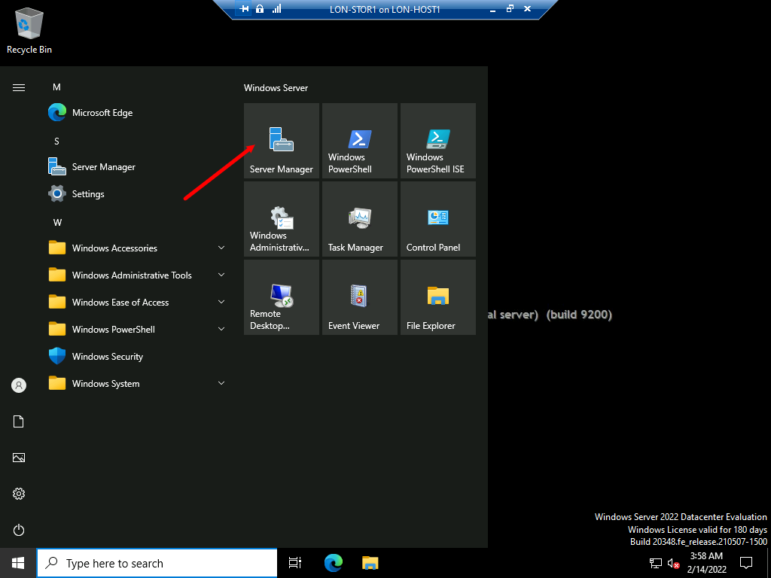

1. In **Server Manager**, in the left pane, click **File and Storage Services**,

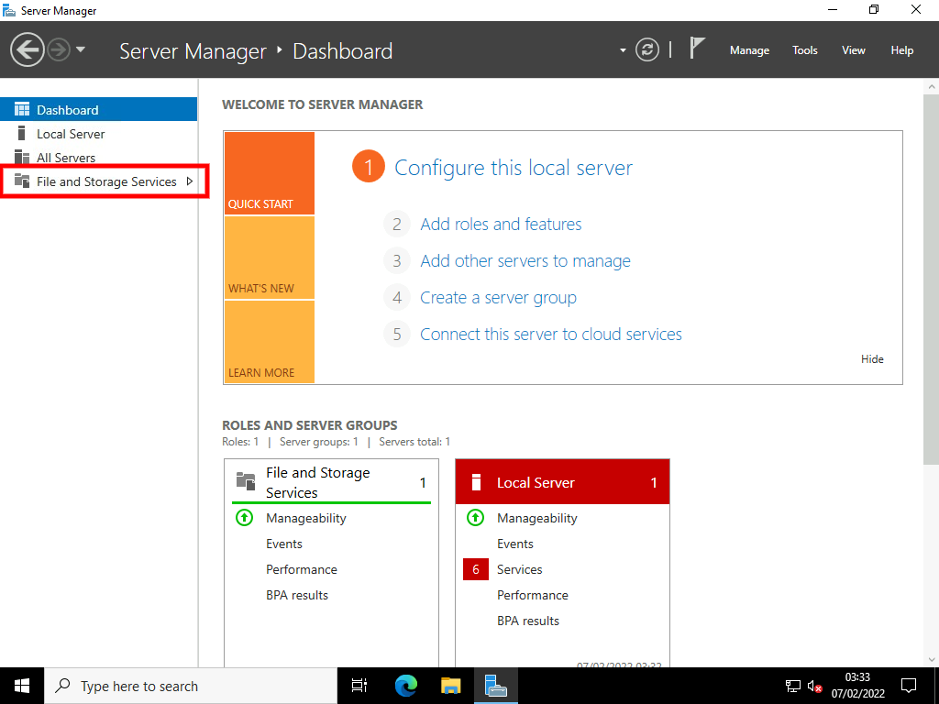

1. In the **Servers** pane, click **Storage Pools**.

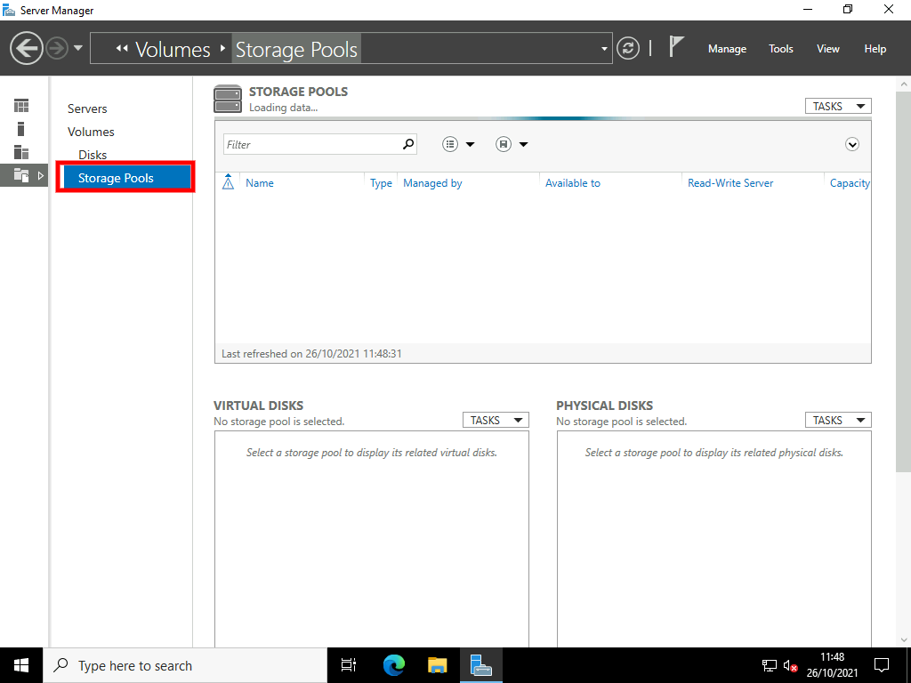

1. In the **STORAGE POOLS** pane, click **TASKS**, and then, in the **TASKS** drop-down list, click **New Storage Pool**.

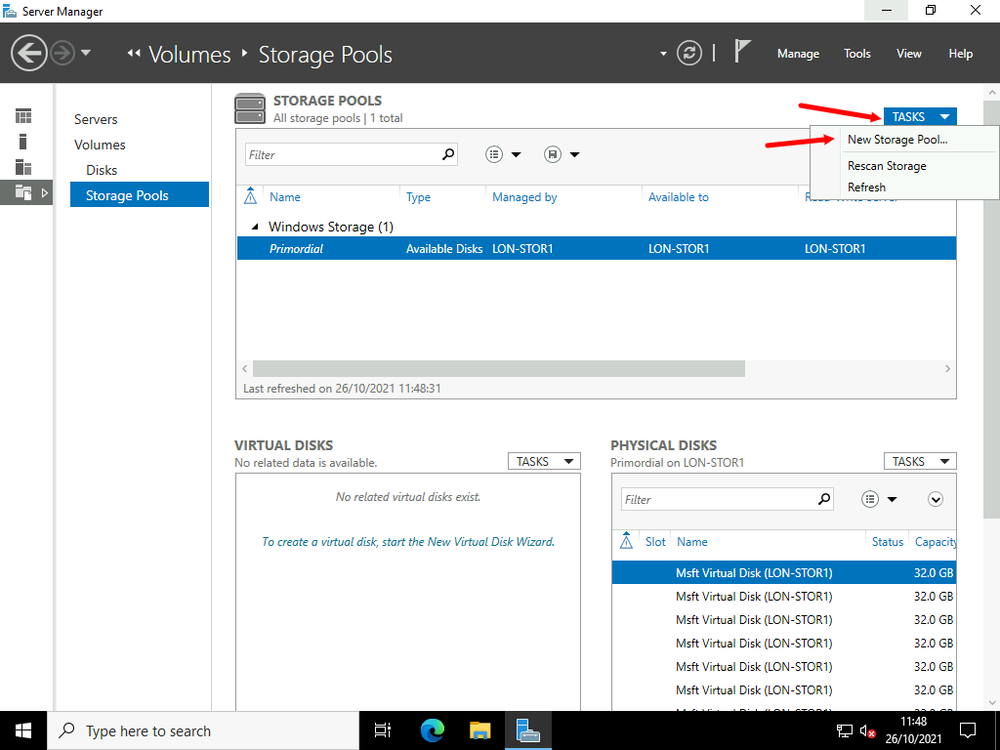

1. In the **New Storage Pool Wizard**, on the **Before you begin** page, click **Next**.

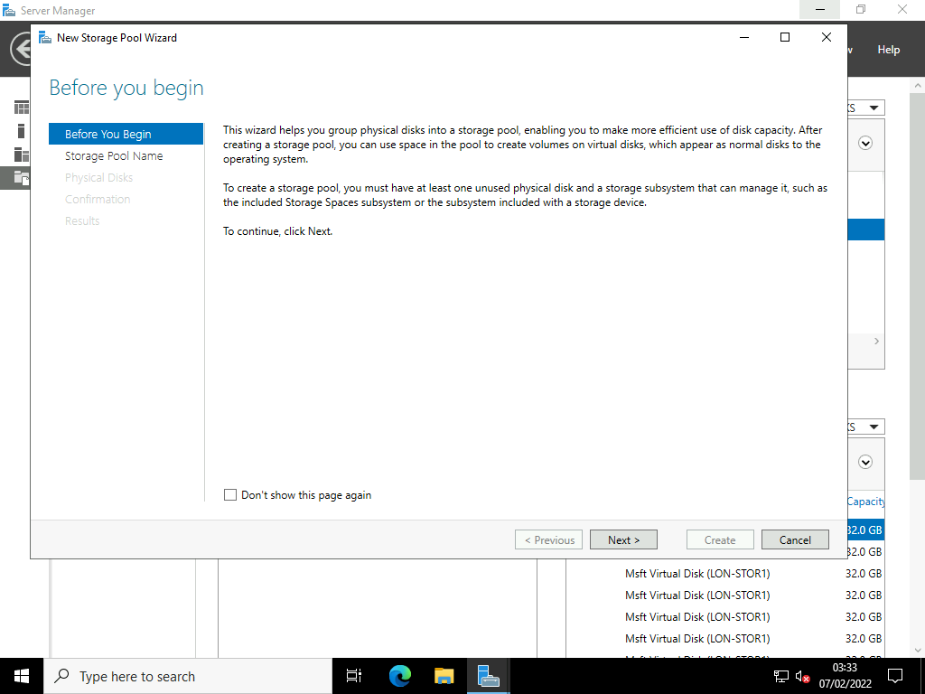

1. On the **Specify a storage pool name and subsystem** page, in the **Name** text box, type [**StoragePool1**](urn:gd:lg:a:send-vm-keys), and then click **Next**.

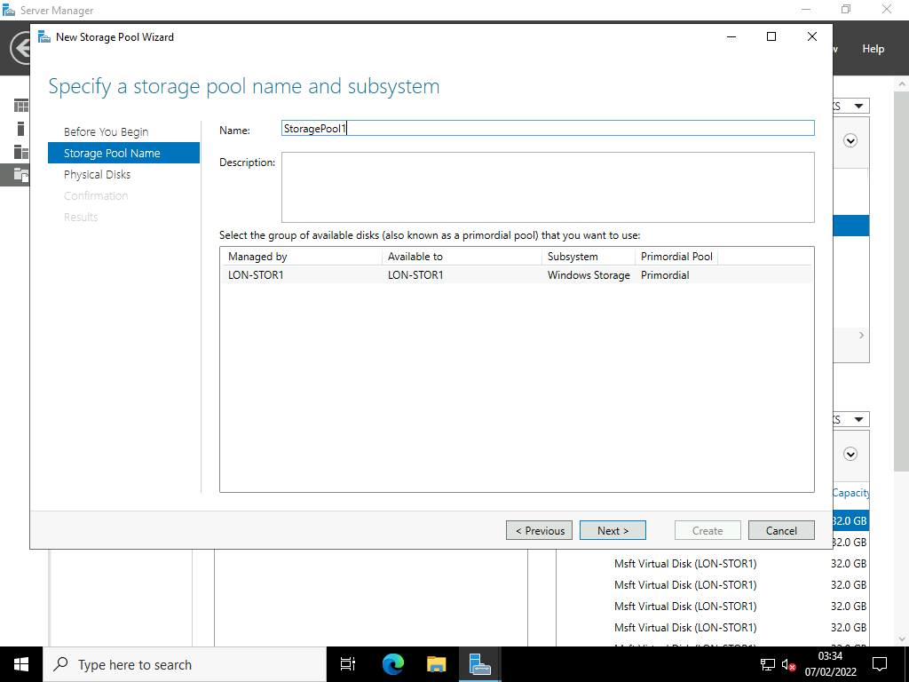

1. On the **Select physical disks for the storage pool** page, select the first six disks in the **Physical disks** list and then click **Next**.

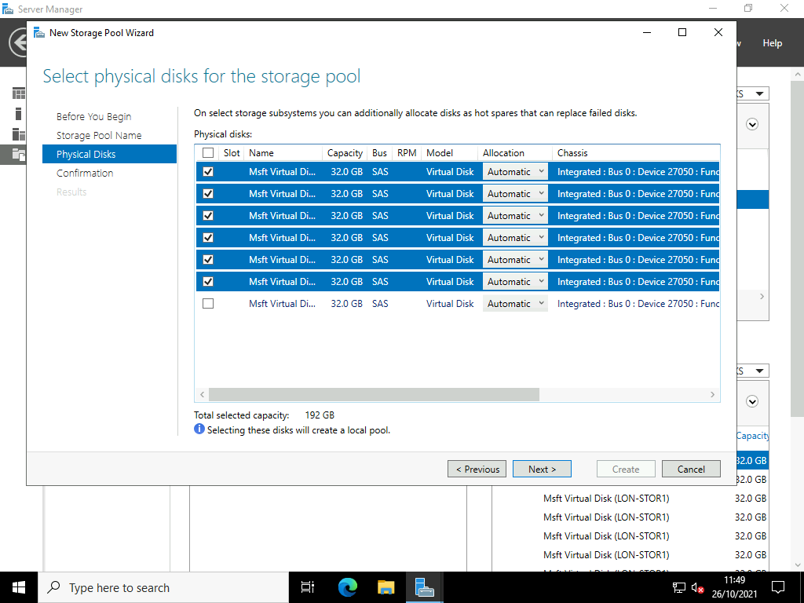

1. On the **Confirm selections** page, click **Create**.

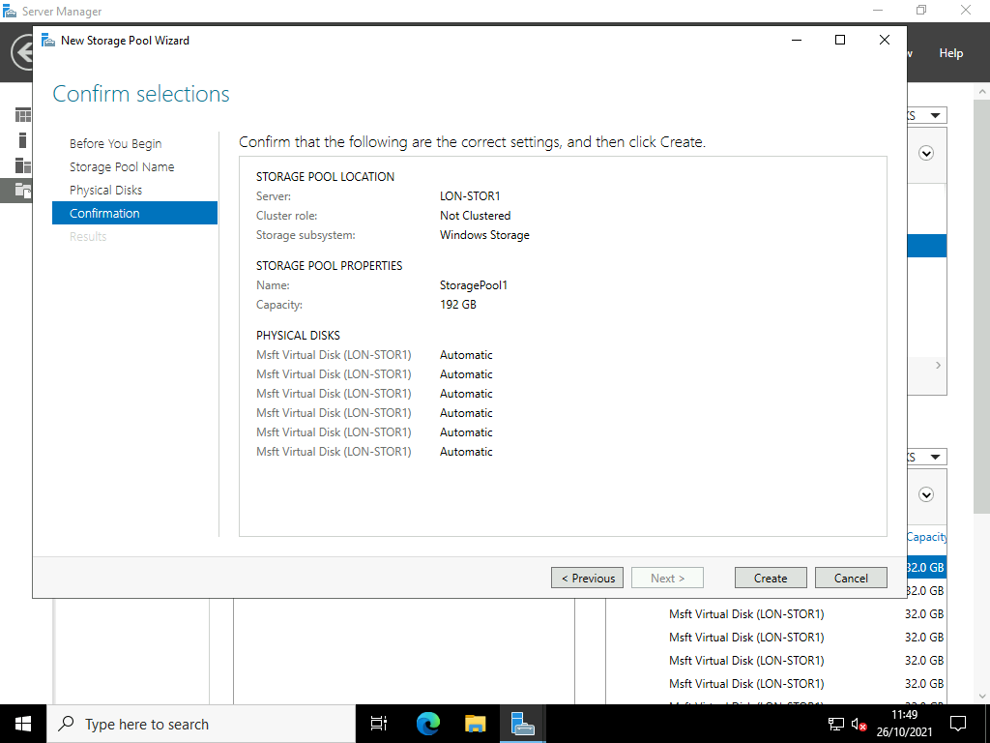

1. On the **View results** page, wait until the task completes, and then click **Close**.

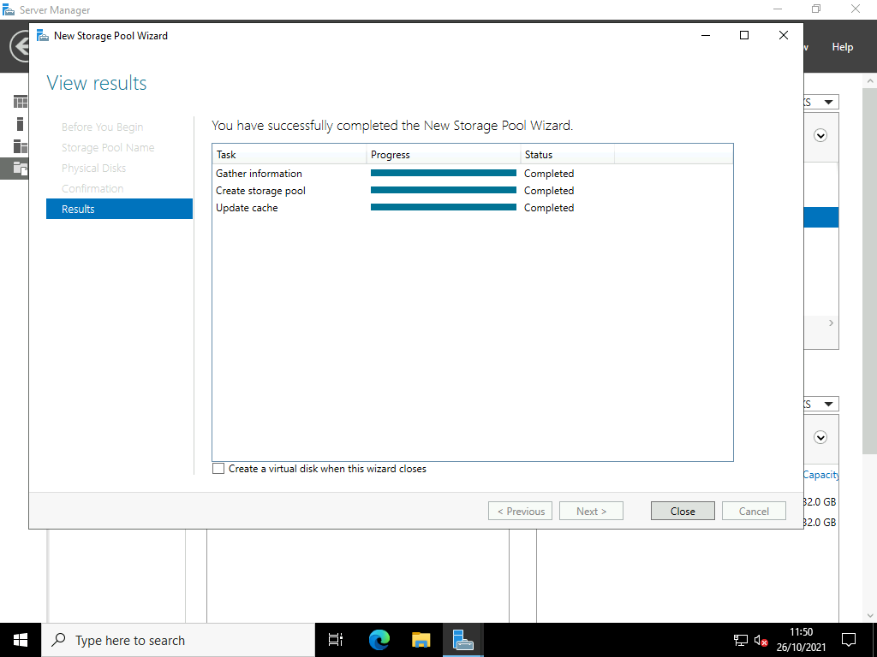

Task 2: Create a three-way mirrored virtual disk (need at least five physical disks)

1. On **LON-STOR1**, in Server Manager, in the **Storage Pools** pane, click **StoragePool1**.

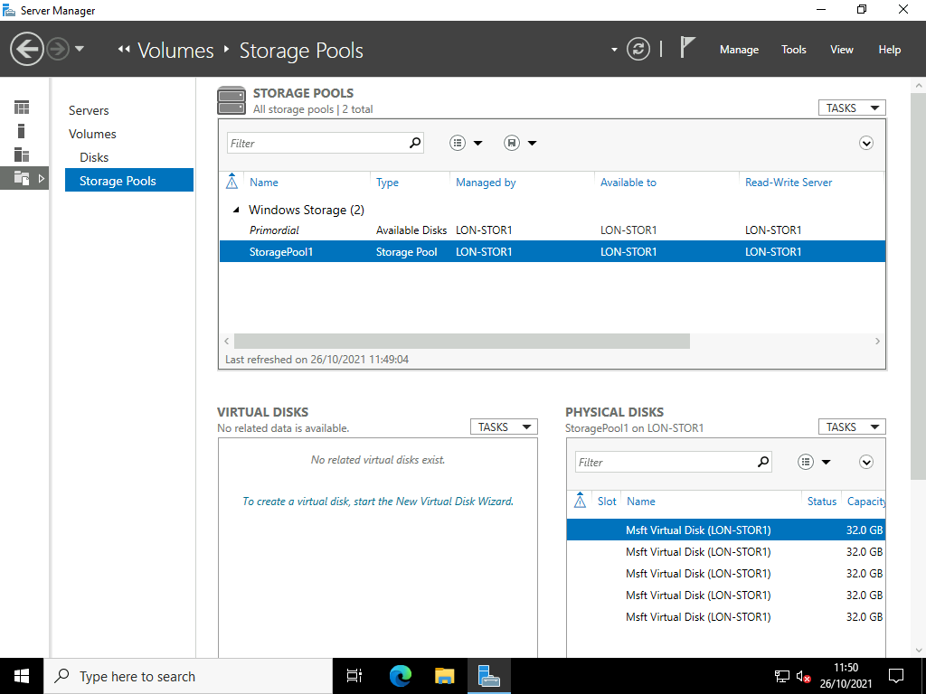

1. In the **VIRTUAL DISKS** pane, click **TASKS**, and then, from the **TASKS** drop-down list, click **New Virtual Disk**.

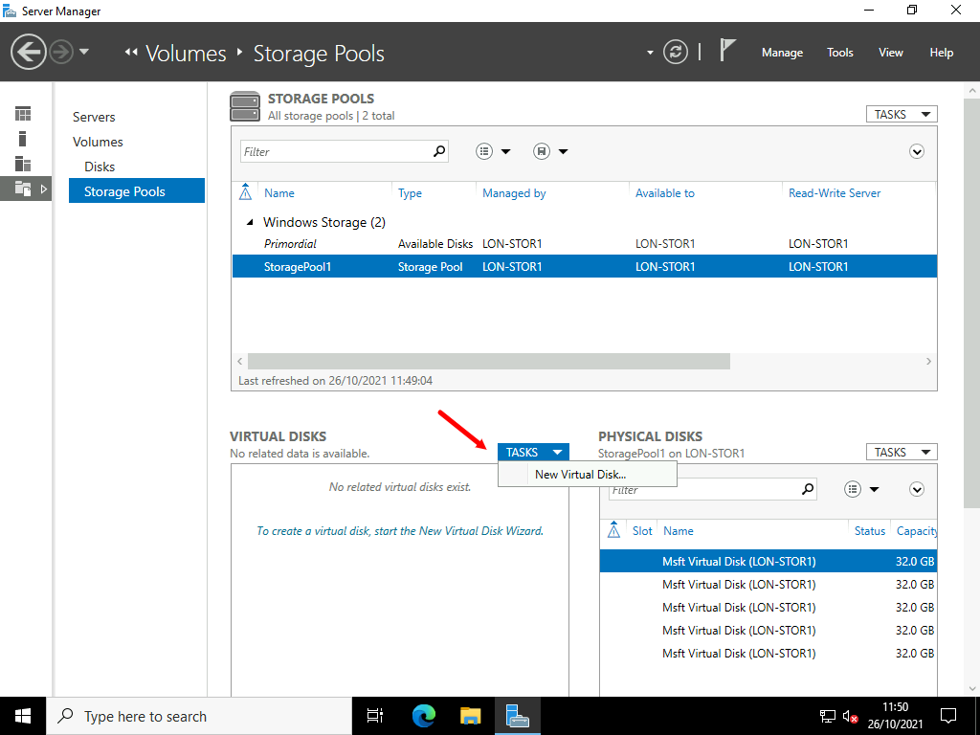

1. In the **Select the storage pool** dialog box, click **StoragePool1**, and then click **OK**.

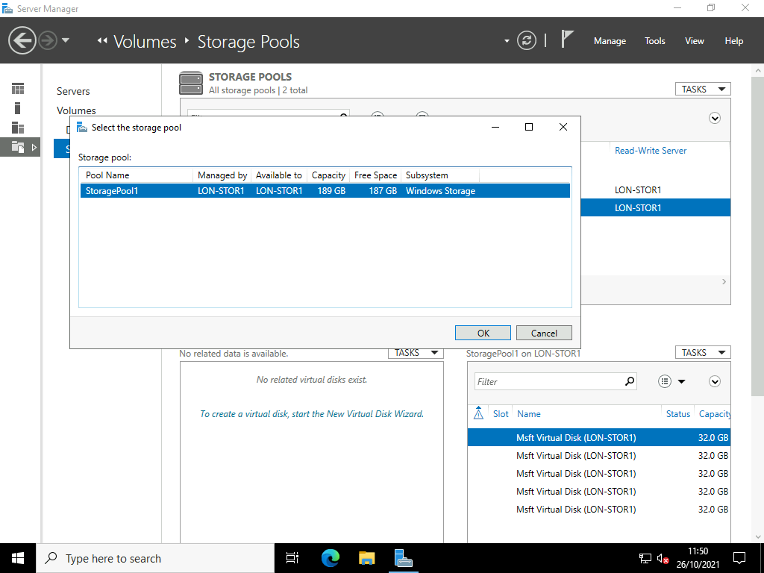

1. In the **New Virtual Disk Wizard**, on the **Before you begin** page, click **Next**.

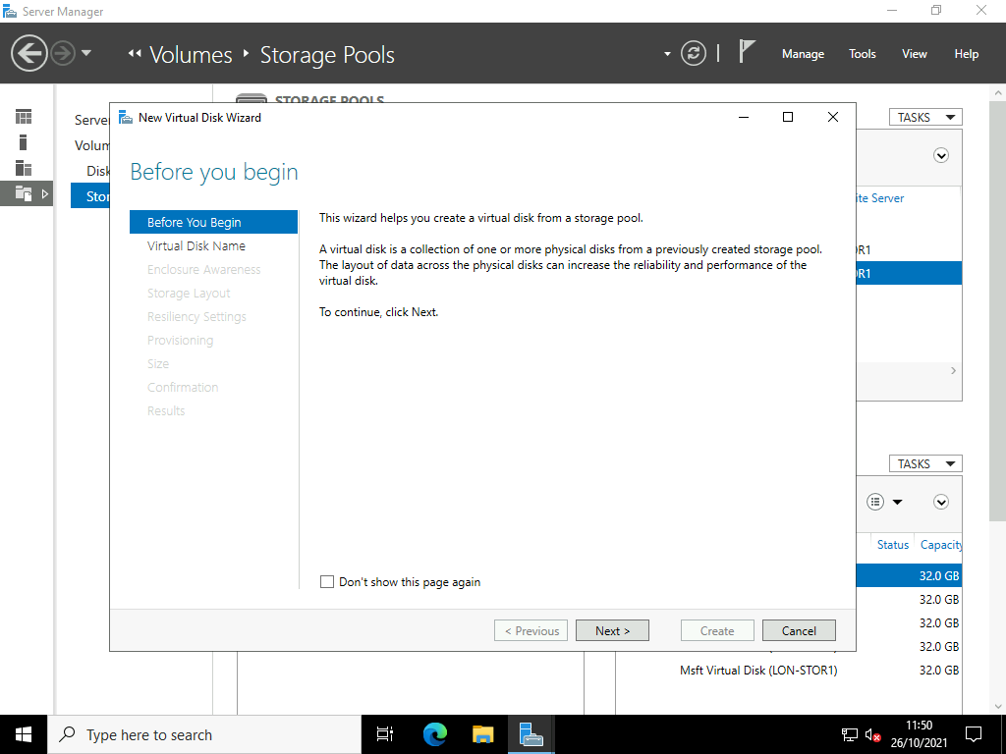

1. On the **Specify the virtual disk name** page, in the **Name** text box, type [**Mirrored Disk**](urn:gd:lg:a:send-vm-keys), and then click **Next**.

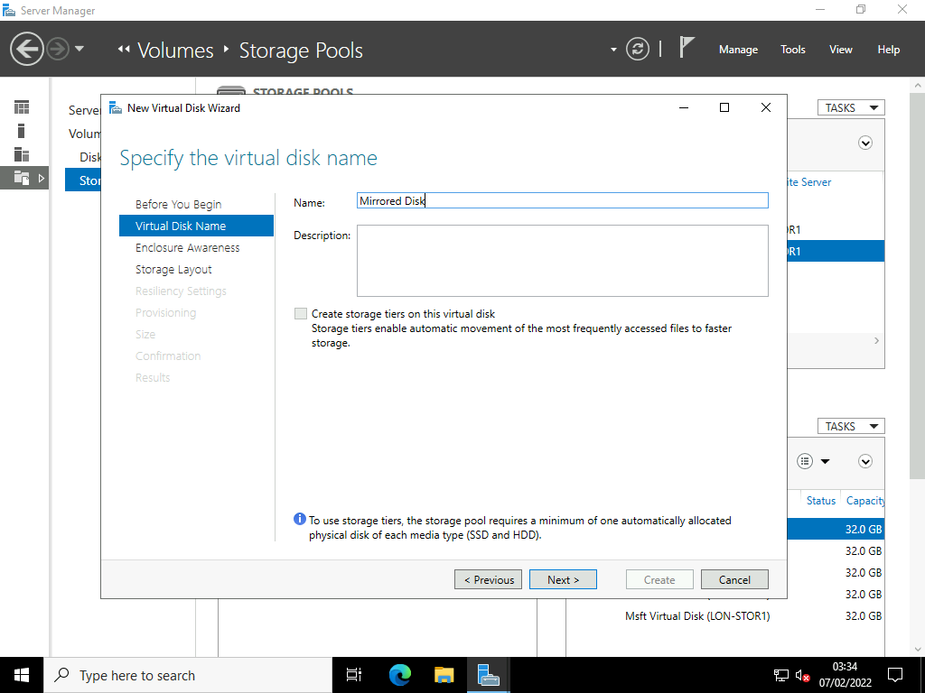

1. On the **Specify enclosure resiliency** page, click **Next**.

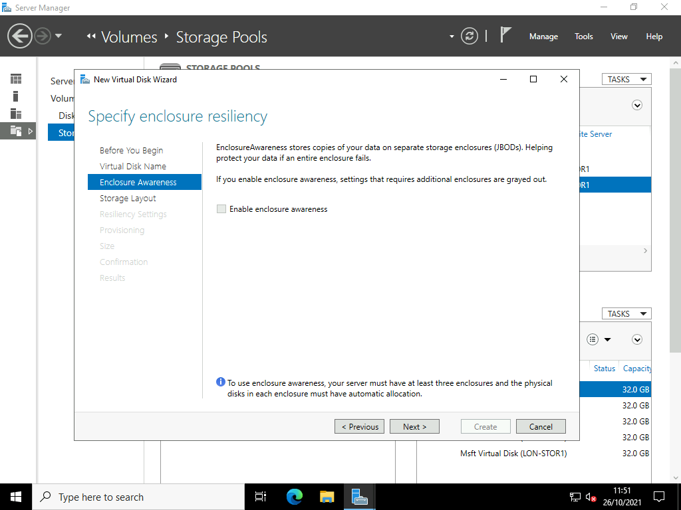

1. On the **Select the storage layout** page, in the **Layout** list, click **Mirror**, and then click **Next**.

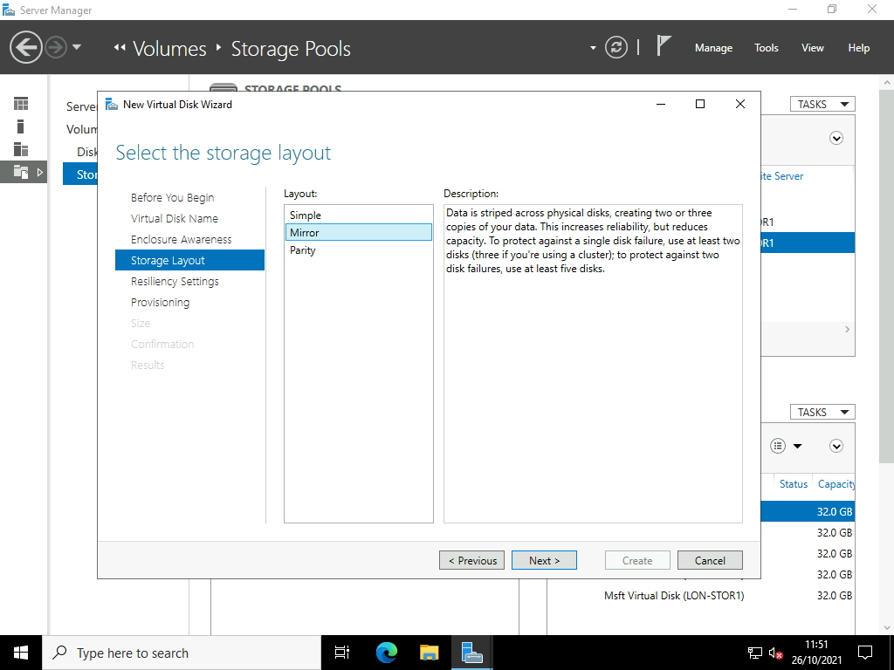

1. On the **Configure the resiliency settings** page, click **Three-way mirror**, and then click **Next**.

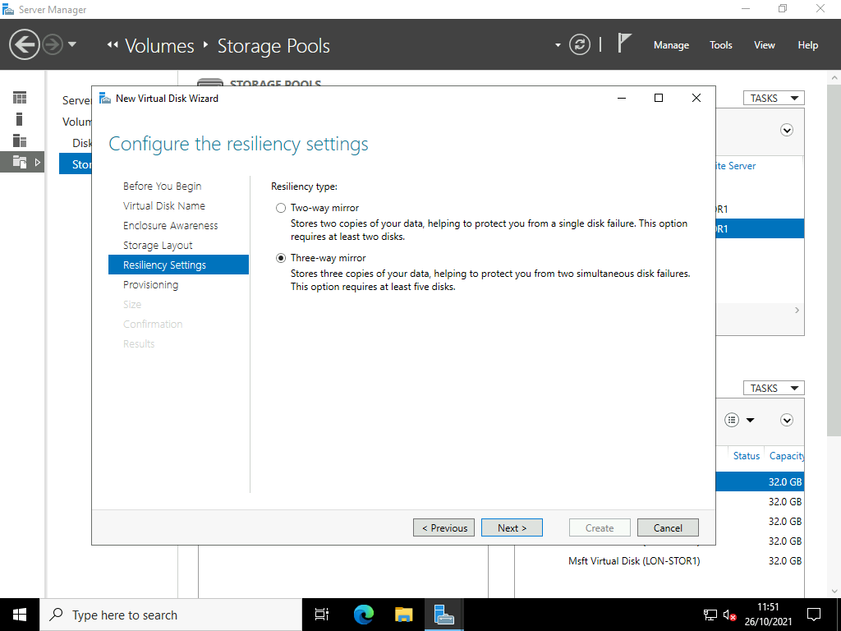

1. On the **Specify the provisioning type** page, click **Thin**, and then click **Next**.

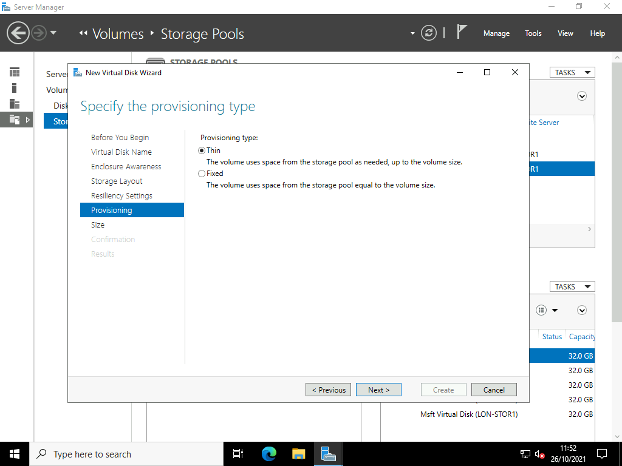

1. On the **Specify the size of the virtual disk** page, in the **Specify size** text box, type [**10**](urn:gd:lg:a:send-vm-keys), and then click **Next**.

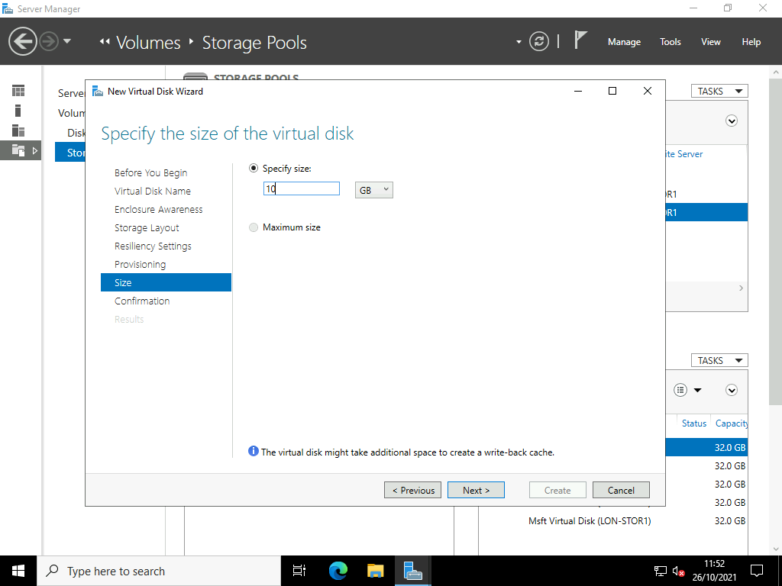

1. On the **Confirm selections** page, click **Create**.

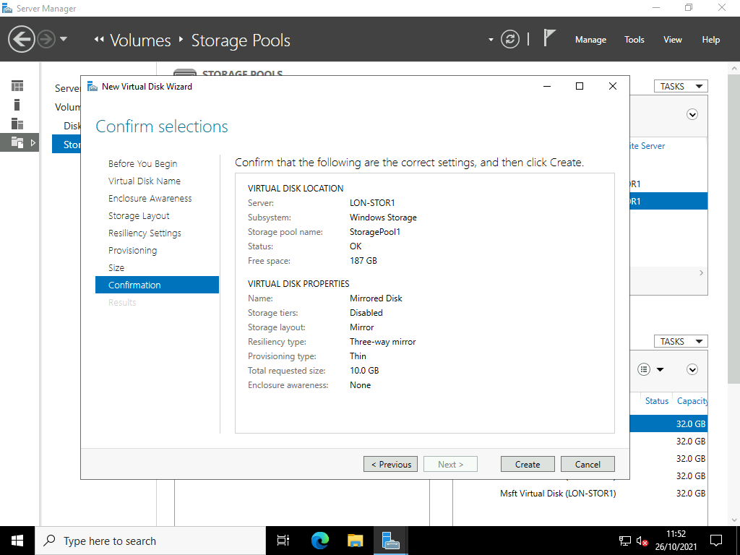

1. On the **View results** page, wait until the task completes.
2. Ensure that the **Create a volume when this wizard closes** check box is selected, and then click **Close**.

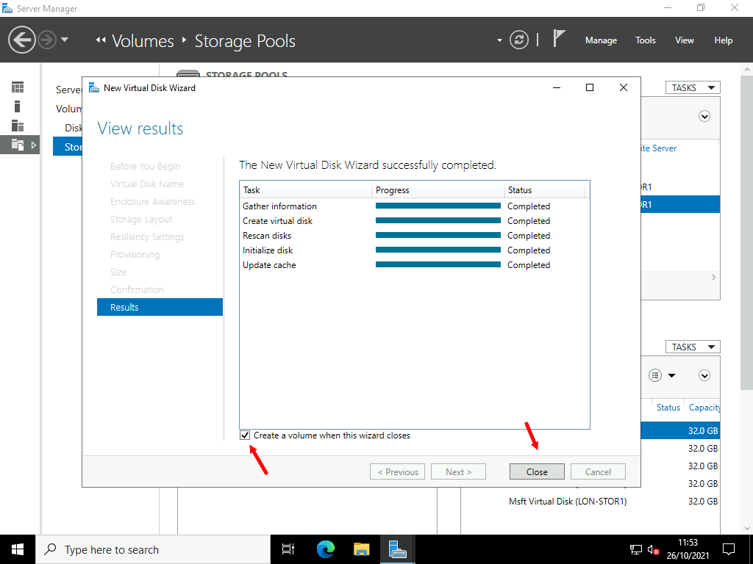

1. In the **New Volume Wizard** window, on the **Before you begin** page, click **Next**.

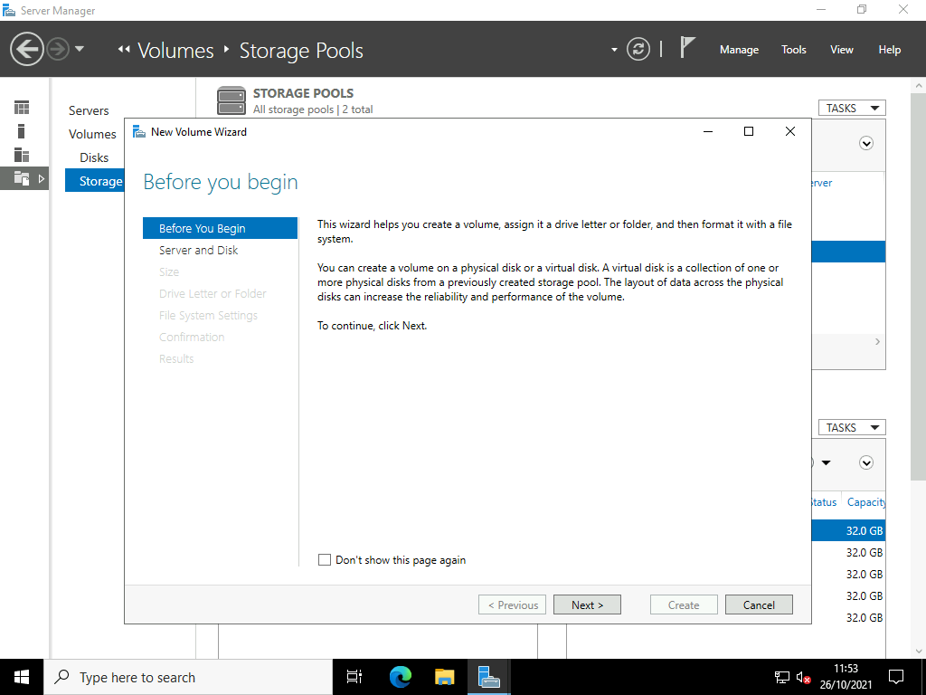

1. On the **Select the server and disk** page, in the Disk pane, click the **Mirrored Disk** virtual disk, and then click **Next**.

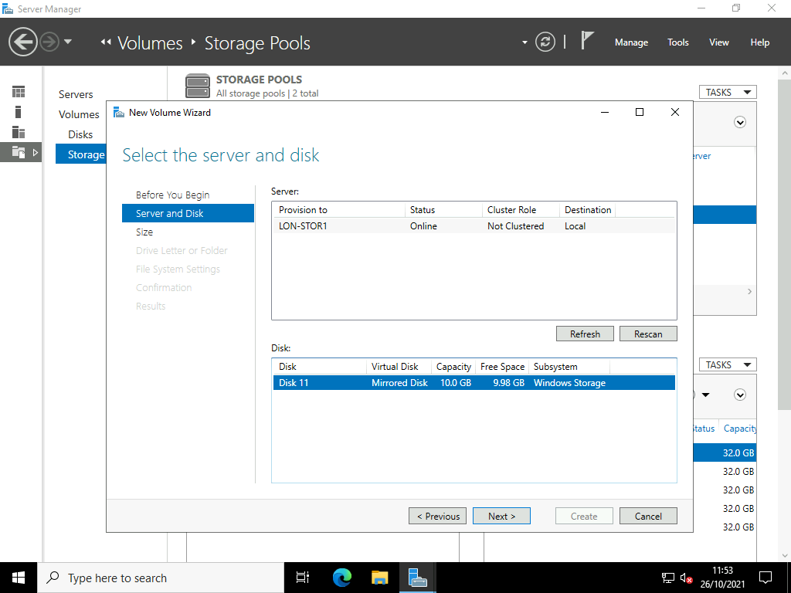

1. On the **Specify the size of the volume** page, click **Next** to confirm the default selection.

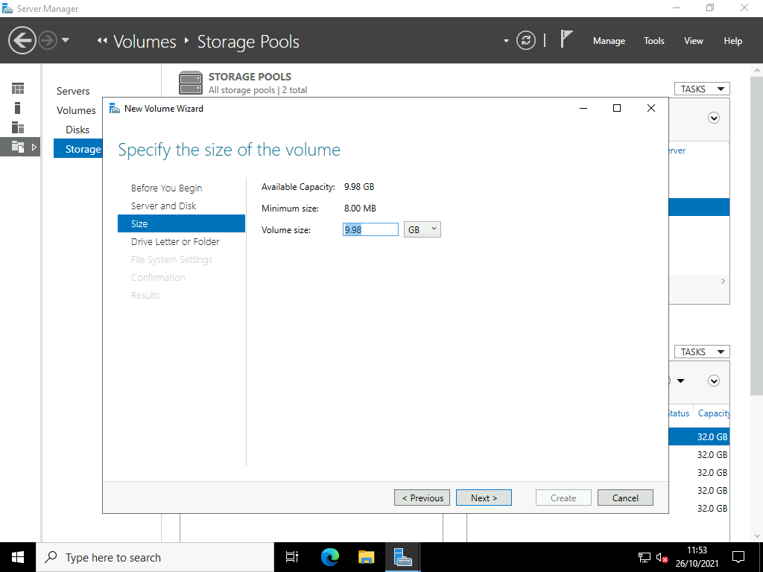

1. On the **Assign to a drive letter or folder** page, in the **Drive letter** drop-down list, select **H**, and then click **Next**.

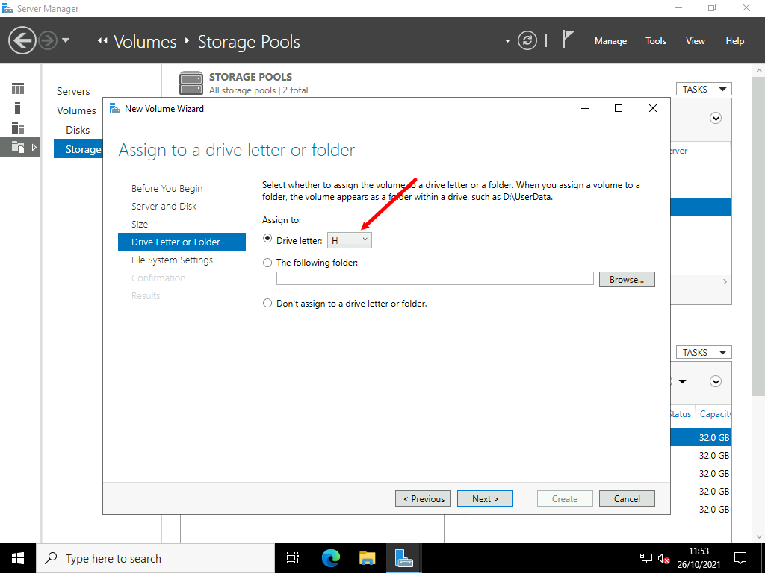

1. On the **Select file system settings** page, in the **File system** drop-down list, click **ReFS**, in the **Volume label** text box, type [**Mirrored Volume**](urn:gd:lg:a:send-vm-keys), and then click **Next**.

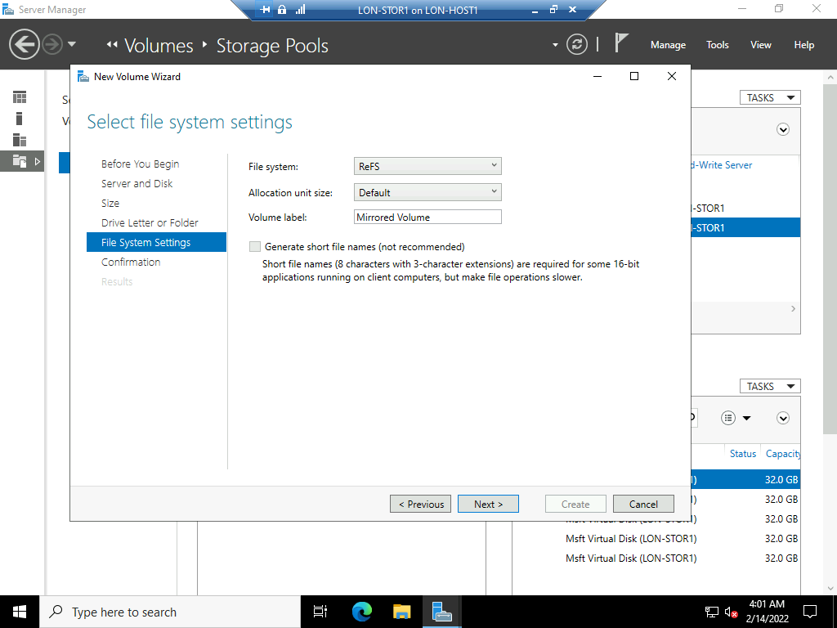

1. On the **Confirm selections** page, click **Create**.

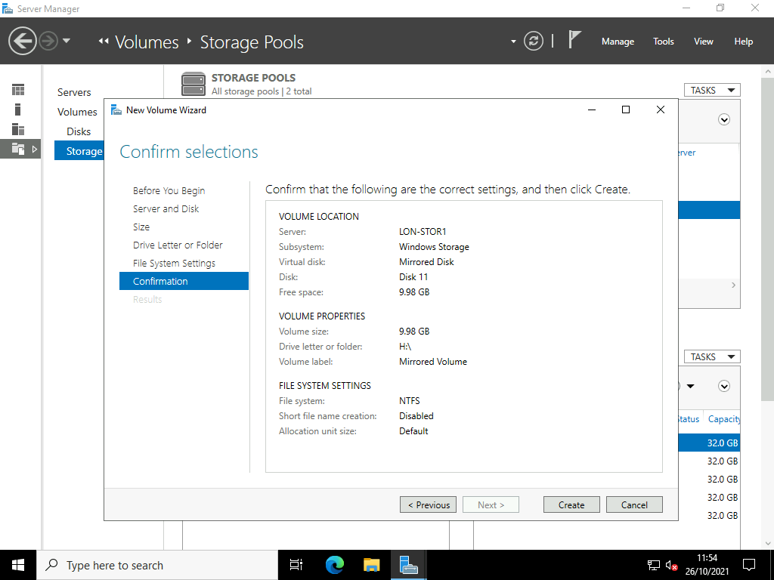

1. On the **Completion** page, wait until the creation completes, and then click **Close**.

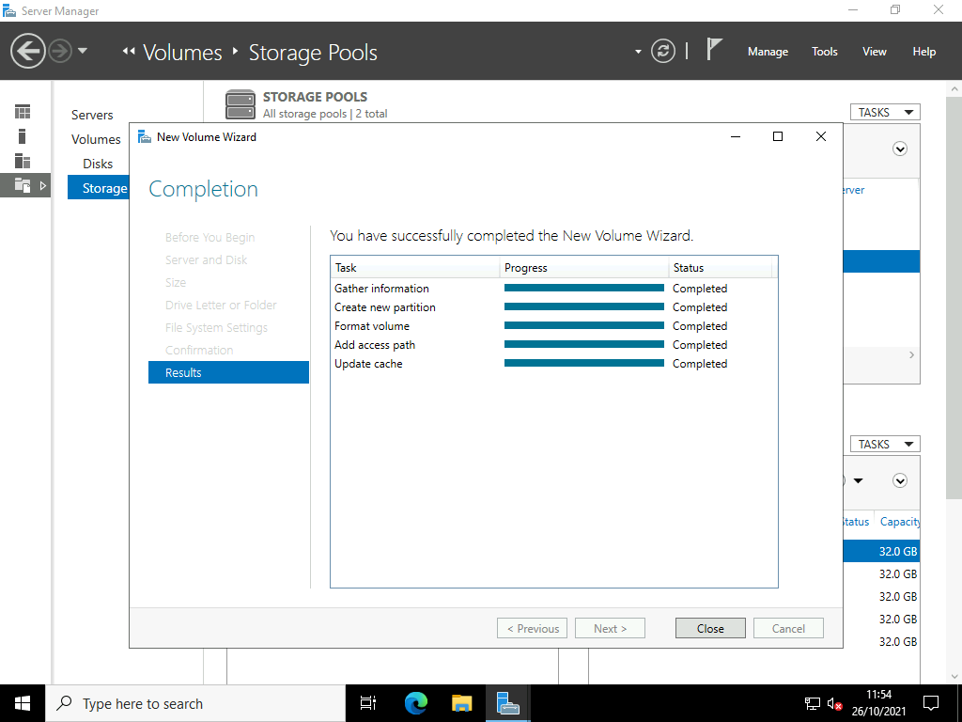

Task 3: Copy a file to the volume, and verify it is visible in File Explorer

1. On **LON-STOR1**, right click the **Start** menu, and select **Windows PowerShell (Admin)**.

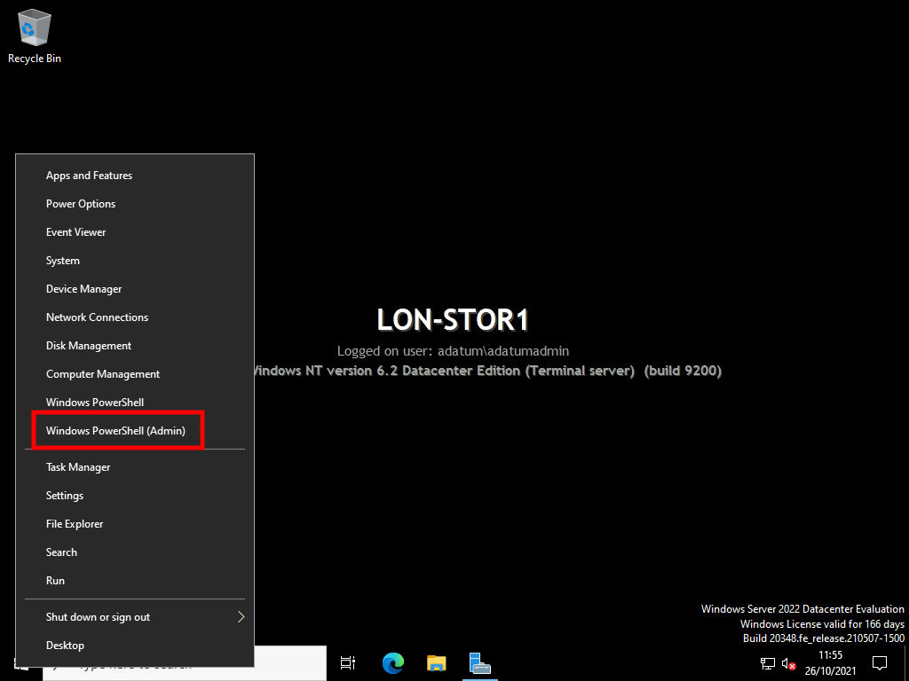

1. When you receive the PowerShell window, type the following command, and then press Enter:
2. Copy C:\windows\system32\write.exe H:\

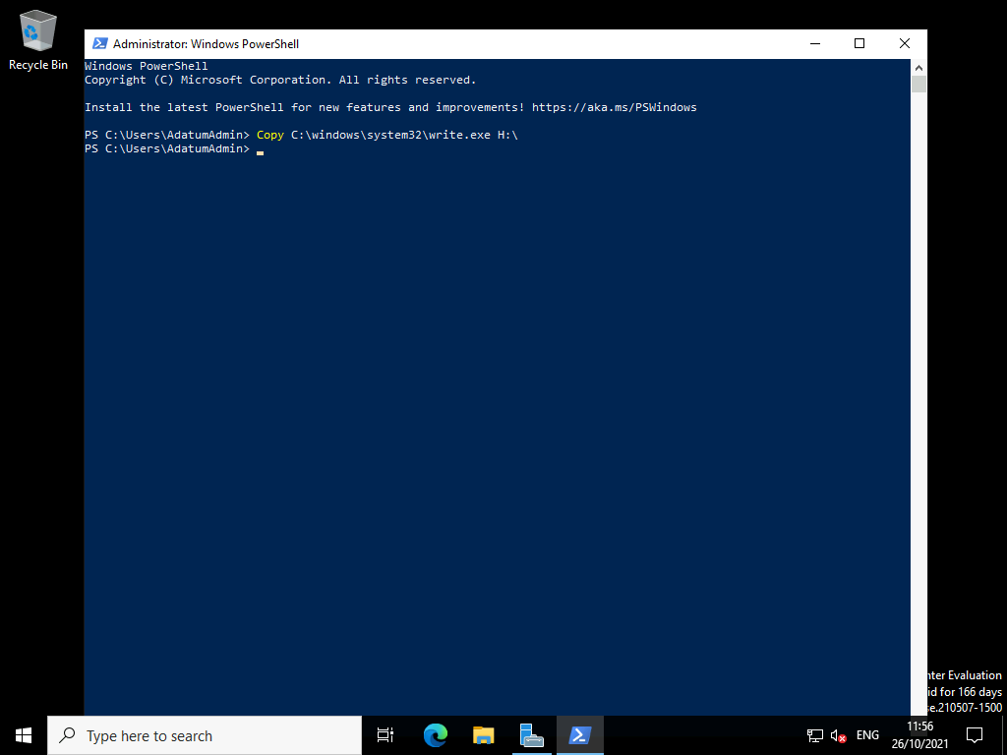

1. Close the **PowerShell** window.
2. On the taskbar, click the **File Explorer** icon.

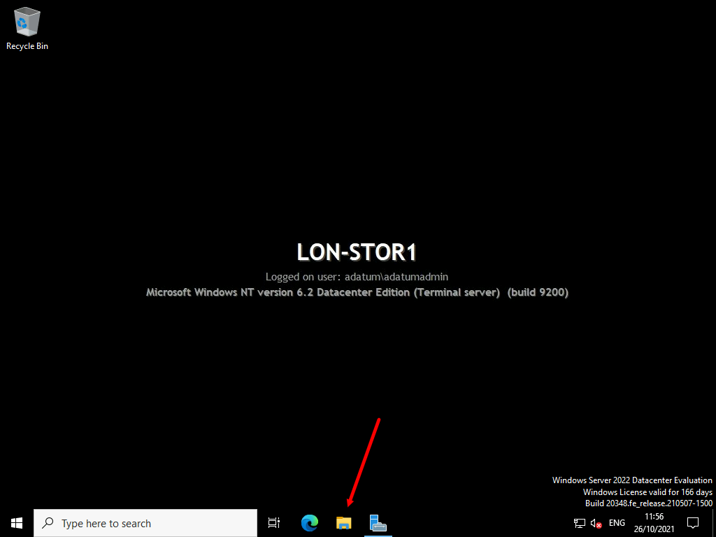

1. In **File Explorer**, in the **navigation** pane, double click **Mirrored Volume (H:)**.

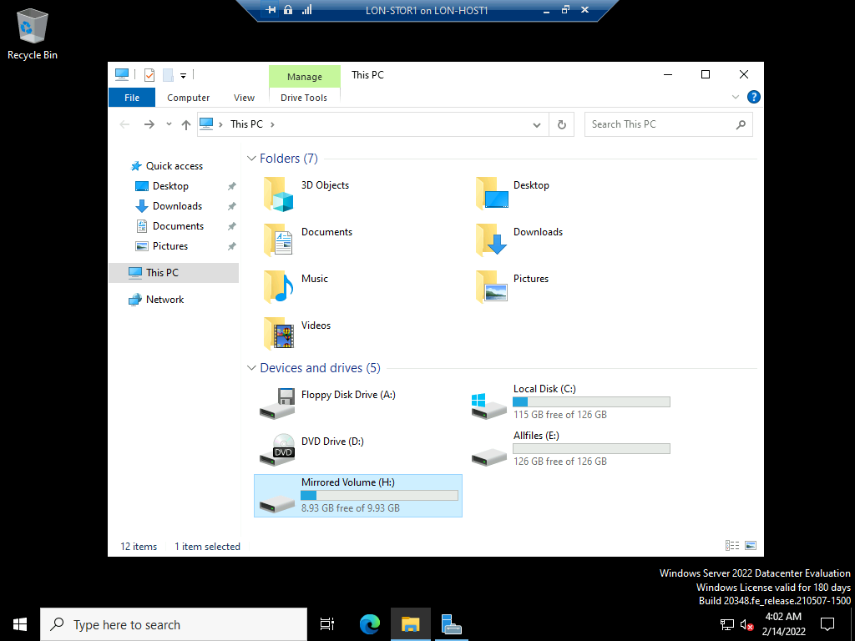

1. Verify that **write.exe** is visible in the file list.

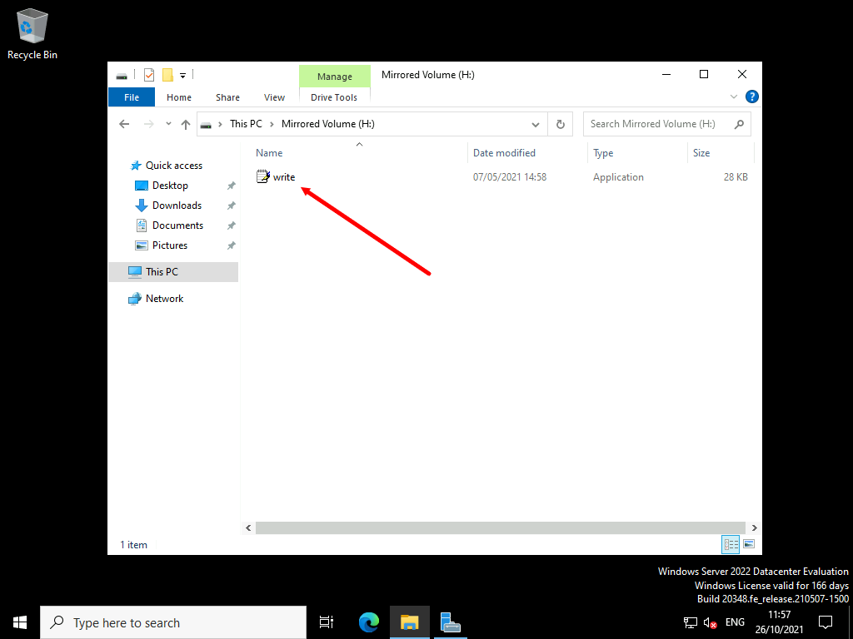

1. Close **File Explorer**.

Task 4: Remove a physical drive to simulate drive failure

1. Minimize the VM connection to **LON-STOR1** so you return to [**LON-HOST1**](urn:gd:lg:a:select-vm).

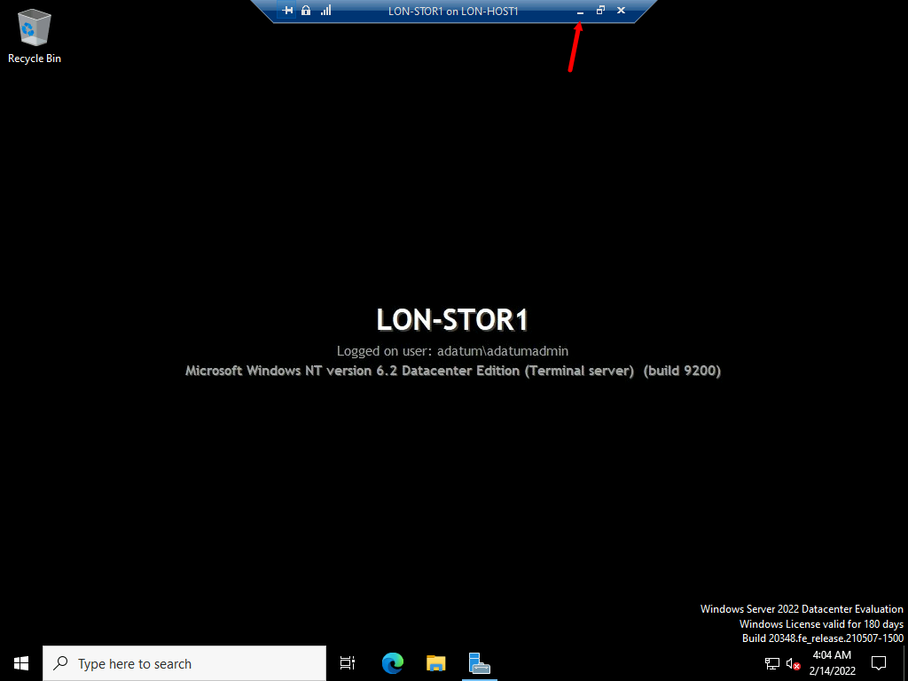

1. In **Virtual Machines** pane, right-click **LON-STOR1**, and then click **Settings**.

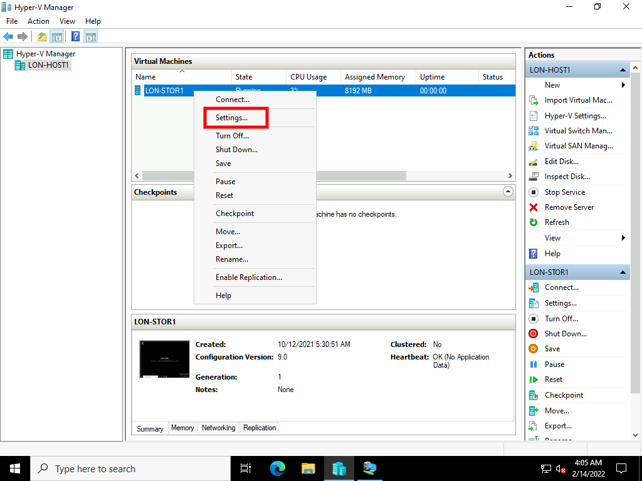

1. In **Settings** for **LON-STOR1**, in the **Hardware** pane, click the hard drive named **LON-STOR1-Disk1.vhd**.

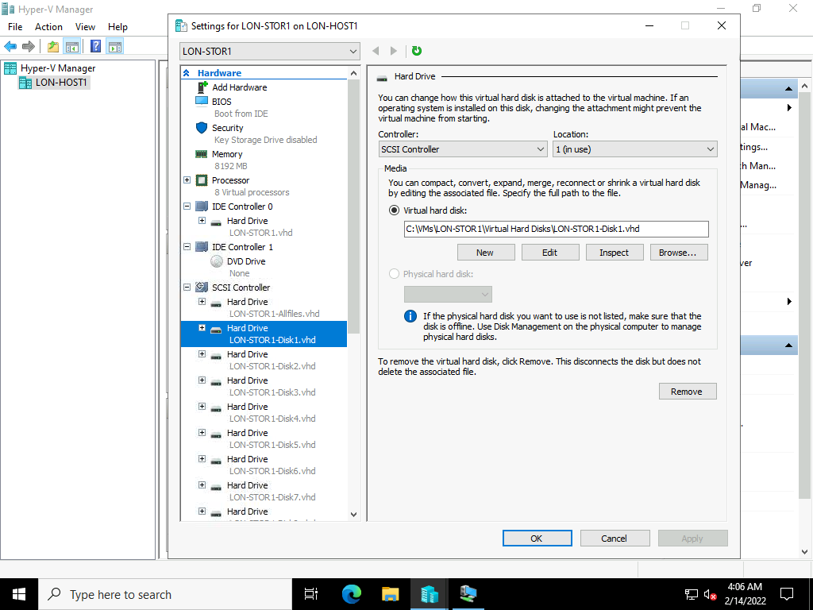

1. In the **Hard Drive** pane, click **Remove**, click **Apply**, and then click **Ok**.

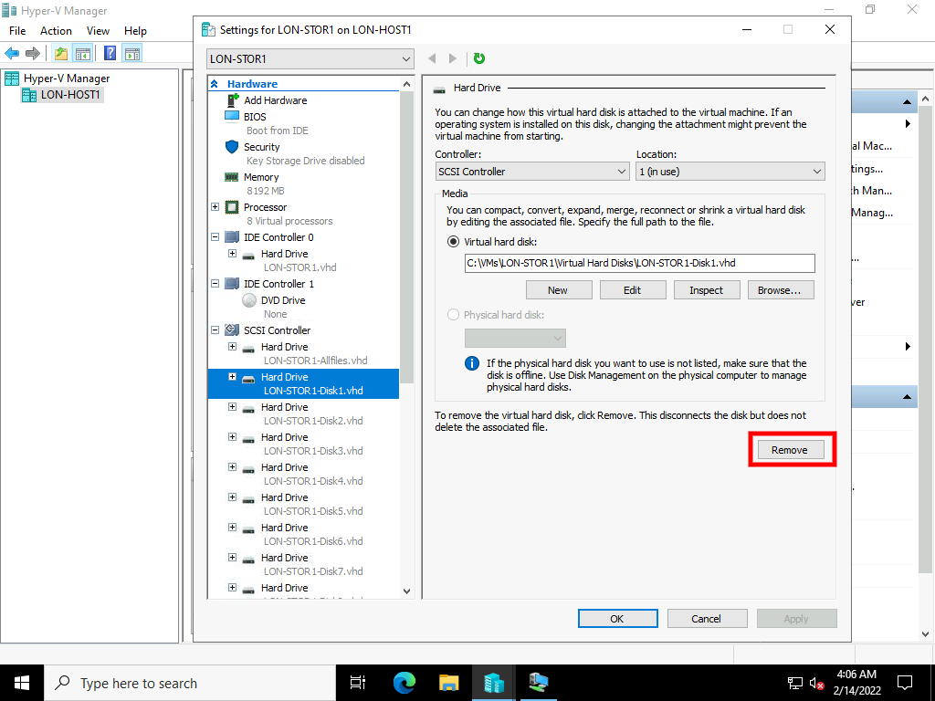

Task 5: Verify that the file is still available

1. Restore the connection to **LON-STOR1**.
2. On the taskbar, click the **File Explorer** icon.
3. In **File Explorer**, in the navigation pane, double click **Mirrored Volume (H:)**.

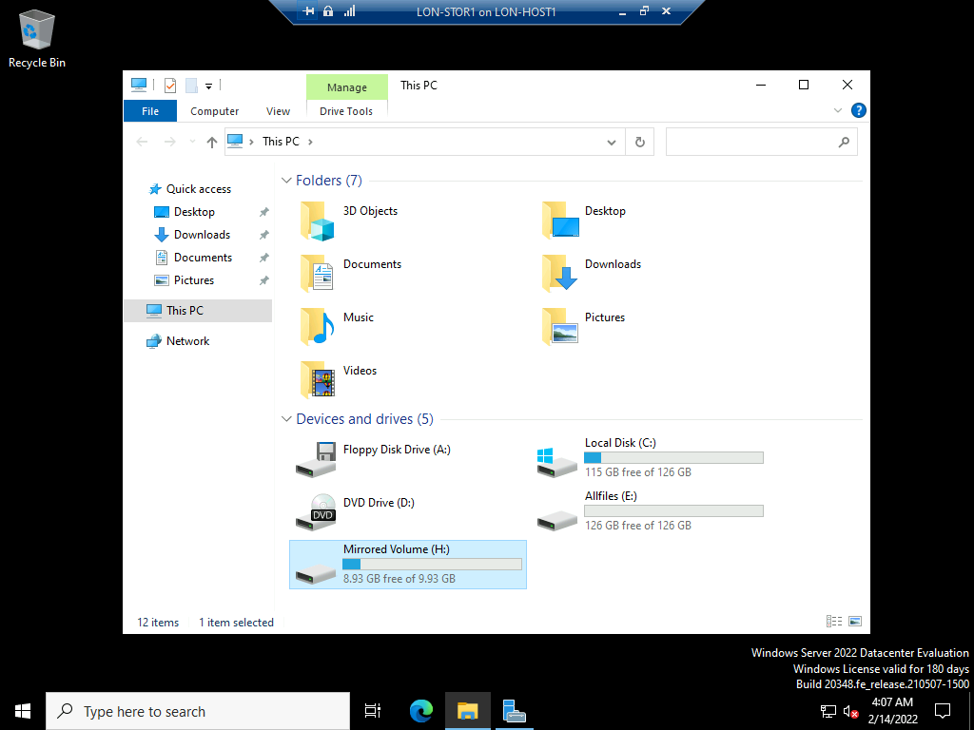

1. In the **file list** pane, verify that **write.exe** is still available.
2. Close **File Explorer**.
3. In **Server Manager**, in the **STORAGE POOLS** pane, on the menu bar, click **Refresh "Storage Pools"**.

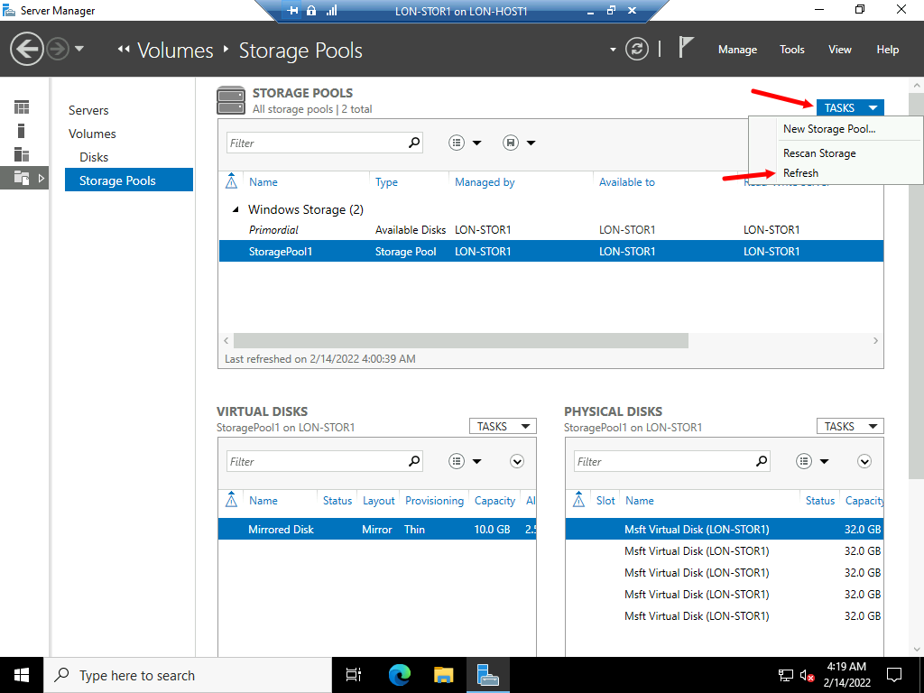

**Note:** Notice the warning that is visible next to **Mirrored Disk**.

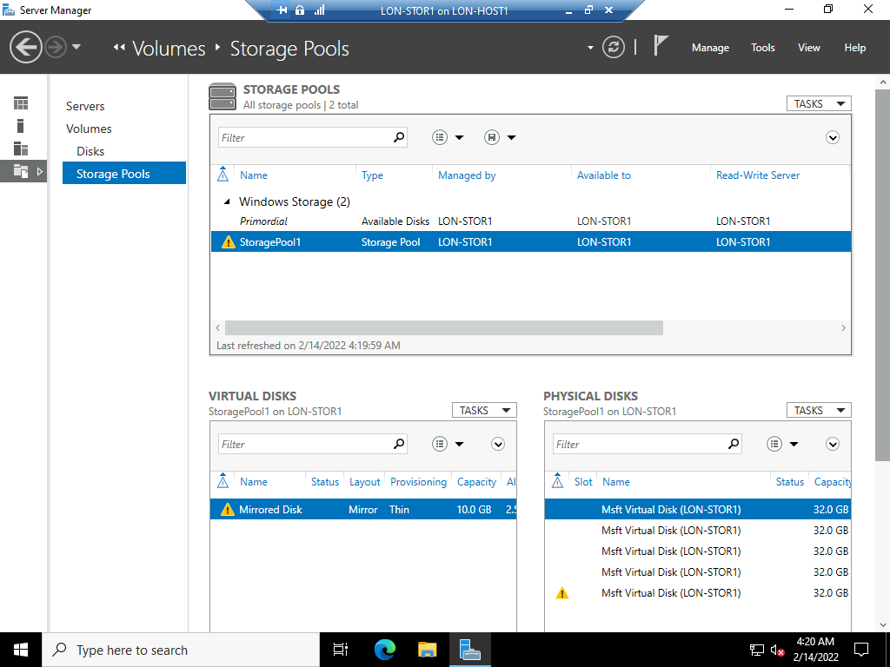

1. In the **VIRTUAL DISK** pane, right-click **Mirrored Disk**, and then click **Properties**.

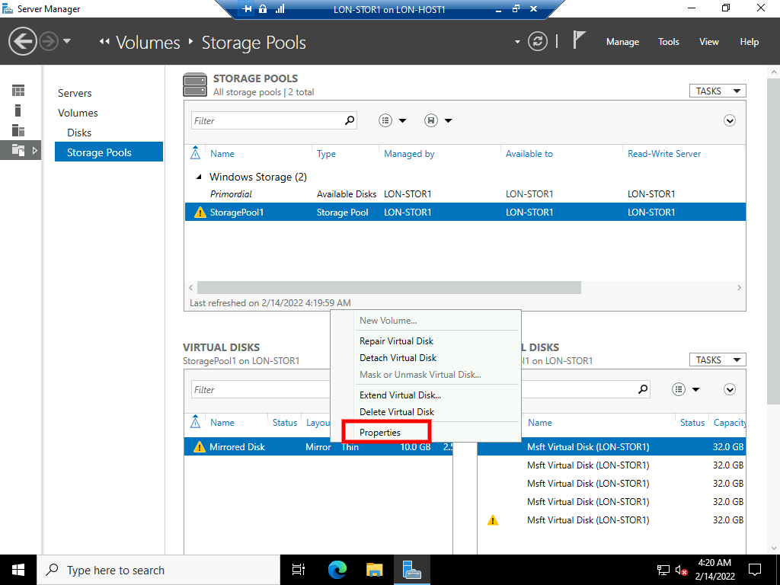

1. In the **Mirrored Disk Properties** dialog box, in the left pane, click **Health**.

**Note:** Notice that the Health Status indicates a warning. The Operational Status should indicate one or more of the following: Incomplete, Unknown, or Degraded.

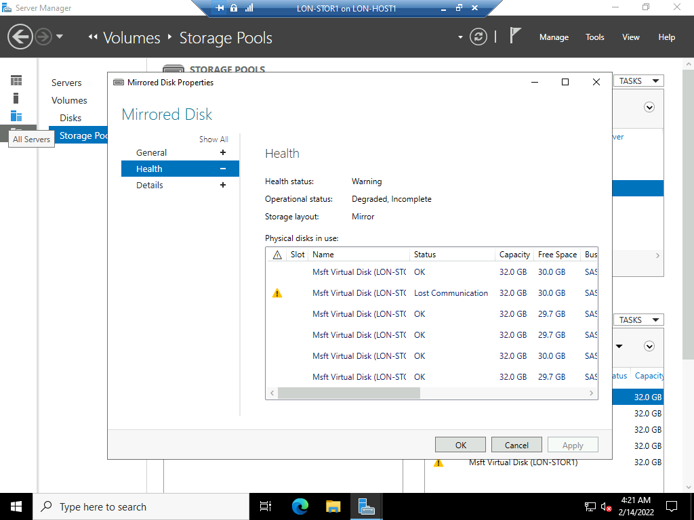

1. In the **Mirrored Disk Properties** dialog box, click **OK**.

Task 6: Add a new disk to the storage pool and remove the broken disk

1. On **LON-STOR1**, in **Server Manager**, in the **STORAGE POOLS** pane, on the menu bar, click **Refresh"**.

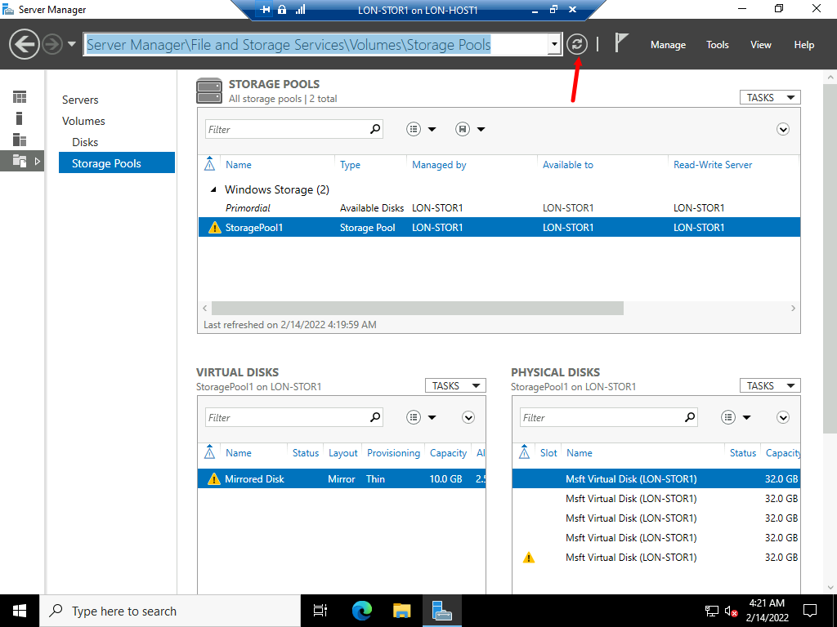

1. In the **STORAGE POOLS** pane, right-click **StoragePool1**, and then click **Add Physical Disk**.

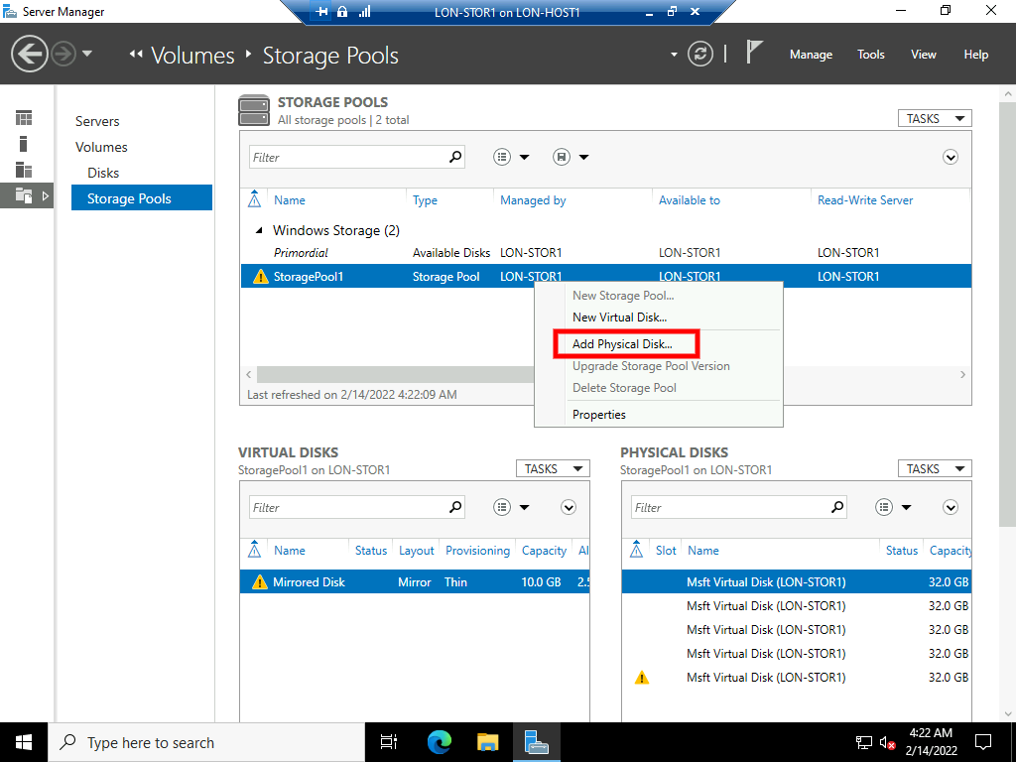

1. In the **Add Physical Disk** window, click the first disk in the list, and then click **OK**.

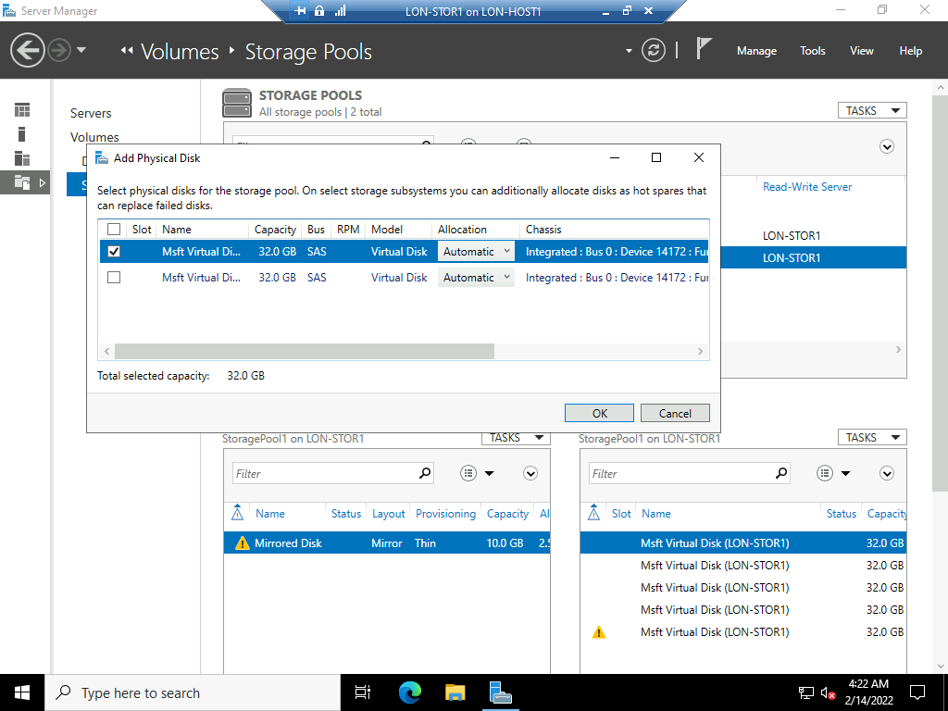

1. Right-click **Start**, and then click **Windows PowerShell (Admin)**.

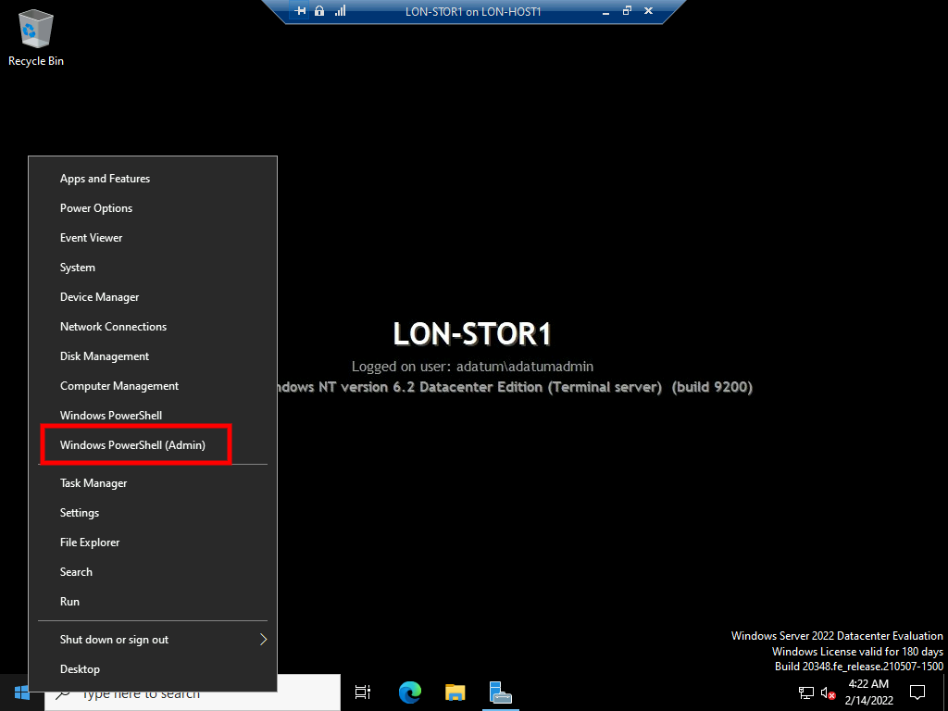

1. In **Windows PowerShell**, type the following command, and then press Enter:
2. Get-PhysicalDisk

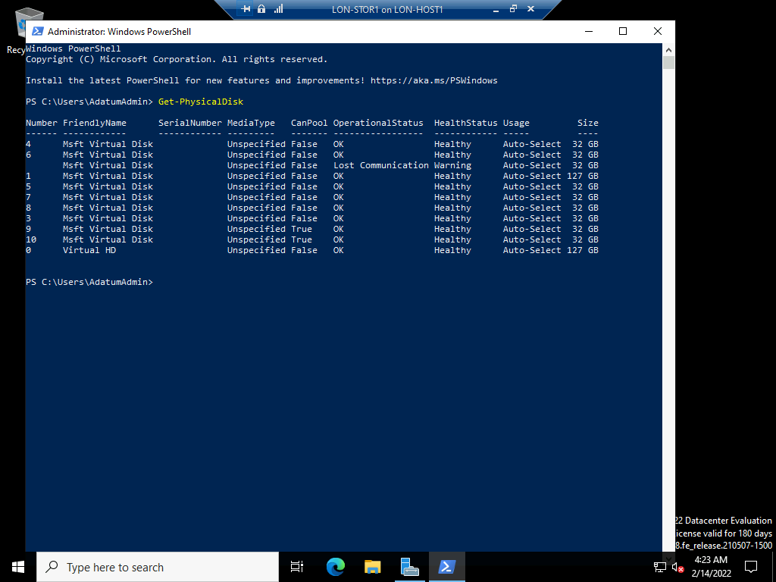

1. Note the disk that shows an OperationalStatus of **Lost Communication**.
2. Return to Server Manager and right click the Physical Disk in **Physical Disks** with the warning icon next to it. Select **Remove Disk**.

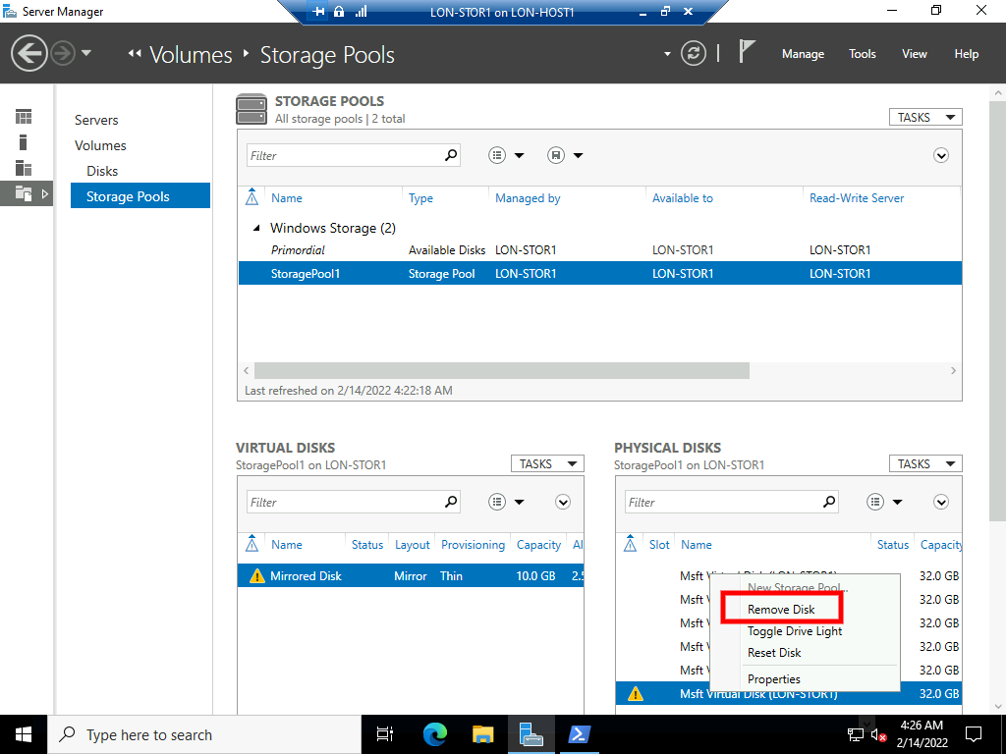

1. On the warning pop up select **Yes**.

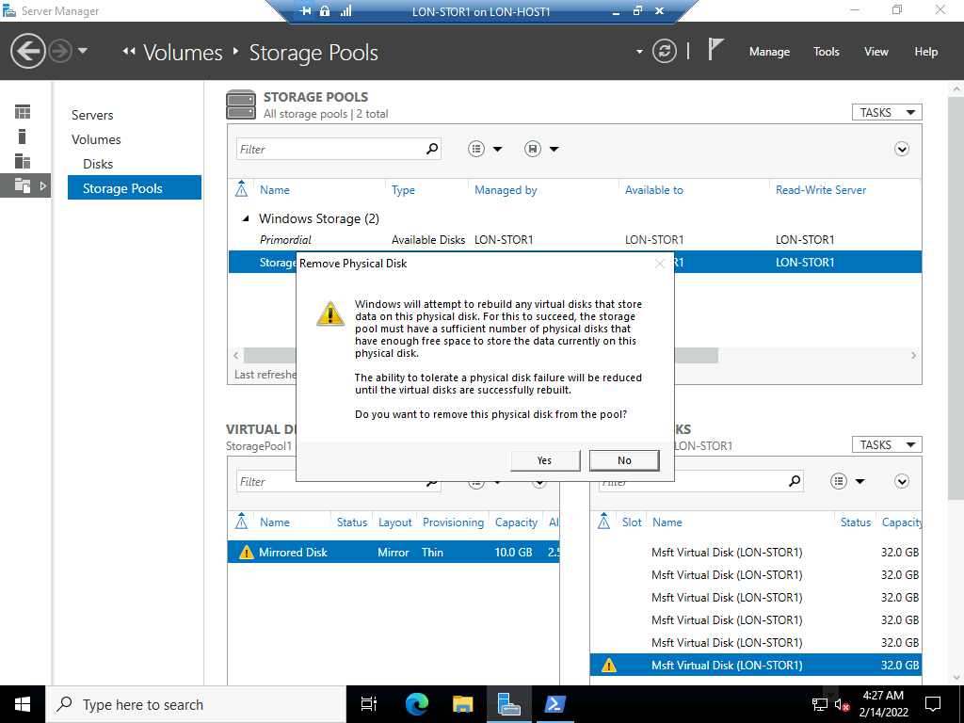

1. Once the disk has been removed click **Ok**.

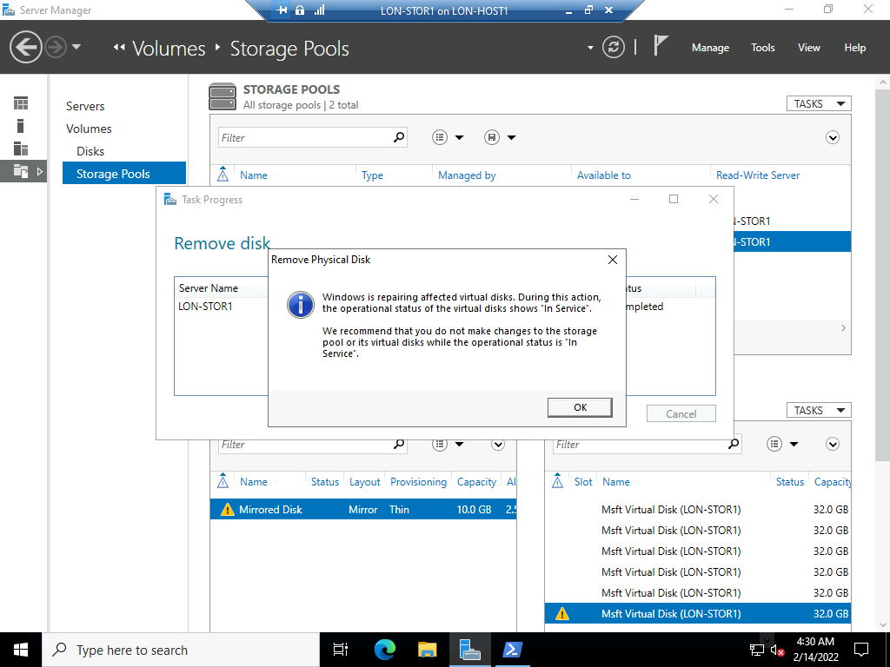

1. In Server Manager, in the **STORAGE POOLS** pane, on the menu bar, click the **Refresh "Storage Pools"** button to see the warnings disappear.

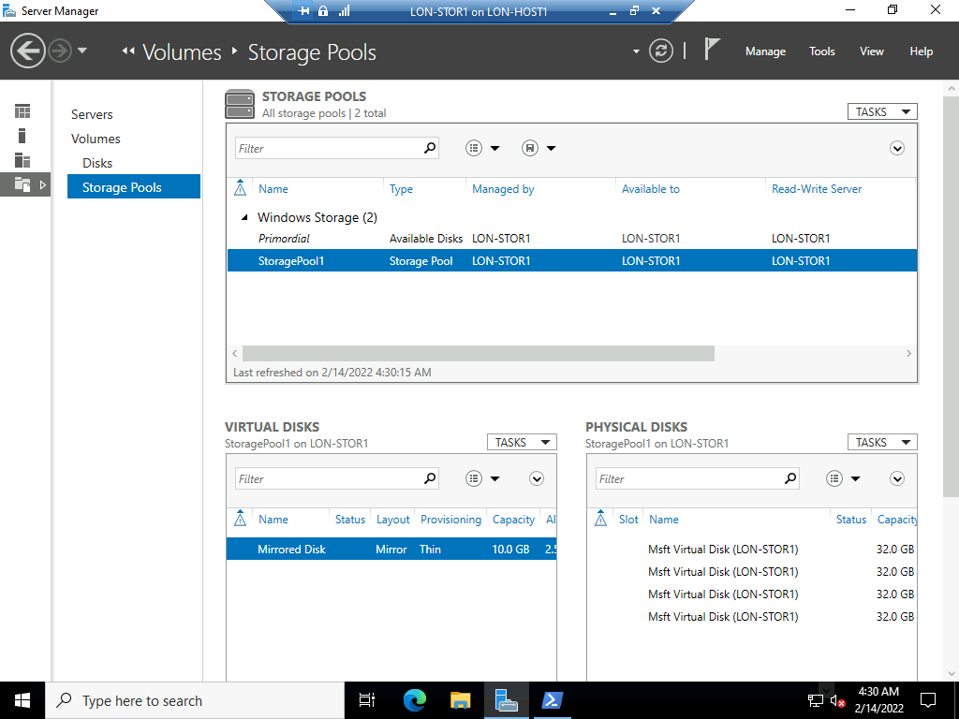

**Results** : After completing this exercise, you should have successfully created a storage pool and added five disks to it. Additionally, you should have created a three-way mirrored, thinly-provisioned virtual disk from the storage pool. You also should have copied a file to the new volume and then verified that it is accessible. Next, after removing a physical drive, you should have verified that the virtual disk was still available and that you could access it. Finally, you should have added another physical disk to the storage pool.

Exercise 2: Enabling and configuring storage tiering

Scenario

Management wants you to implement storage tiers to take advantage of the high-performance attributes of a number of SSDs, while utilizing less expensive hard disk drives for less frequently accessed data.

The main tasks for this exercise are as follows:

1. Use the Get-PhysicalDisk cmdlet to view all available disks on the system.
2. Create a new storage pool.
3. View the media types.
4. Specify the media type for the sample disks and verify that the media type is changed.
5. Create pool-level storage tiers by using Windows PowerShell.
6. Create a new virtual disk with storage tiering by using the New Virtual Disk Wizard.

Task 1: Use the Get-PhysicalDisk cmdlet to view all available disks on the system

1. On **LON-STOR1**, right-click **Start**, and then click **Windows PowerShell (Admin)**.

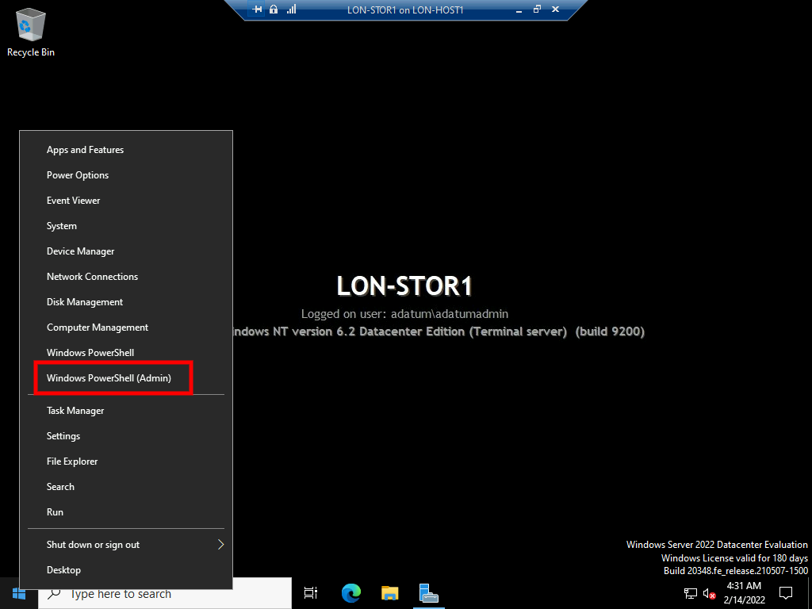

1. In **Windows PowerShell**, type the following command, and then press Enter:
2. Get-PhysicalDisk

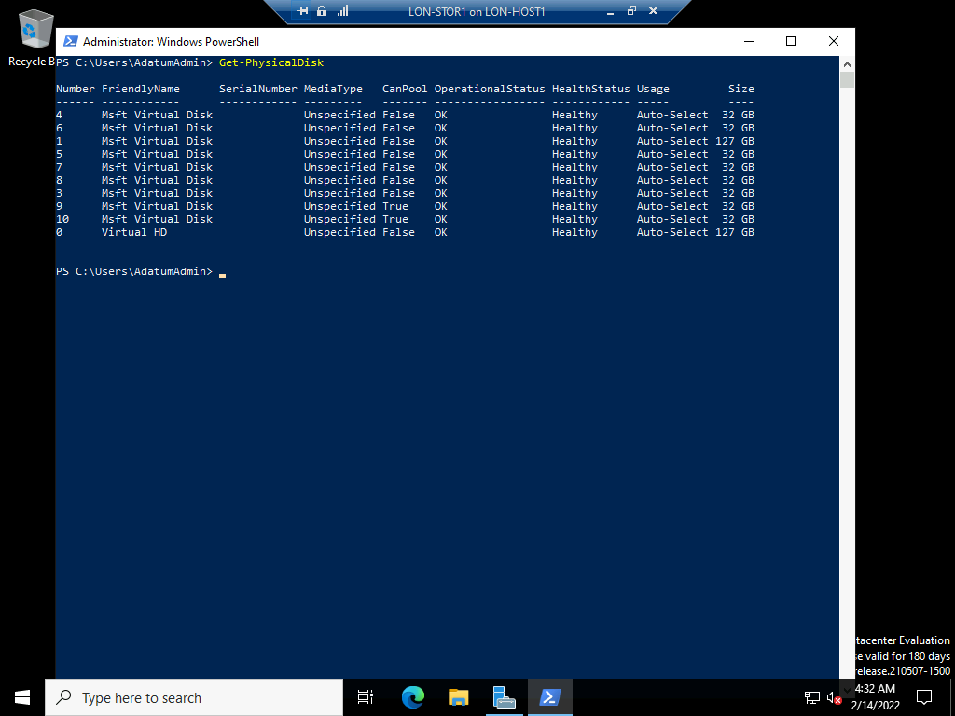

Task 2: Create a new storage pool

1. At the **Windows PowerShell** command prompt, type the following command, and then press Enter:
2. $canpool = Get-PhysicalDisk -CanPool $true

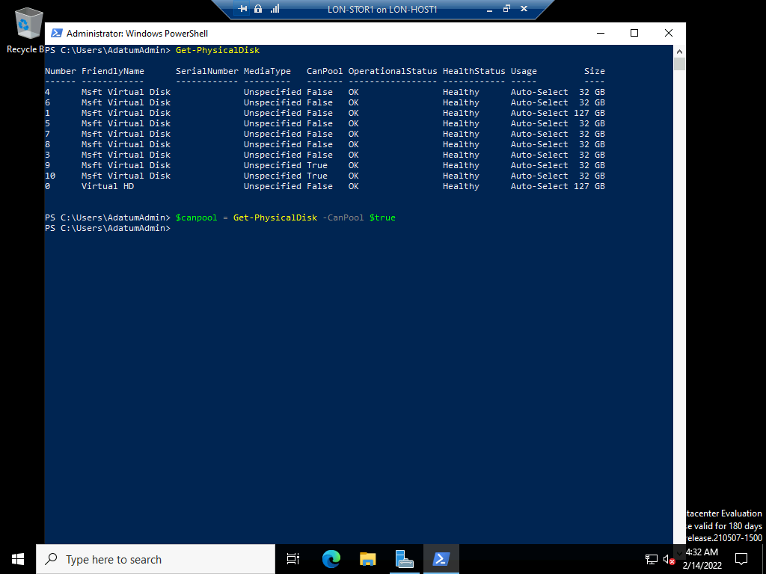

1. At the **Windows PowerShell** command prompt, type the following command, and then press Enter:
2. New-StoragePool -FriendlyName "TieredStoragePool" -StorageSubsystemFriendlyName "Windows Storage*" -PhysicalDisks $canpool

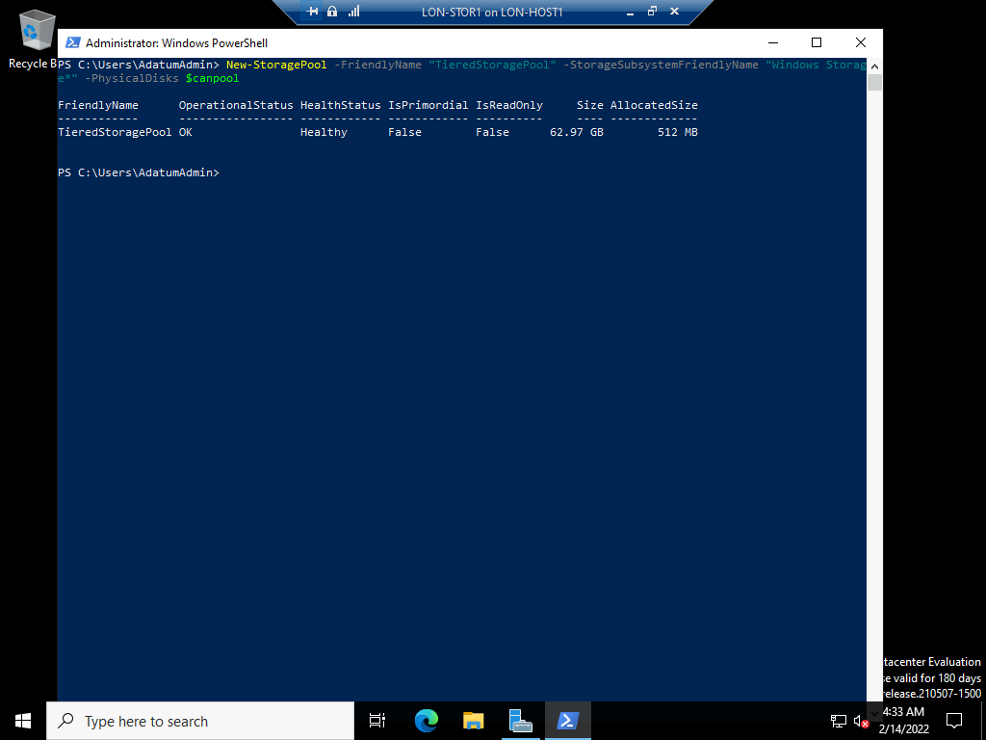

1. Open **File Explorer**, and then browse to [**E:\Labfiles\Mod04**](urn:gd:lg:a:send-vm-keys).

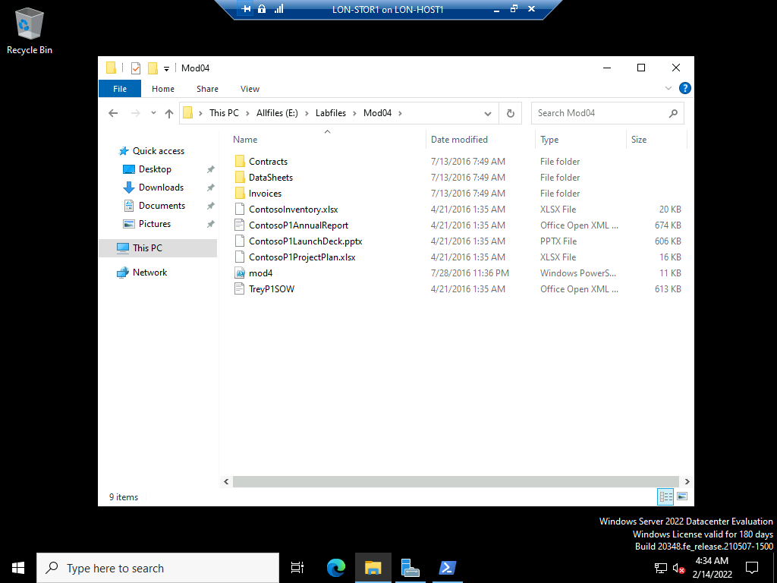

1. Right-click **mod4.ps1** , click **Run with PowerShell**, and press [**Y**](urn:gd:lg:a:send-vm-keys) if prompted. This configures the disk names for the next part of the exercise.

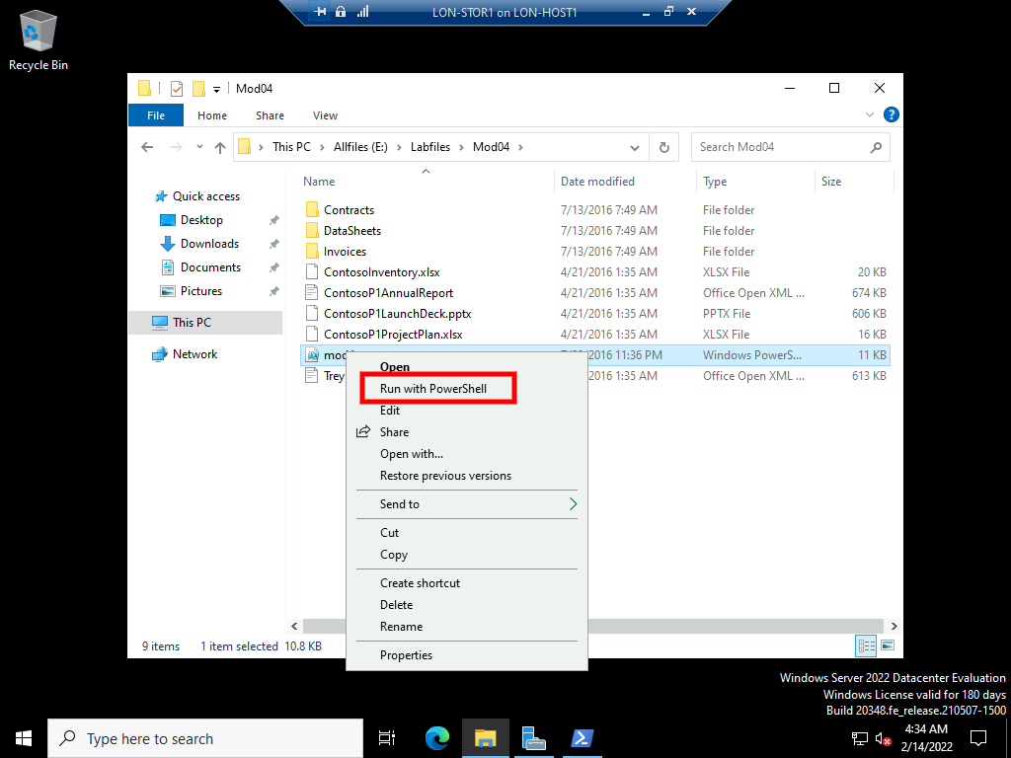

Task 3: View the media types

1. On **LON-STOR1** , at the **Windows PowerShell** command prompt, type the following command, and then press Enter:
2. Get-StoragePool -FriendlyName TieredStoragePool | Get-PhysicalDisk | Select FriendlyName, MediaType, Usage, BusType

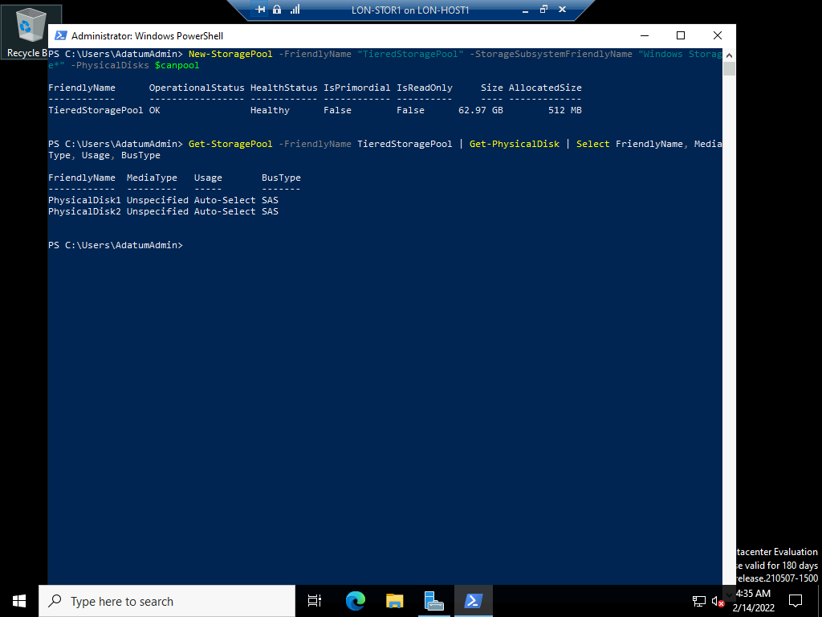

Task 4: Specify the media type for the sample disks and verify that the media type is changed

1. On **LON-STOR1**, at the **Windows PowerShell** command prompt, type the following command, and then press Enter:
2. Set-PhysicalDisk -FriendlyName PhysicalDisk1 -MediaType SSD

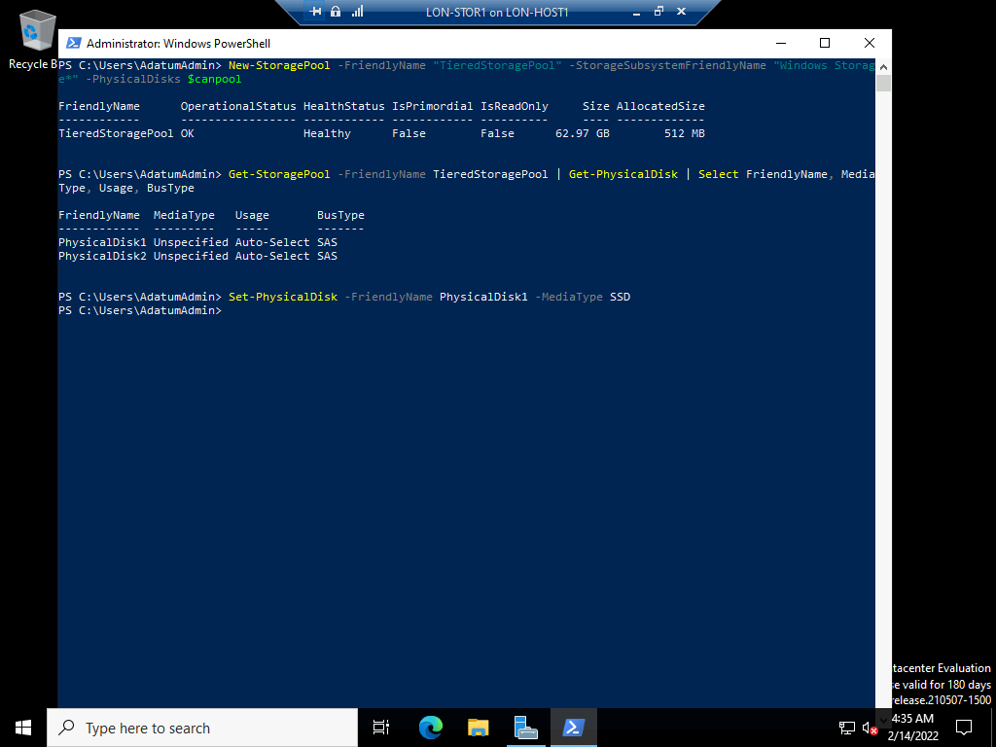

1. At the **Windows PowerShell** command prompt, type the following command, and then press Enter:
2. Set-PhysicalDisk -FriendlyName PhysicalDisk2 -MediaType HDD

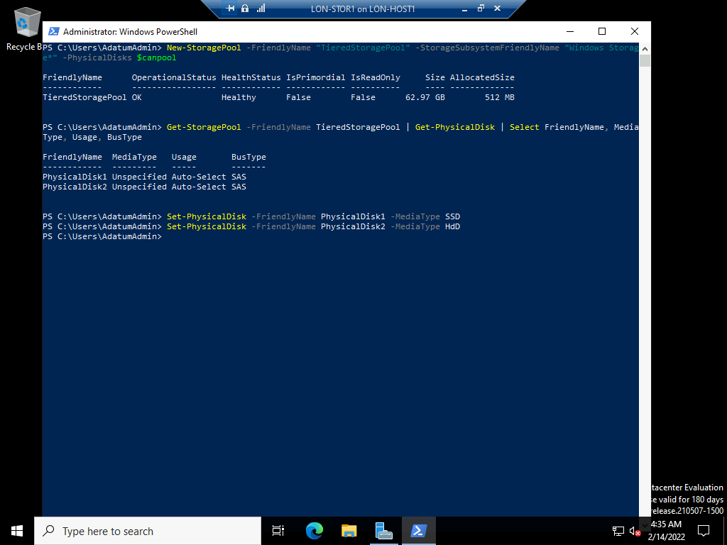

1. At the **Windows PowerShell** command prompt, type the following command, and then press Enter:
2. Get-PhysicalDisk | Select FriendlyName, MediaType, Usage, BusType

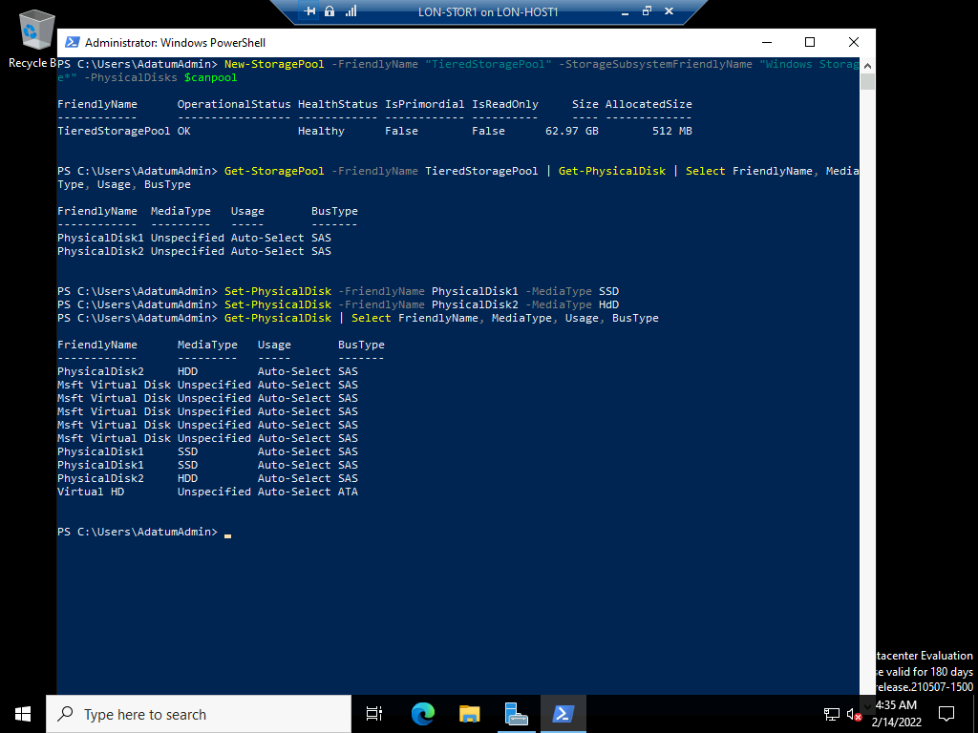

Task 5: Create pool-level storage tiers by using Windows PowerShell

1. On **LON-STOR1**, at the **Windows PowerShell** command prompt, type the following command, and then press Enter:
2. New-StorageTier -StoragePoolFriendlyName TieredStoragePool -FriendlyName HDD_Tier -MediaType HDD

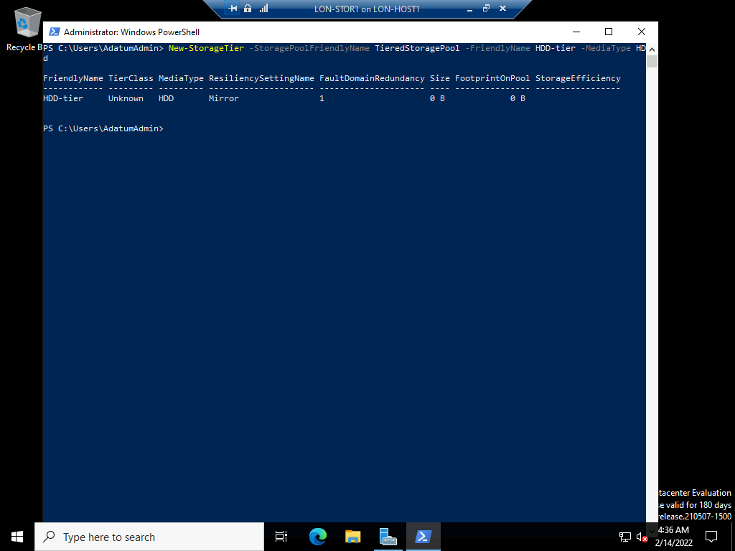

1. At the **Windows PowerShell** command prompt, type the following command, and then press Enter:
2. New-StorageTier -StoragePoolFriendlyName TieredStoragePool -FriendlyName SSD_Tier -MediaType SSD

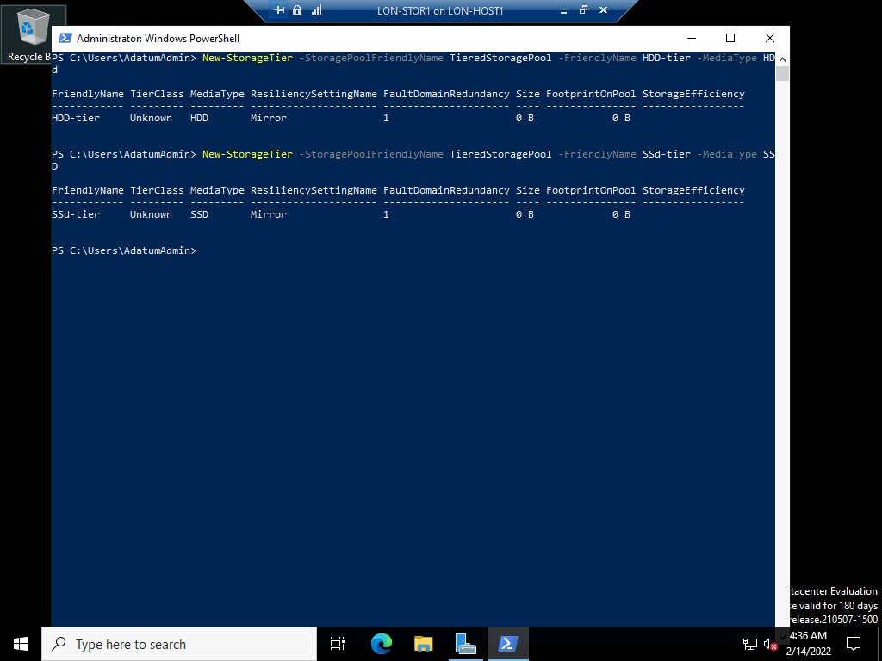

Task 6: Create a new virtual disk with storage tiering by using the New Virtual Disk Wizard

1. On **LON-STOR1** , in **Server Manager**, in the **Storage Pools** pane, click **Refresh**, and then click **TieredStoragePool**.

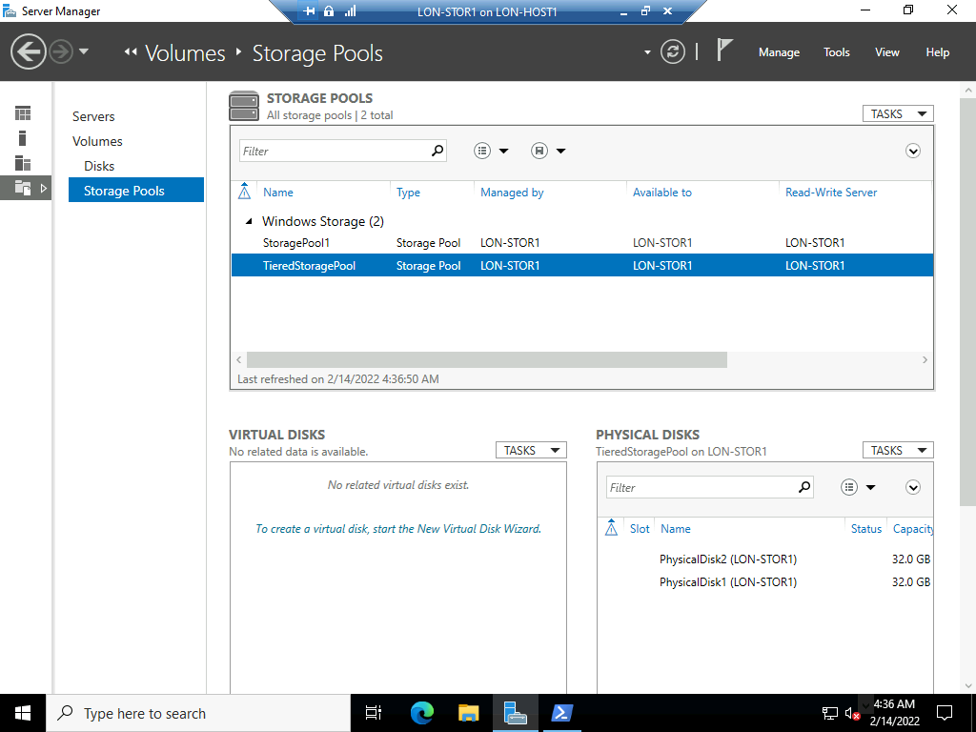

1. In the **VIRTUAL DISKS** pane, click **TASKS**, and then in the **TASKS** drop-down list, click **New Virtual Disk**.

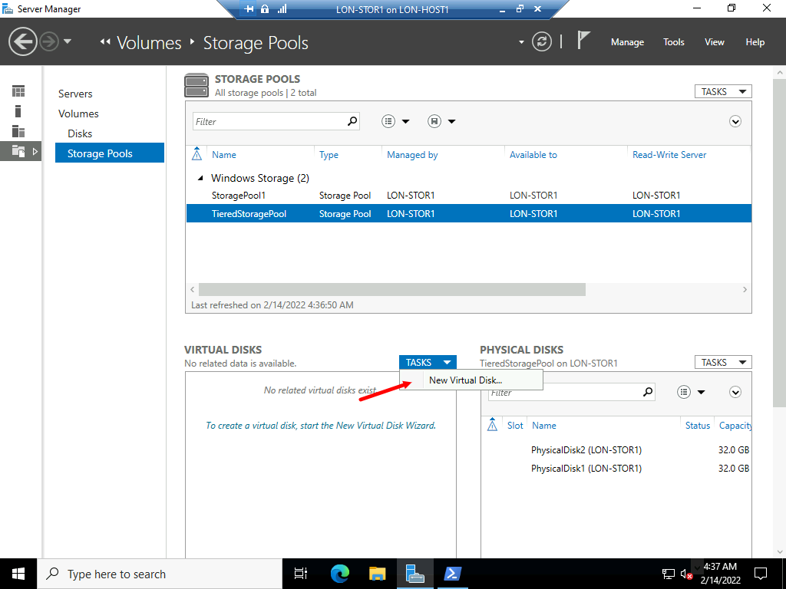

1. In the **Select the storage pool** dialog box, click **TieredStoragePool**, and then click **OK**.

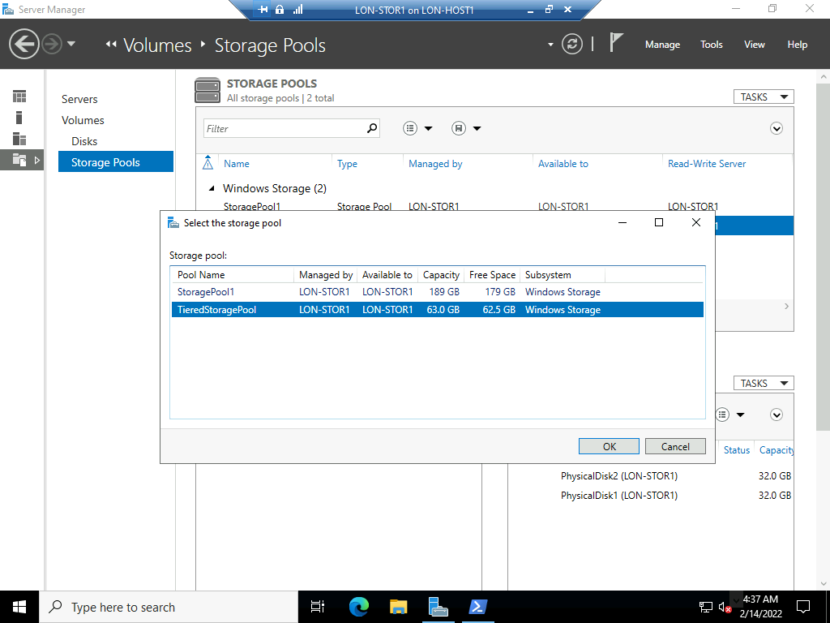

1. In the **New Virtual Disk Wizard**, on the **Before you begin** page, click **Next**.

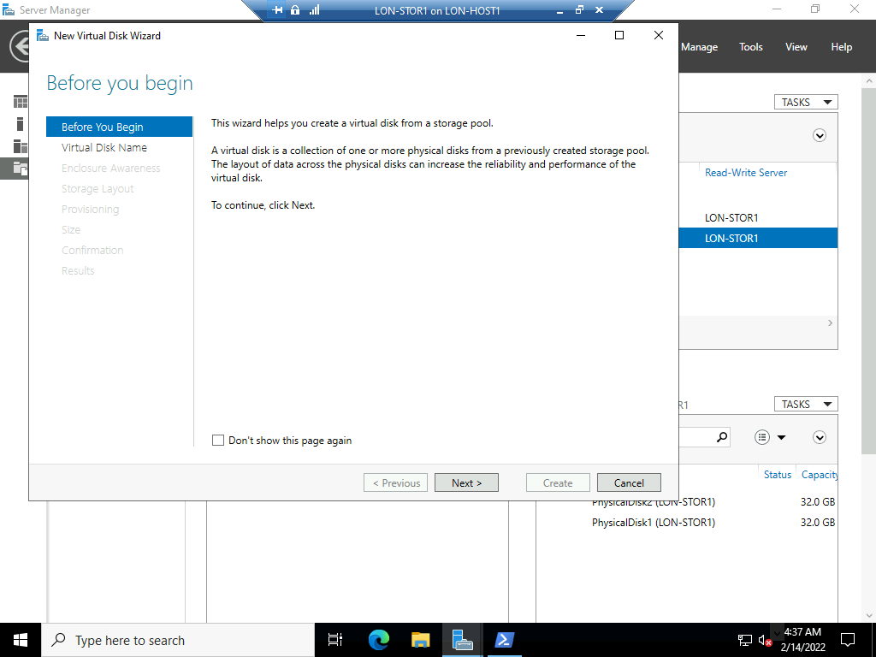

1. On the **Specify the virtual disk name** page, in the **Name** text box, type **[TieredVirtDisk](urn:gd:lg:a:send-vm-keys" \o "Paste text into VM)**, select **Create storage tiers on this virtual disk** , and then click **Next**.

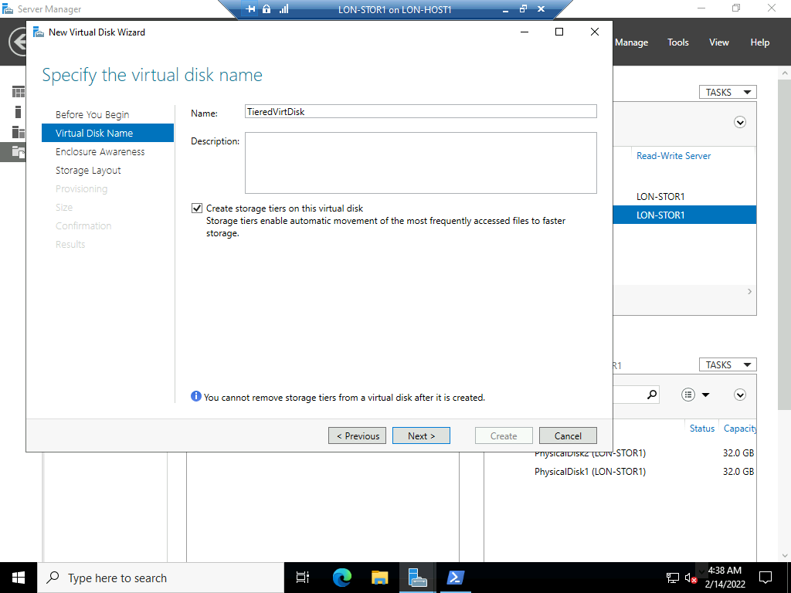

1. On the **Specify enclosure resiliency** page, click **Next**.

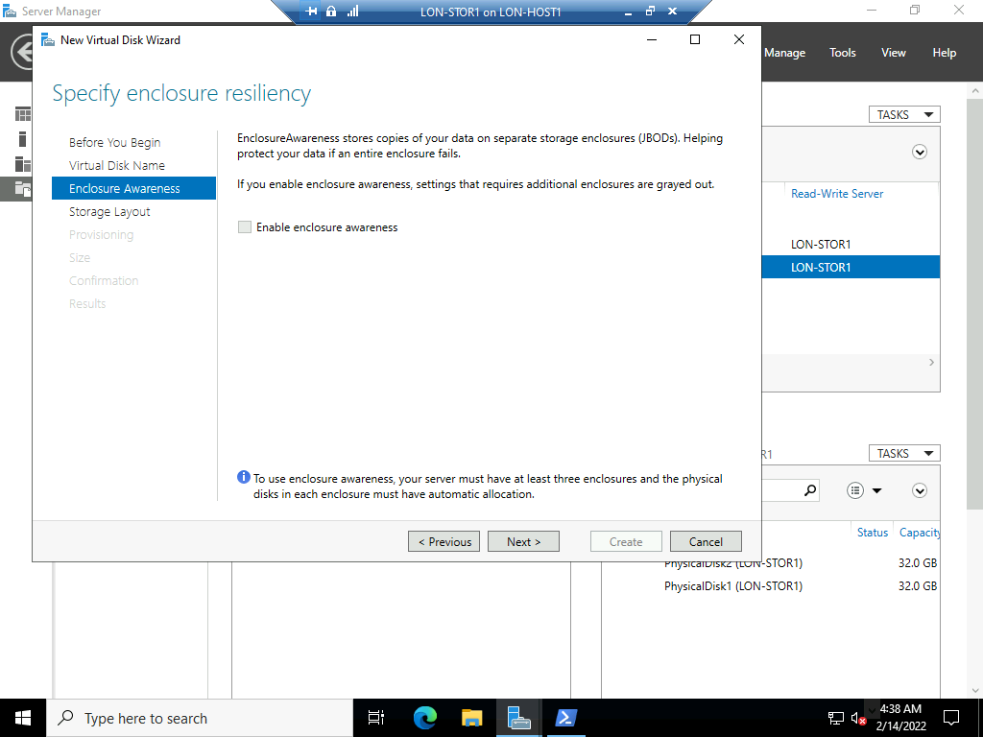

1. On the **Select the storage layout** page, in both the **Layout** lists, click **Simple** , and then click **Next**.

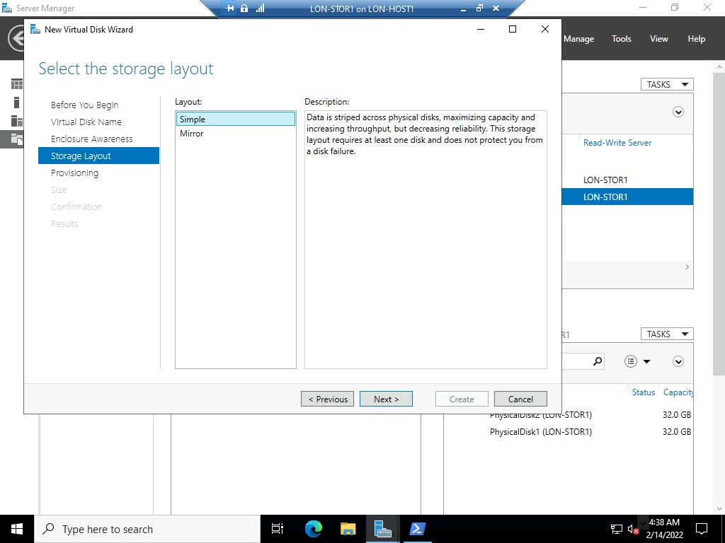

1. On the **Specify the provisioning type** page, click **Next**.

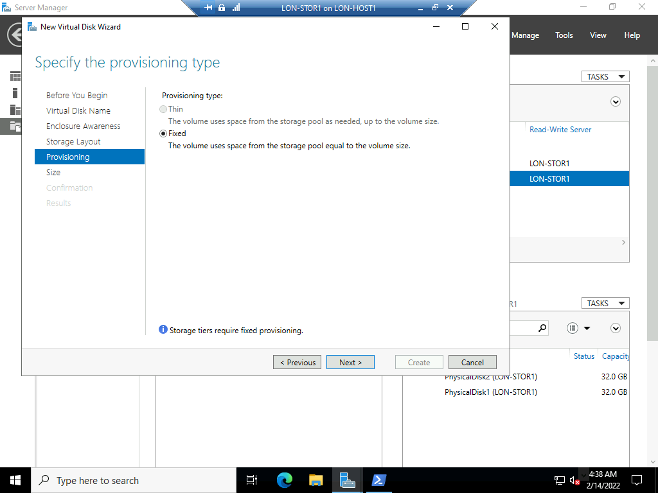

1. On the **Specify the size of the virtual disk** page, in both the **Specify size** text boxes, enter [**2**](urn:gd:lg:a:send-vm-keys), then click **Next**

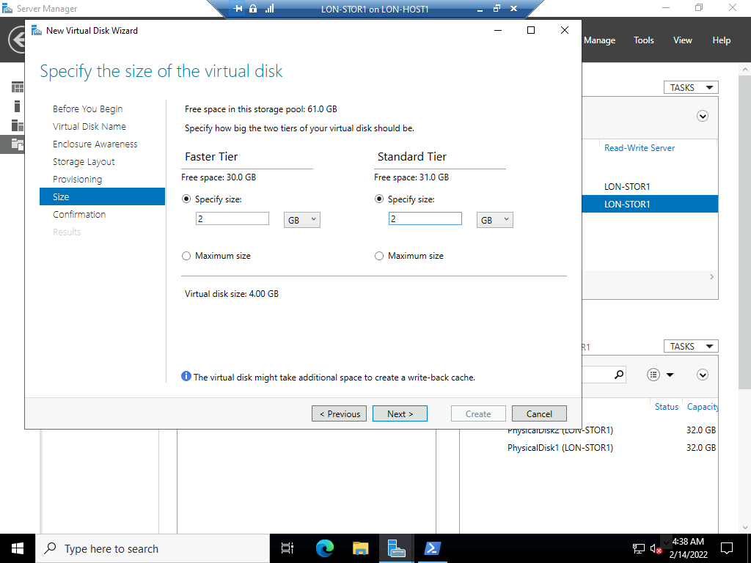

1. On the **Confirm selections** page, click **Create**.

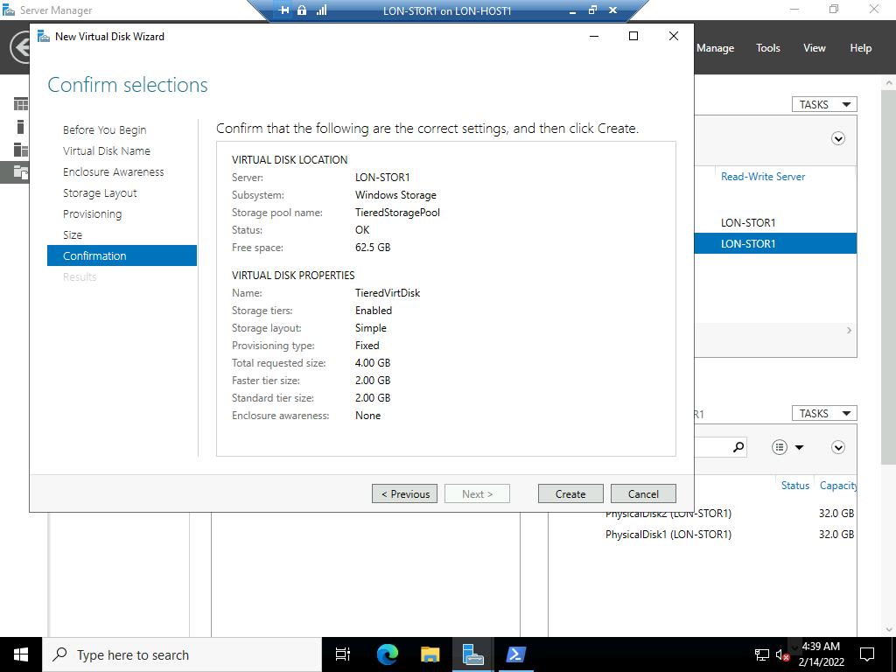

1. On the **View results** page, wait until the task completes.
2. Ensure that **Create a volume when this wizard closes** is selected, and then click **Close**.

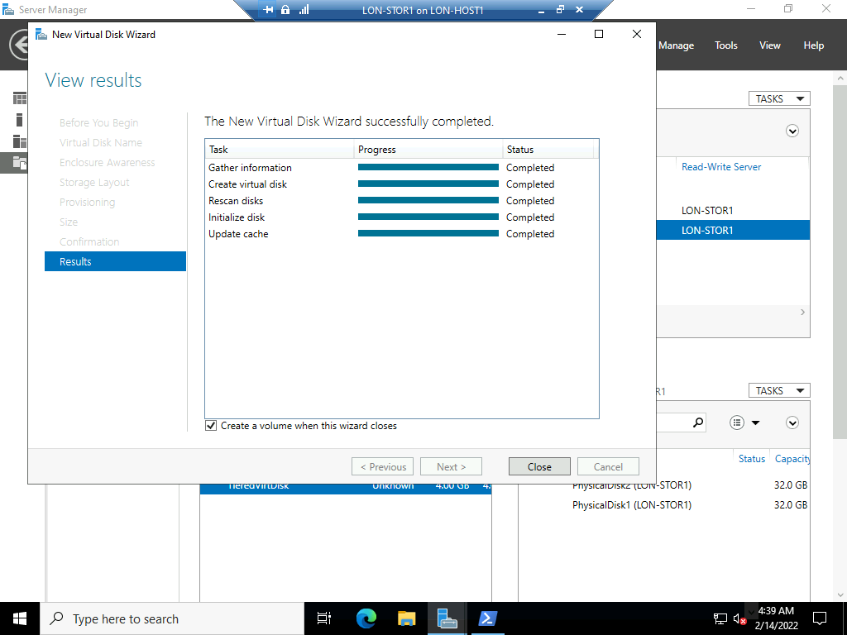

1. In the **New Volume Wizard**, on the **Before you begin** page, click **Next**.

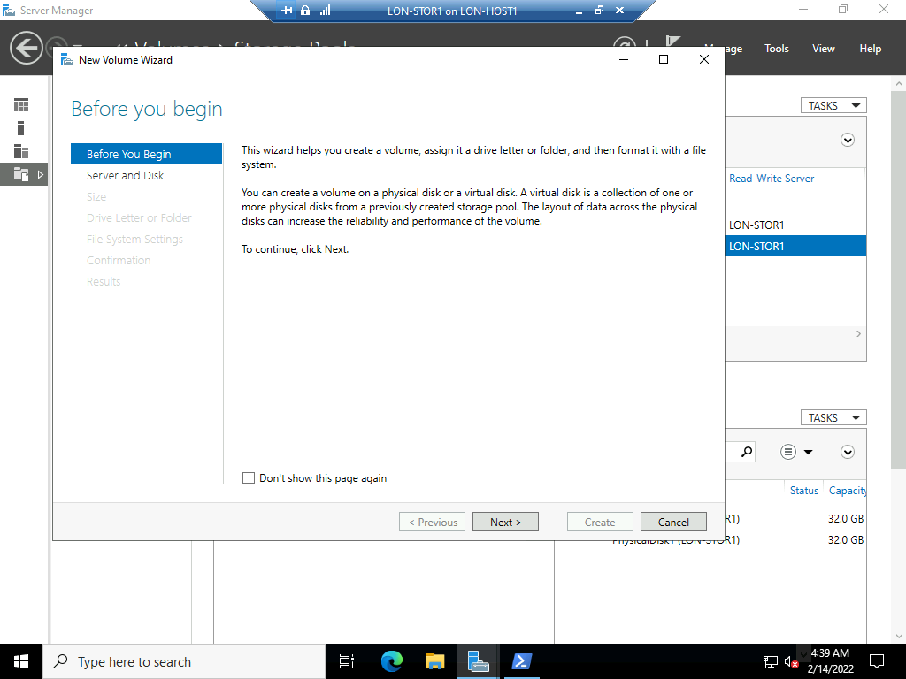

1. On the **Select the server and disk** page, in the **Disk** pane, click the **TieredVirtDisk** virtual disk, and then click **Next**.

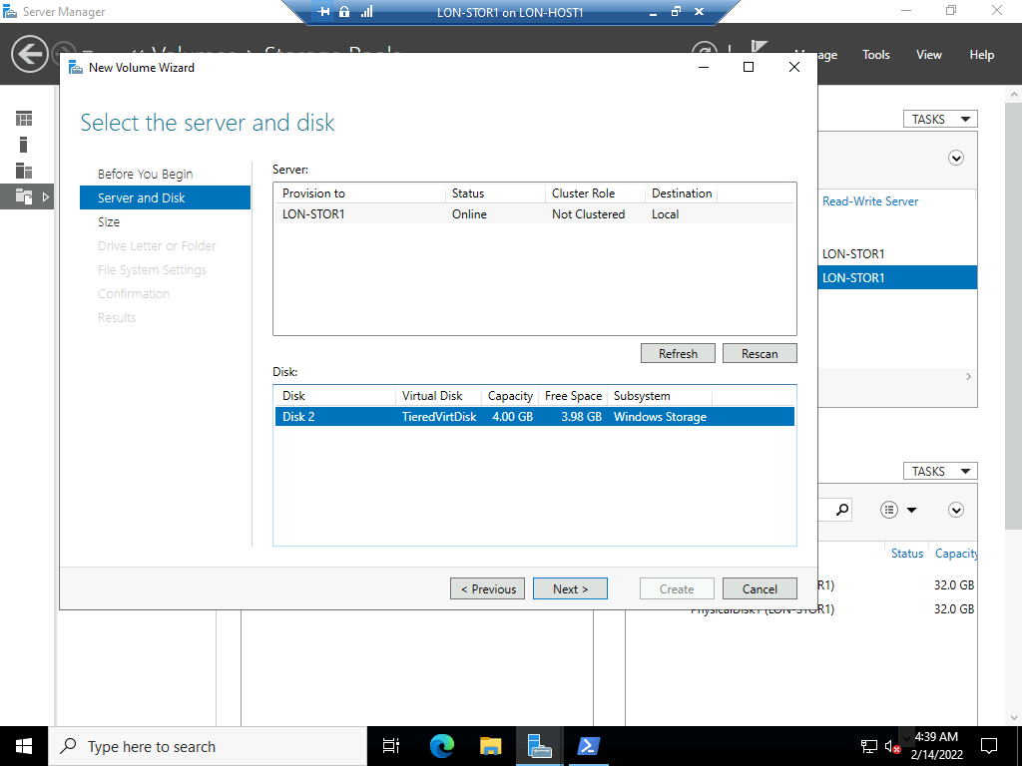

1. On the **Specify the size of the volume** page, click **Next** to confirm the default selection.

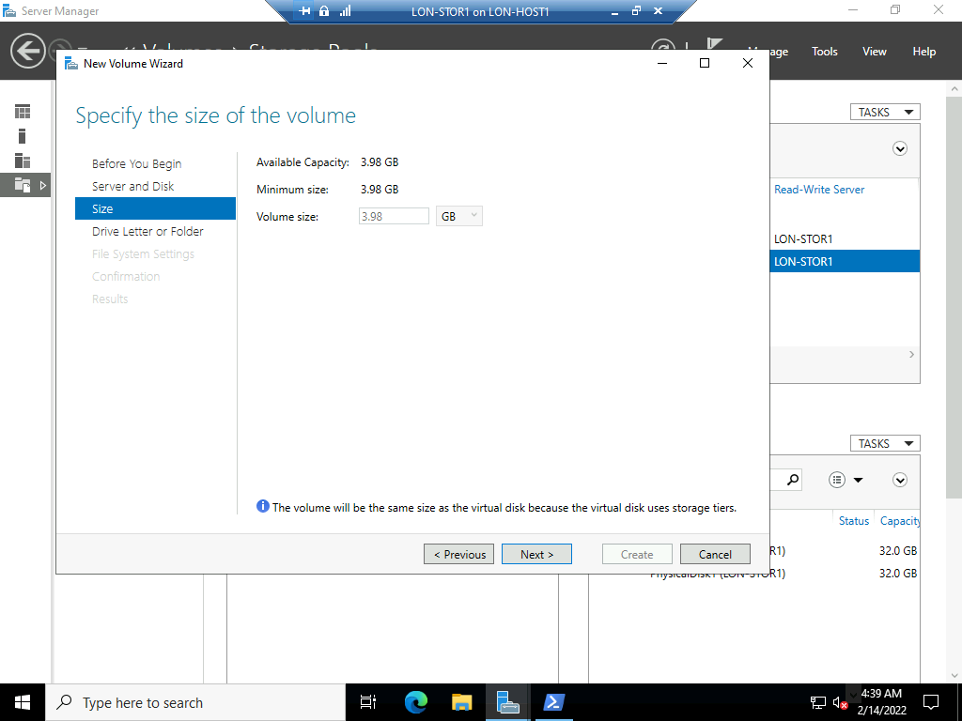

1. On the **Assign to a drive letter or folder** page, in the **Drive letter** drop-down list, select **R**, then click **Next**.

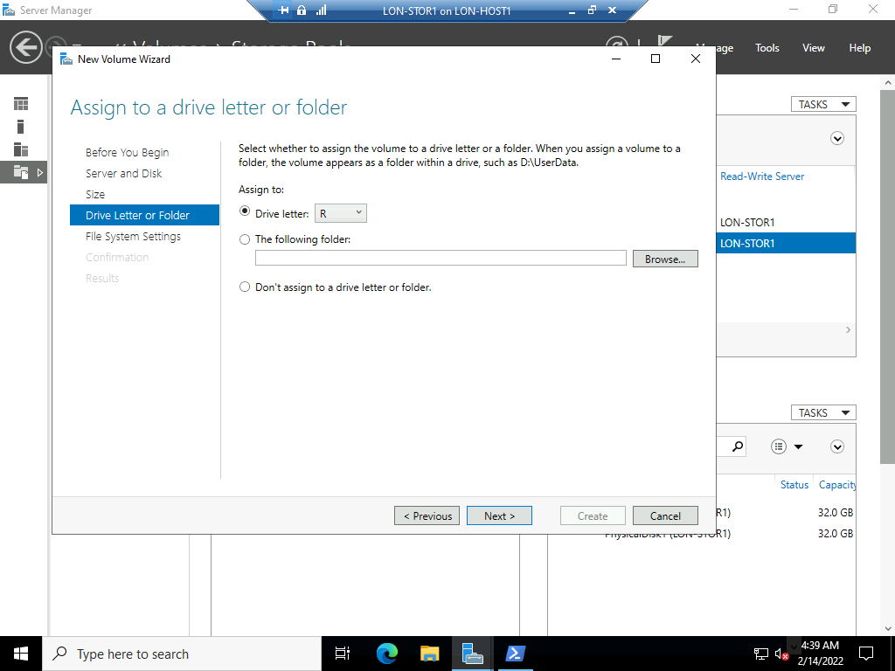

1. On the **Select file system settings** page, in the **Volume label** text box, type [**Tiered Volume**](urn:gd:lg:a:send-vm-keys), and then click **Next**.

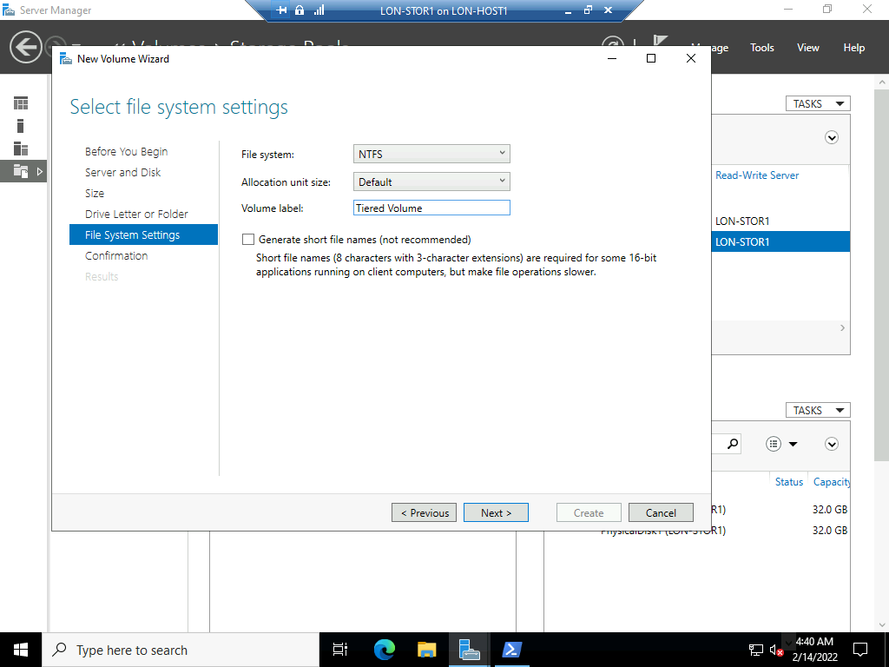

1. On the **Confirm selections** page, click **Create**.

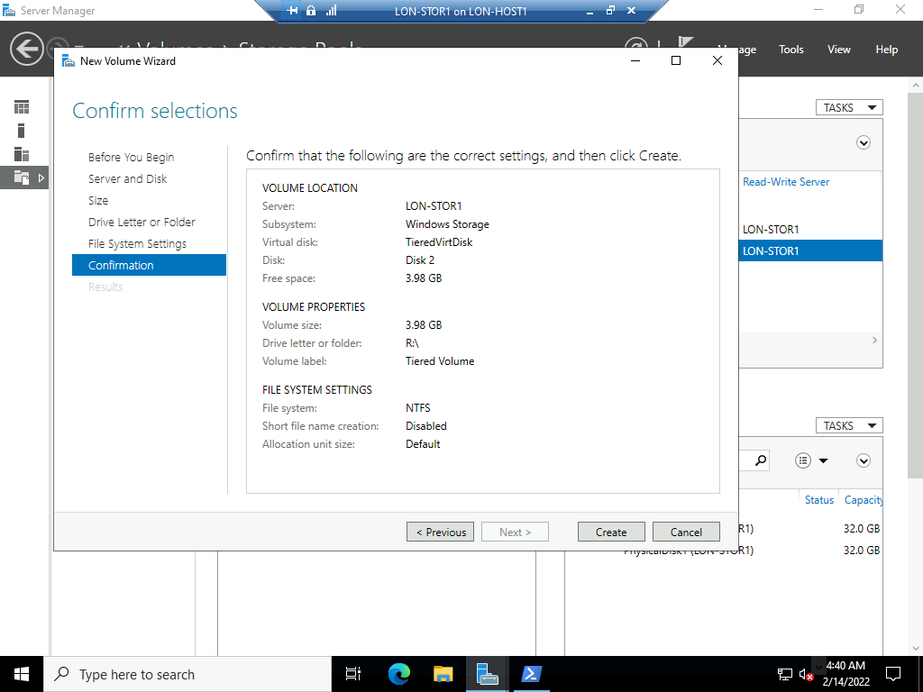

1. On the **Completion** page, wait until the creation completes, and then click **Close**.

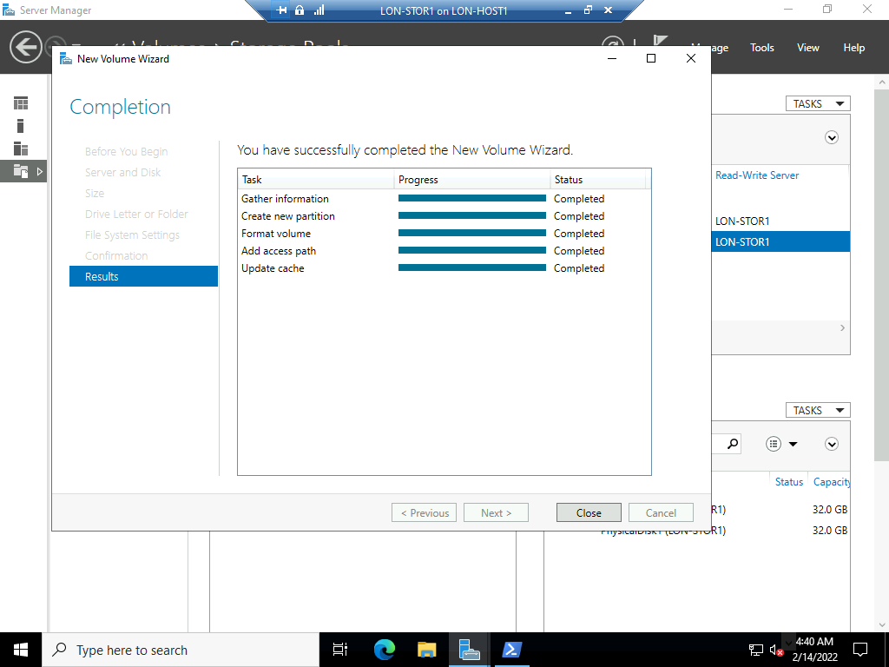

1. In **Server Manager**, right-click **TieredVirtDisk** in **Virtual disks**, then click **Properties**.

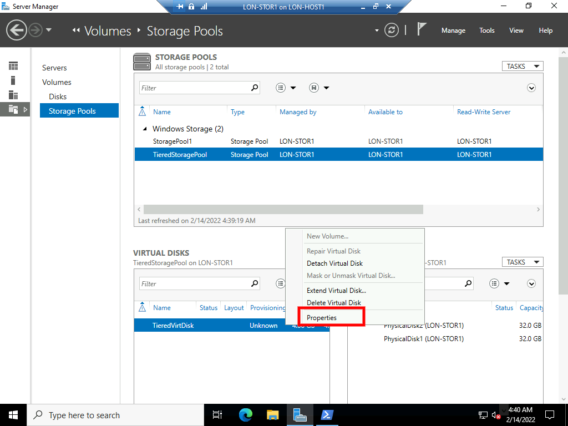

1. In the **TieredVirtDisk Properties** window, on the **General** tab, observe the **Storage tiers**, **Capacity**, **Allocated space**, and **Used pool space** details.

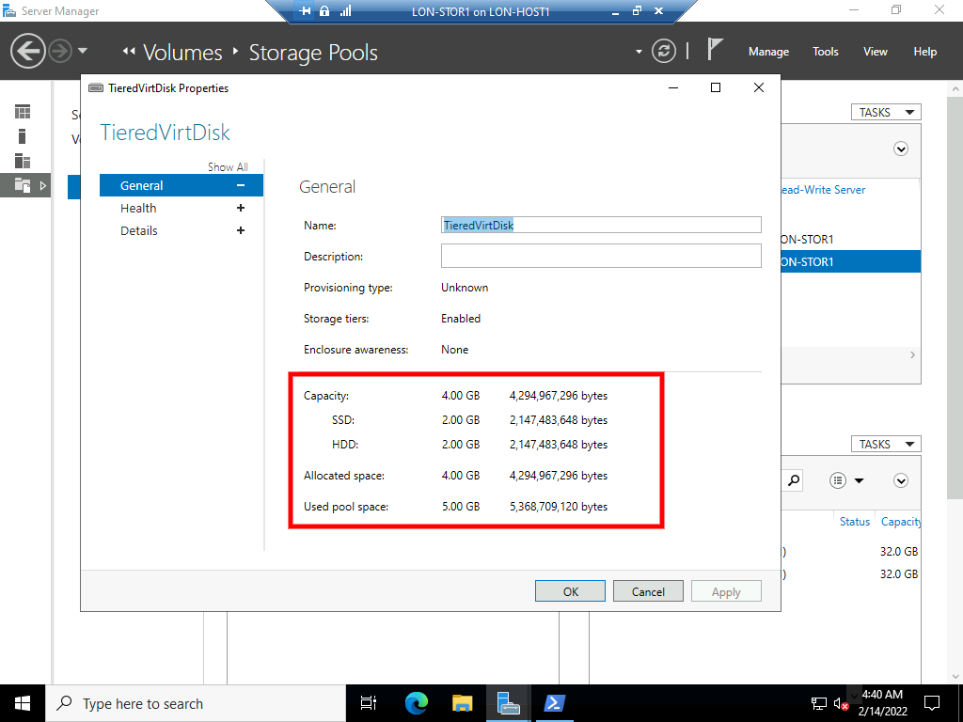

1. Click the **Health** tab, and observe the Storage layout details, and then click **OK**.

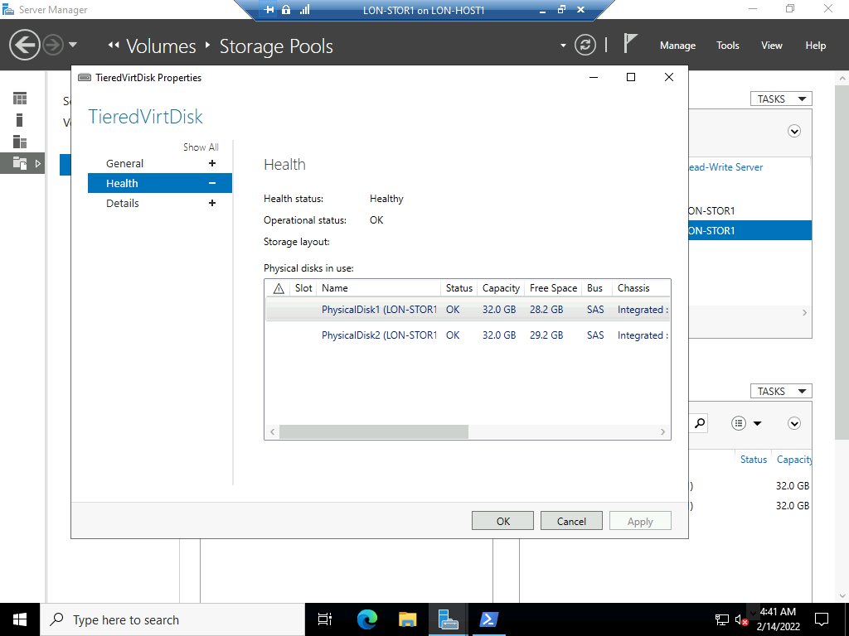

**Results:** After completing this exercise, you should have successfully enabled and configured storage tiering.

Lab B: Implementing Data Deduplication

Scenario

After you have tested the storage redundancy and performance options, you decide that it also would be beneficial to maximize the available disk space that you have, especially on generic file servers. You decide to test Data Deduplication solutions to maximize storage availability for users.

**New:** After you have tested the storage redundancy and performance options, you now decide that it would also be beneficial to maximize the available disk space that you have, especially around virtual machine storage which is in ever increasing demand. You decide to test out Data Deduplication solutions to maximize storage availability for virtual machines.

Exercise 1: Installing Data Deduplication

Scenario

You decide to install the Data Deduplication role service on intensively used file servers by using Server Manager.

The main tasks for this exercise are as follows:

1. Install the Data Deduplication role service.
2. Check the status of Data Deduplication.
3. Verify the virtual machine performance.

Task 1: Install the Data Deduplication role service

1. On **LON-STOR1**, in **Server Manager**, in the **navigation** pane, click **Dashboard**.

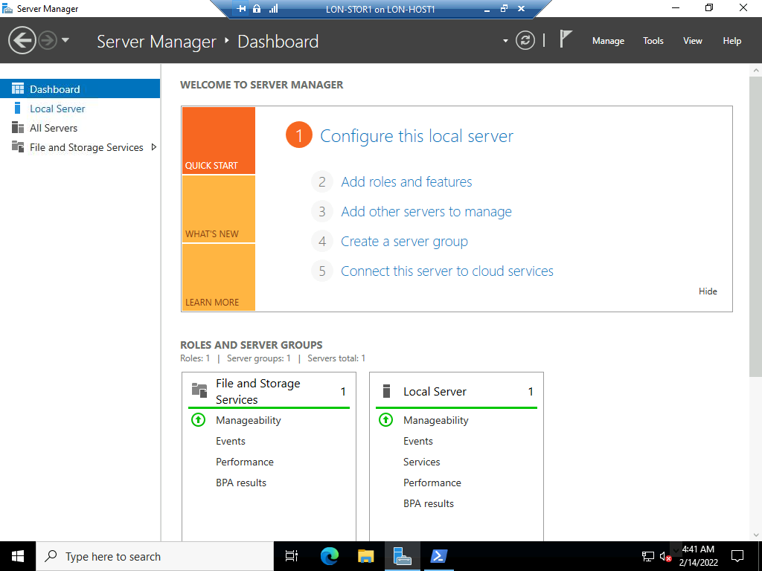

1. In the **Details** pane, click **Add roles and features**.

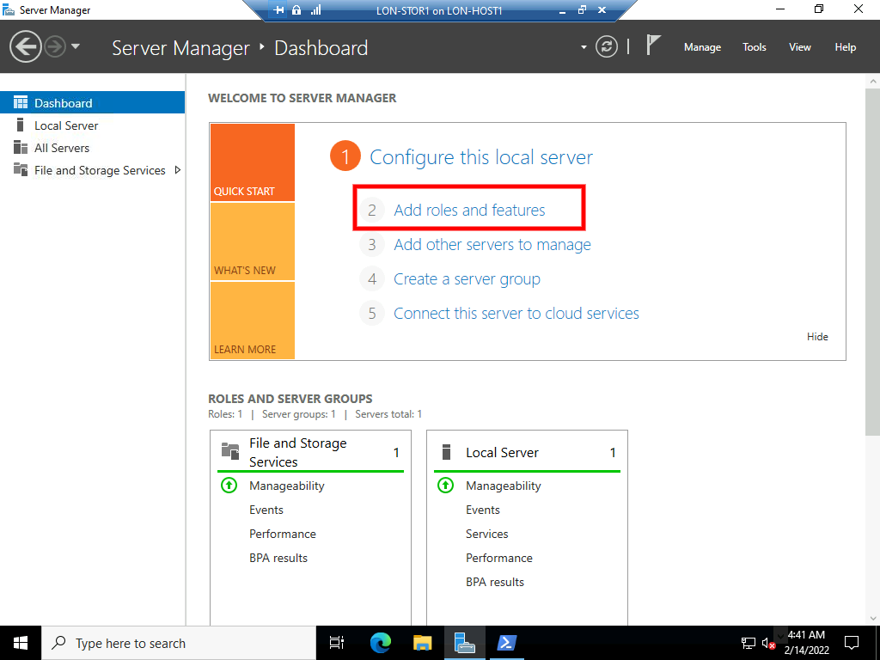

1. In the **Add Roles and Features Wizard**, on the **Before you begin** page, click **Next**.

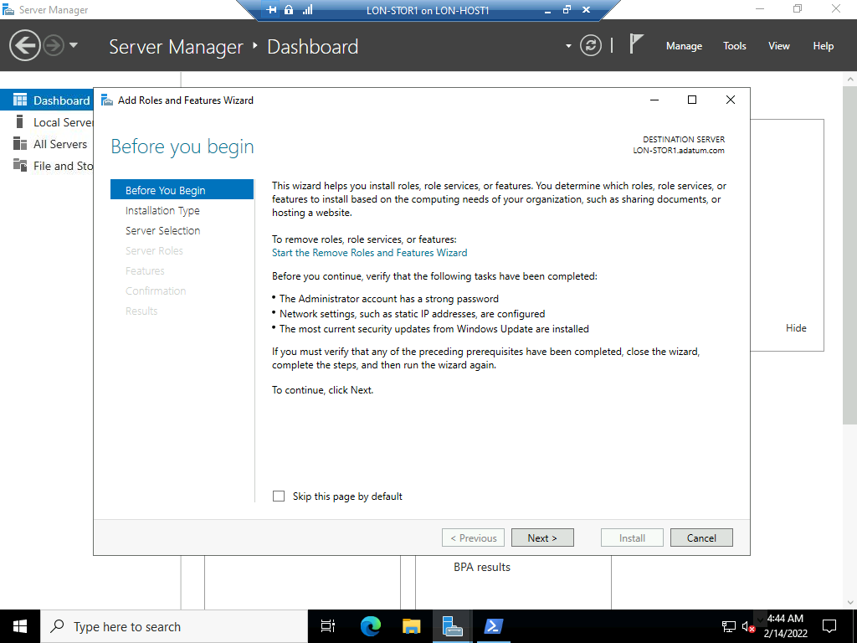

1. On the **Select installation type** page, click **Next**.

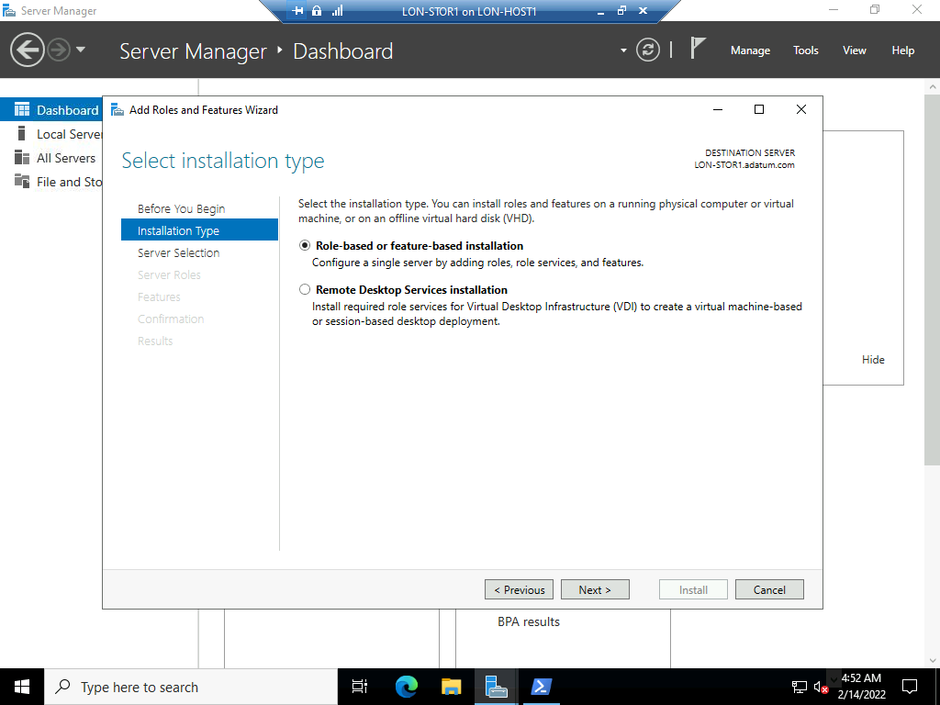

1. On the **Select destination server** page, click **Next**.

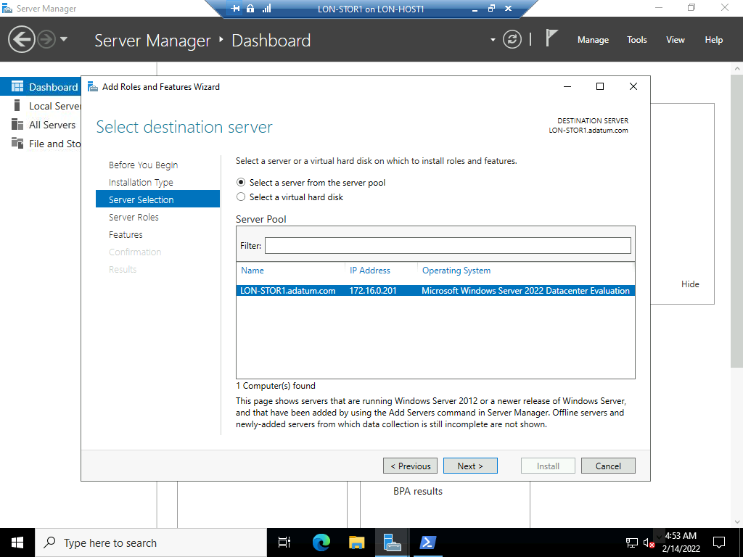

1. On the **Select server roles** page, in the **Roles** list, expand **File and Storage Services (1 of 12 installed)**.
2. Expand **File and iSCSI Services**.

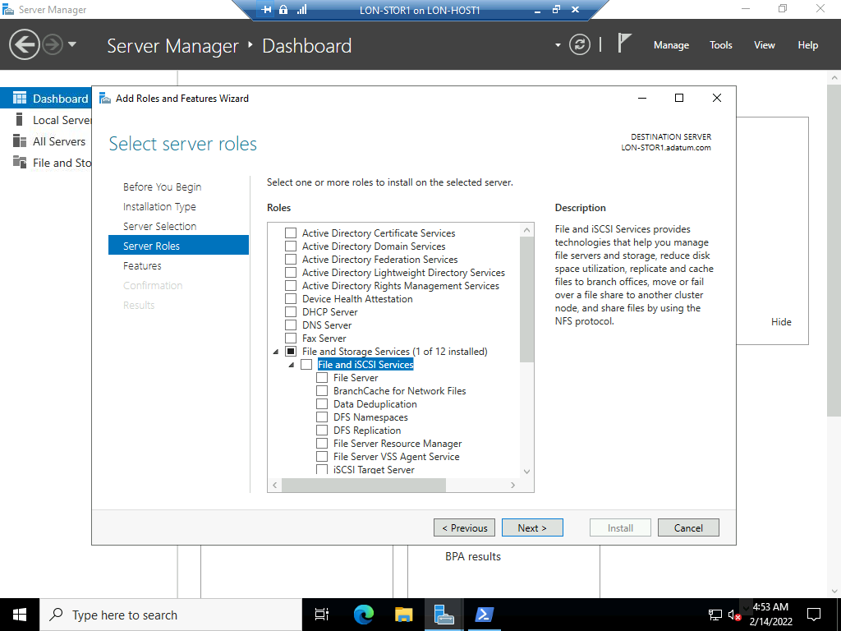

1. Select the **Data Deduplication** check box, click **Add Features**, then click **Next**.

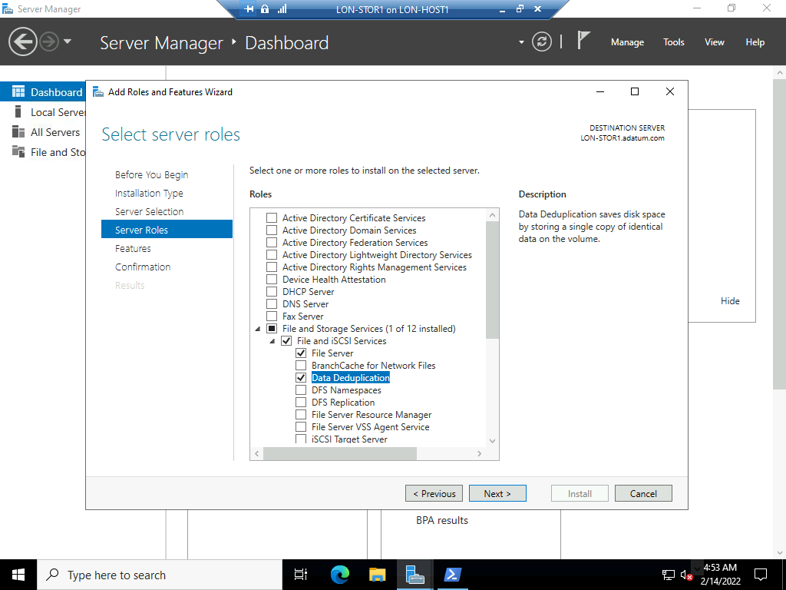

1. On the **Select features** page, click **Next**.

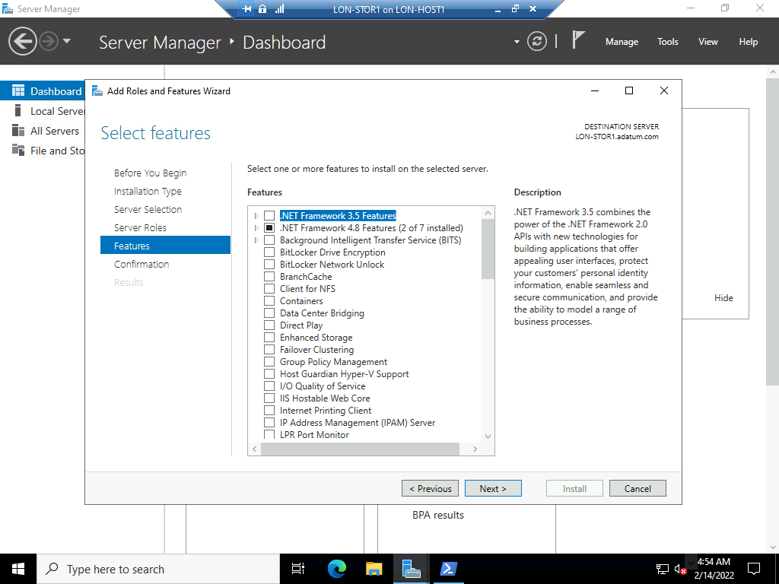

1. On the **Confirm installation selections** page, click **Install**.

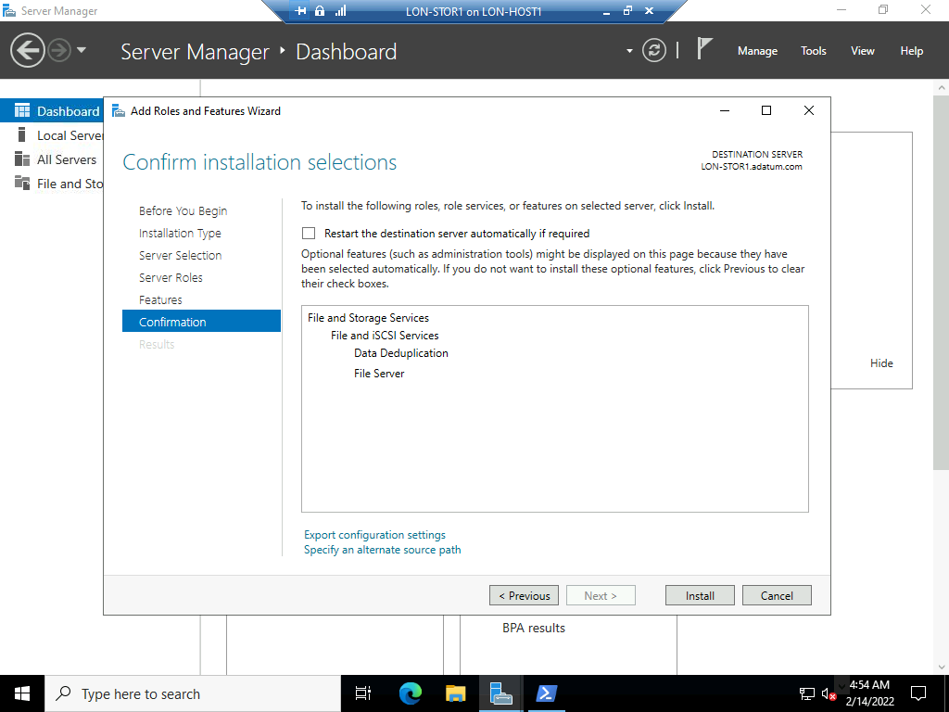

1. When installation is complete, on the **Installation progress** page, click **Close**.

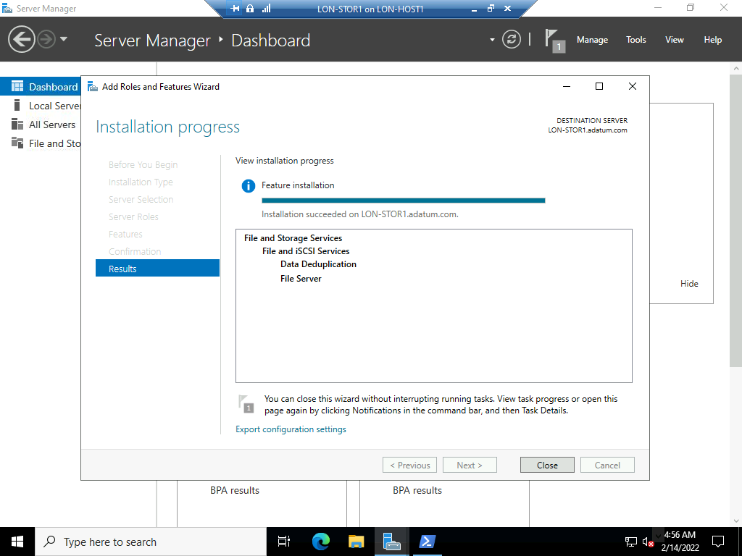

Task 2: Check the status of Data Deduplication

1. On **LON-STOR1** , switch to **Windows PowerShell**.
2. In the **Windows PowerShell command prompt** window, type the following command, and then press Enter:
3. Get-DedupVolume

**Note:** This command returns no results. This is because you need to enable it on the volume after installing it.

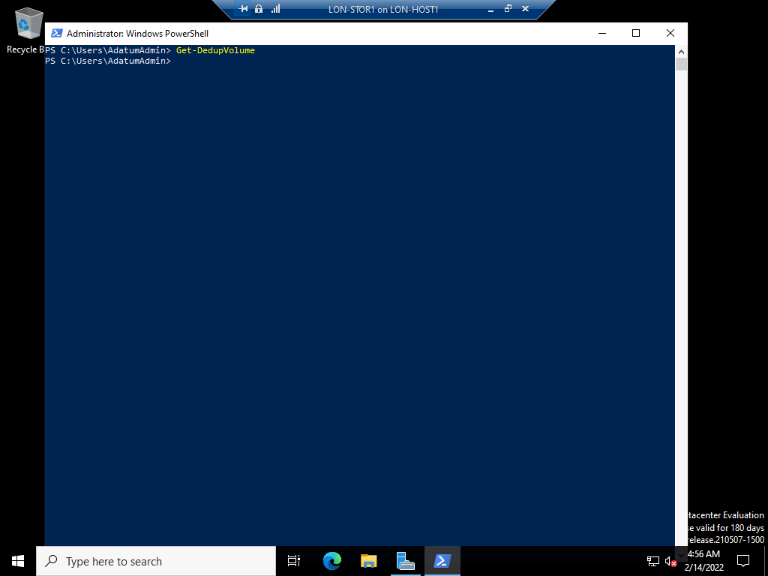

1. In the **Windows PowerShell command prompt** window, type the following command, and then press Enter:
2. Get-DedupStatus

**Note:** This command returns no results. This is because you need to enable it on the volume after installing it.

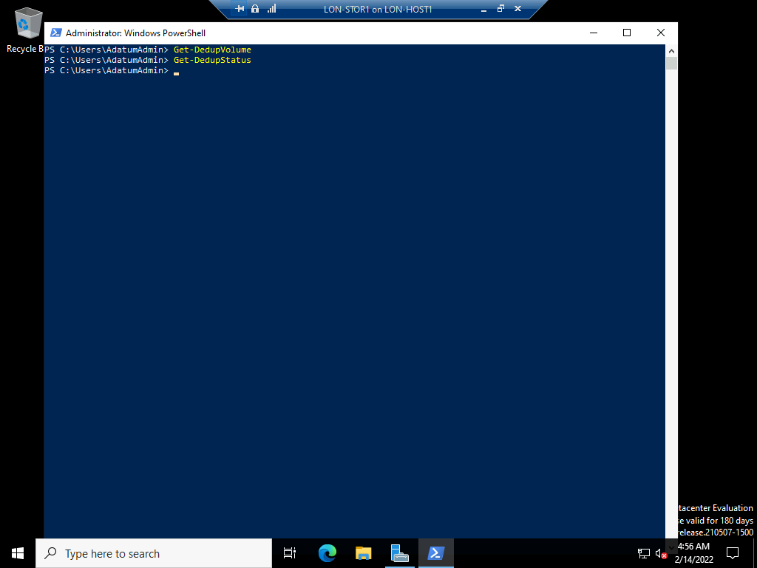

Task 3: Verify the virtual machine performance

1. On **LON-STOR1** , in the **Windows PowerShell** window, type the following, and then press Enter:
2. Measure-Command -Expression {Get-ChildItem -Path E:\ -Recurse}

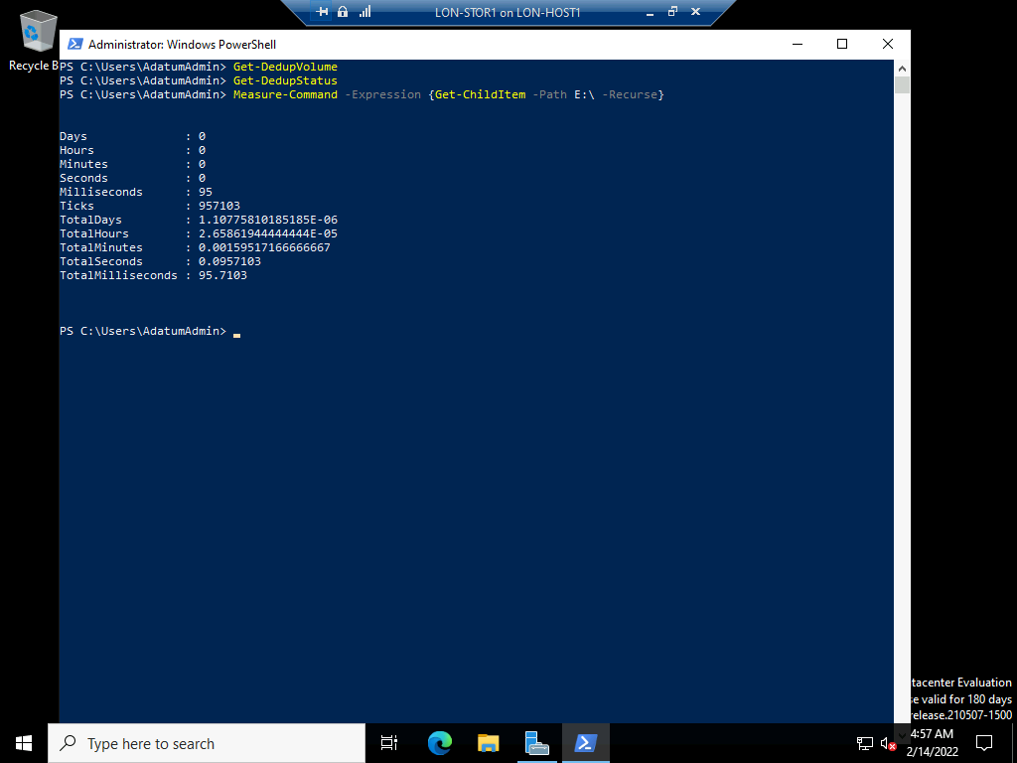

**Note:** You will use the values returned from the previous command later in the lab.

**Results** : After completing this exercise, you should have successfully installed the Data Deduplication role service and enabled it on one of your file servers.

Exercise 2: Configuring Data Deduplication

Scenario

You determine that drive E is heavily used and you suspect it contains duplicate files in some folders. You decide to enable and configure the Data Deduplication role to reduce the consumed space on this volume.

The main tasks for this exercise are as follows:

1. Configure Data Deduplication.
2. Configure optimization to run now and view the status.
3. Verify if the file has been optimized.
4. Verify VM performance again.

Task 1: Configure Data Deduplication

1. On **LON-STOR1**, on the taskbar, click the **File Explorer** icon.
2. Switch to **Server Manager**, in the navigation pane, click **File and Storage Services**, and then click **Disks**.

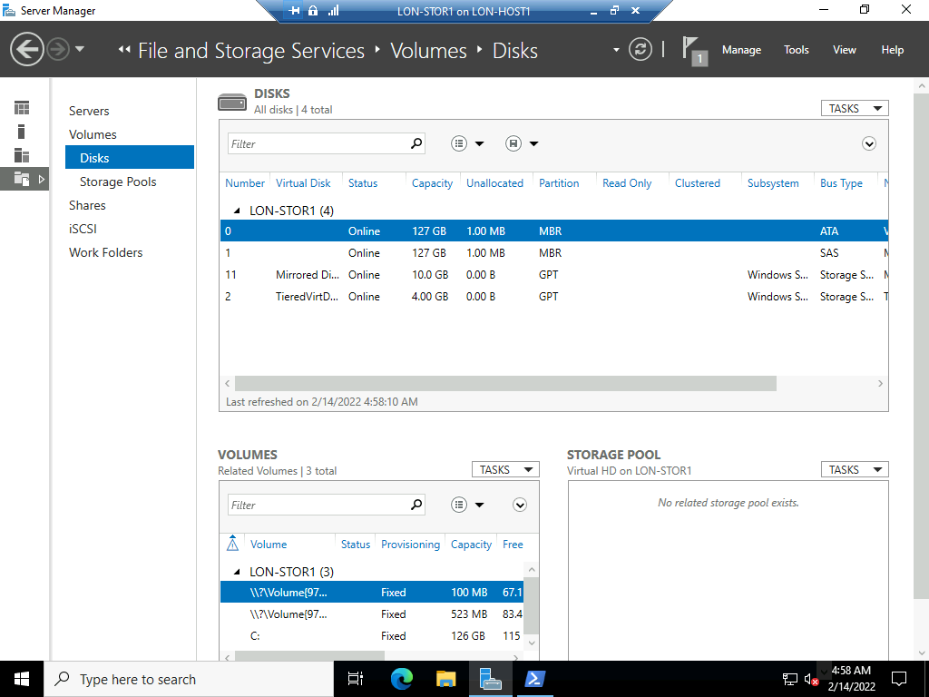

1. In the **Disks** pane, click **1**.

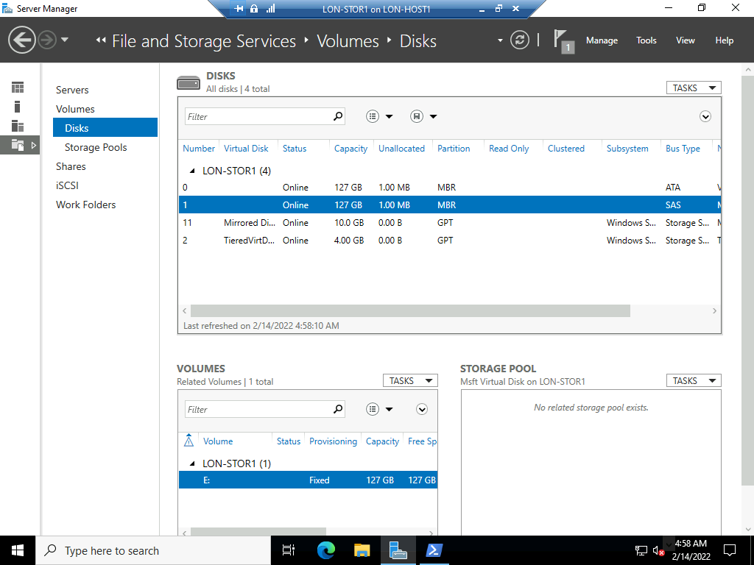

1. Beneath **VOLUMES** , click **E**.



1. Right-click **E**, and then click **Configure Data Deduplication**.

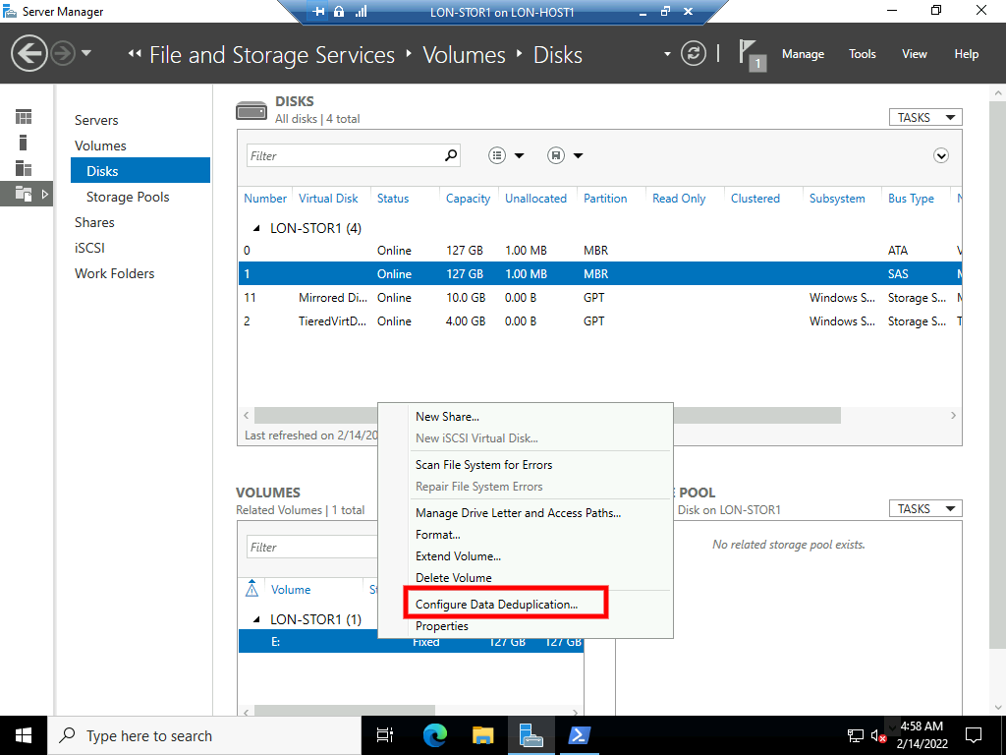

1. In the **Allfiles (E:) Deduplication Settings** dialog box, in the **Data deduplication** list, click **General purpose file server**.

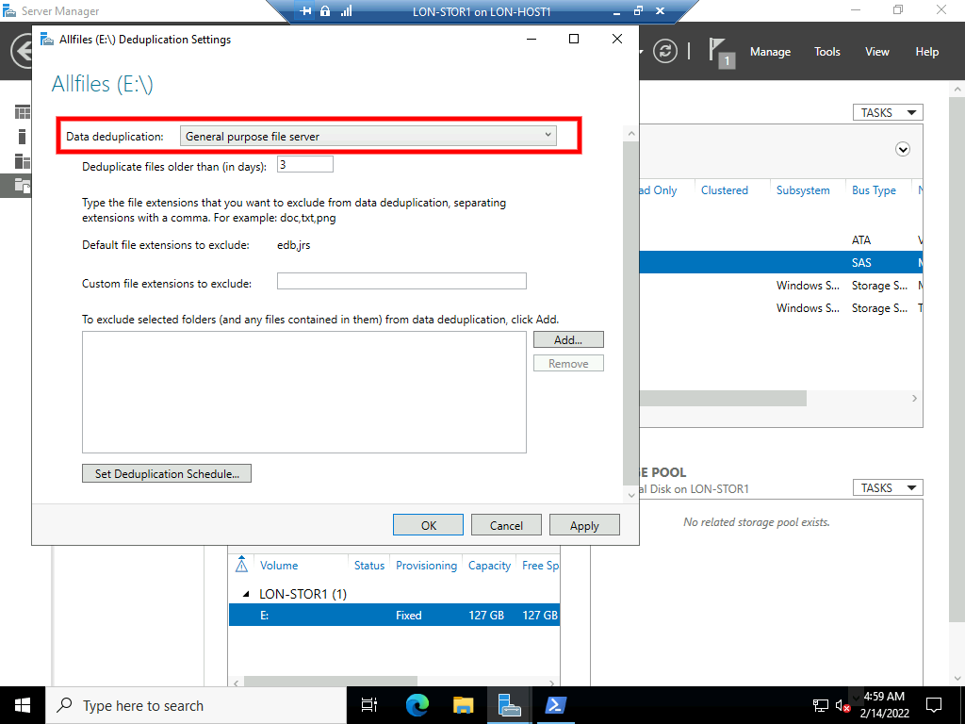

1. In the **Deduplicate files older than (in days)** text box, type [**0**](urn:gd:lg:a:send-vm-keys).

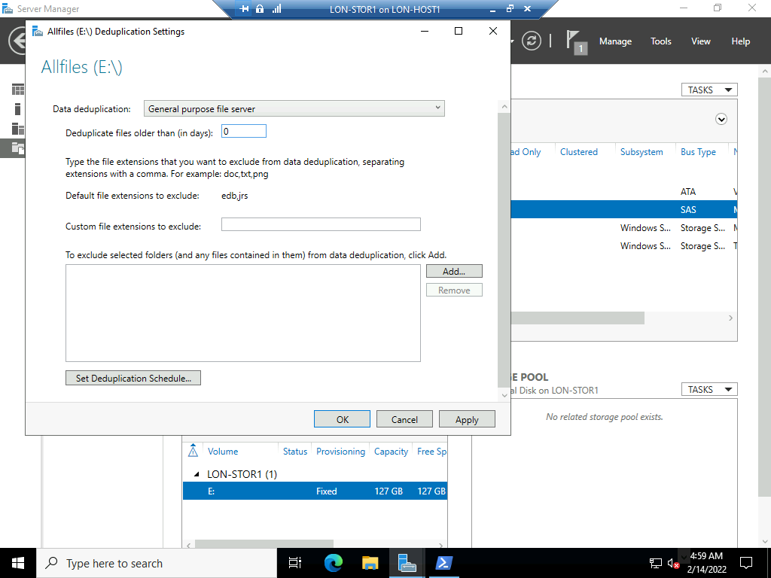

1. Click **Set Deduplication Schedule**.

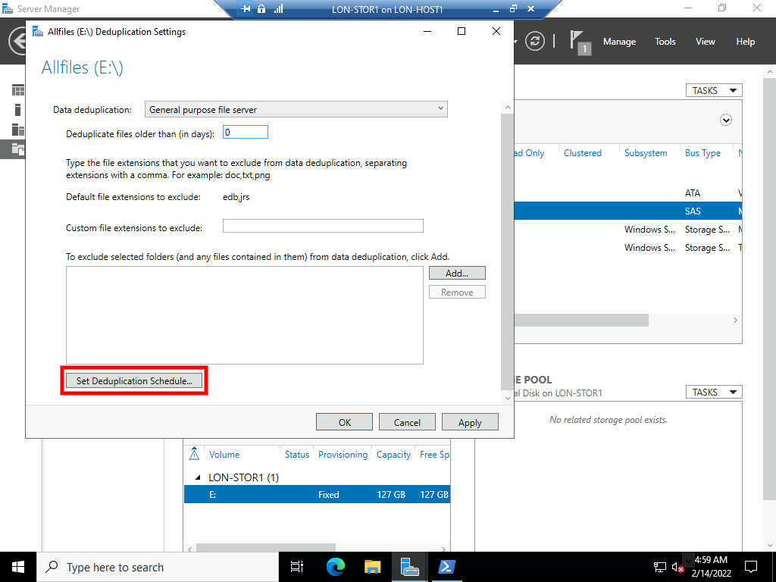

1. In the **LON-SVR1 Deduplication Schedule** dialog box, select the **Enable throughput optimization** check box, and then click **OK**.

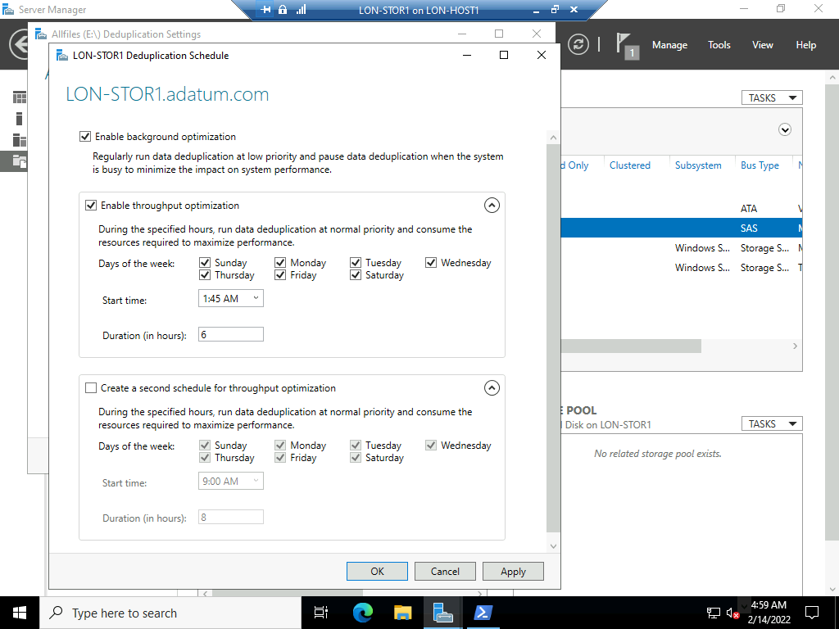

1. In the **Allfiles (E:) Deduplication Settings** dialog box, click **Add**.

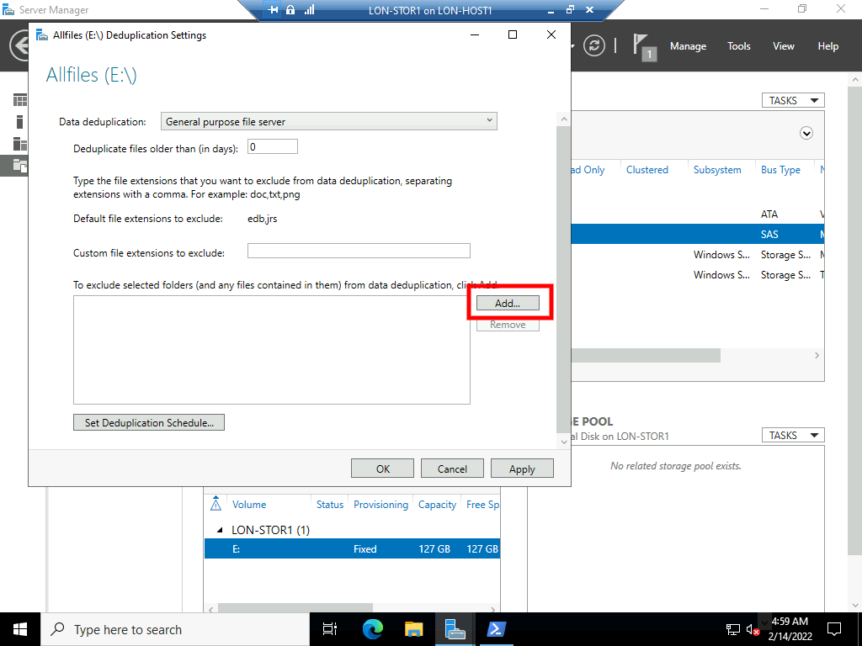

1. In the **Select Folder** dialog box, expand **Allfiles (E:)**, click **shares**.

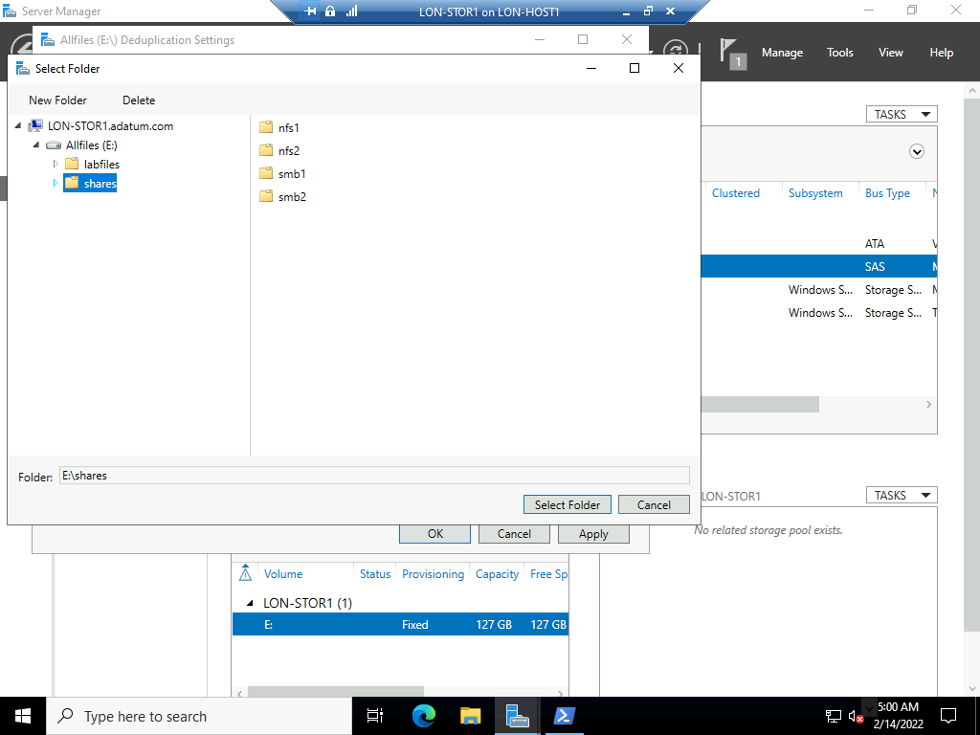

1. Click **Select Folder**, and then click **OK**.

Task 2: Configure optimization to run now and view the status

1. On **LON-STOR1**, in the **Windows PowerShell** window, type the following command, and then press Enter:
2. Start-DedupJob E: -Type Optimization -Memory 50

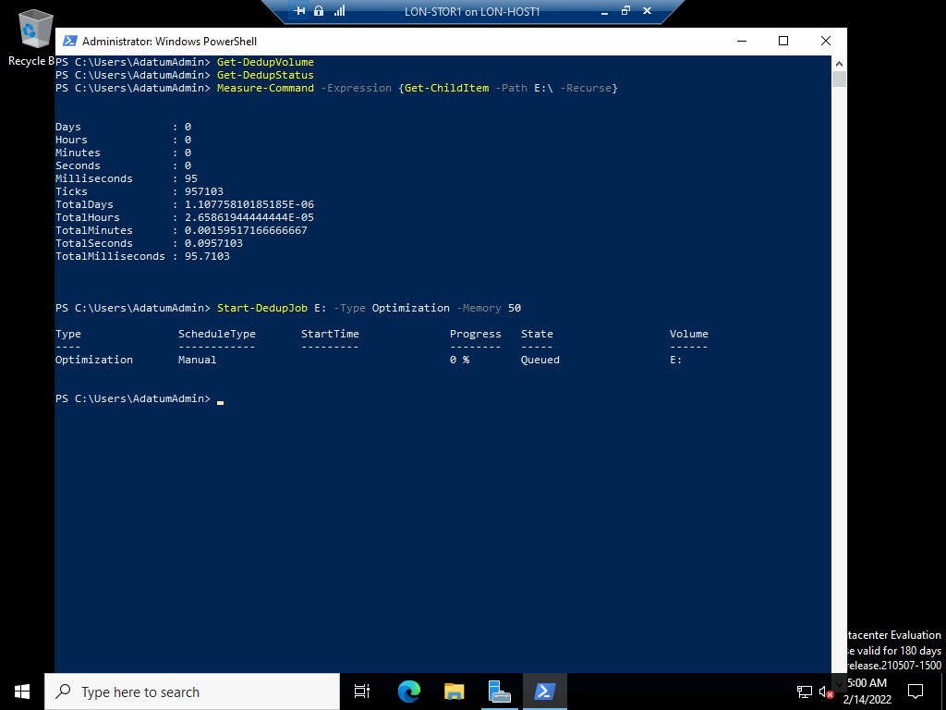

1. In the **Windows PowerShell** window, type the following command, and then press Enter:
2. Get-DedupJob

**Note:** Verify the status of the optimization job from the previous command. Repeat the previous command until the Progress shows as 100%. If there is no output the job has already finished

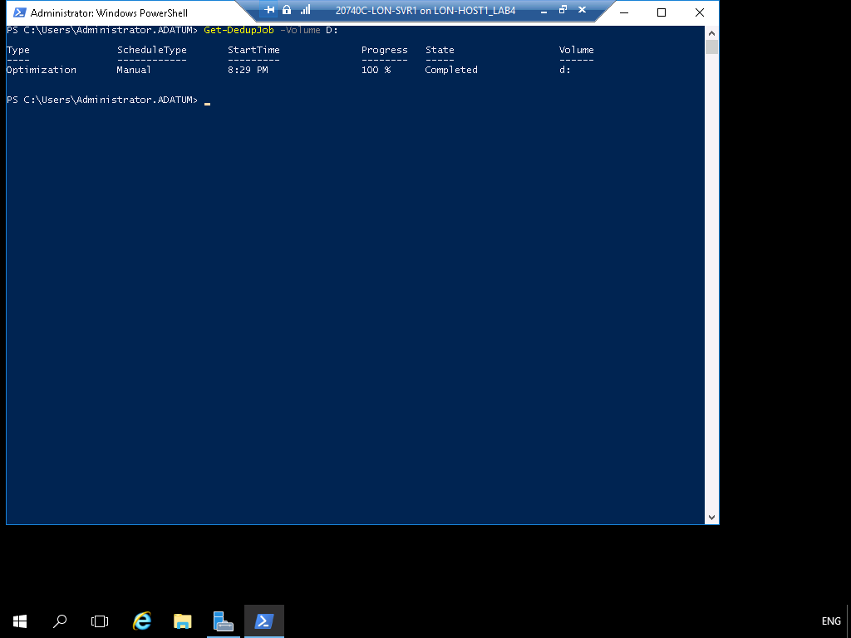

Task 3: Verify if the file has been optimized

1. On **LON-STOR1**, in **File Explorer**, navigate to [**E:\Labfiles\Mod04**](urn:gd:lg:a:send-vm-keys).

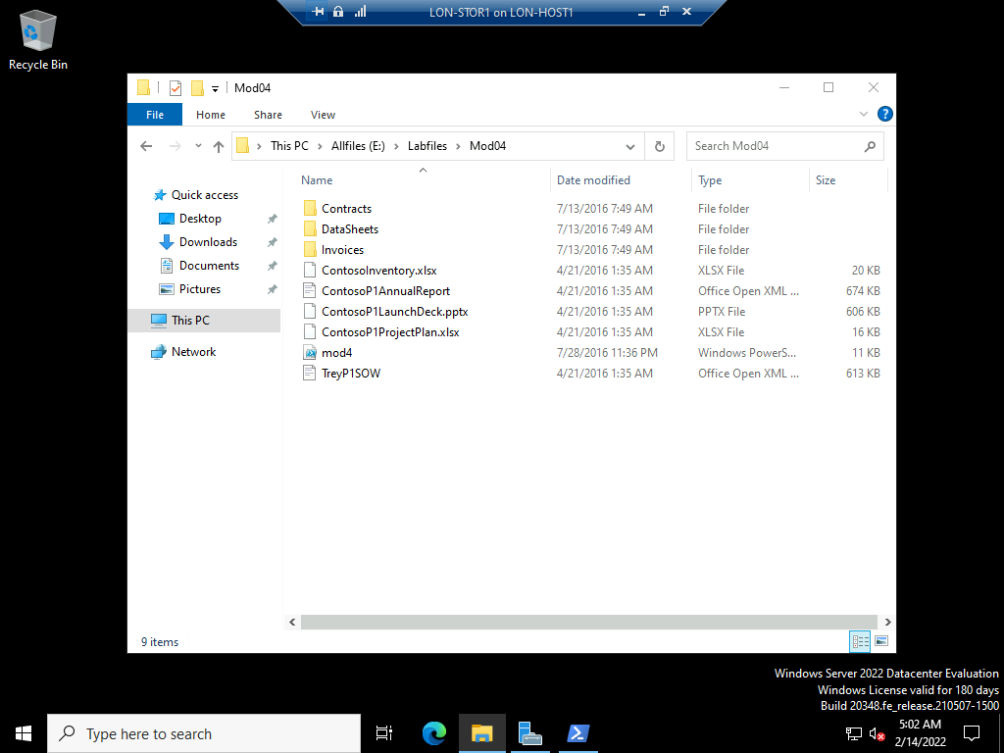

1. Right-click **ContosoP1AnnualReport.docx**, and then select **Properties**.
2. In the **Properties** window, observe the values of **Size** and **Size on disk** and note any differences.

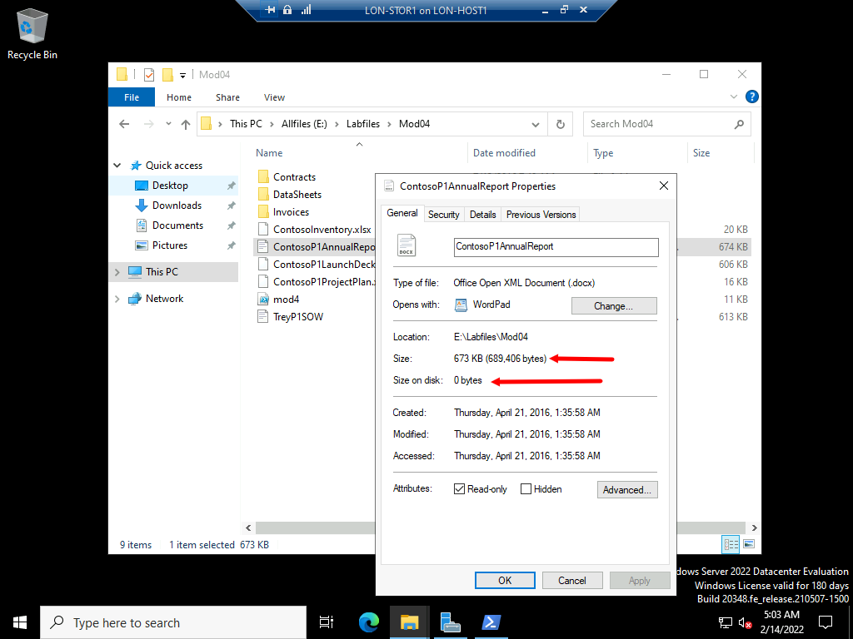

1. Repeat steps 2 and 3 for a few more files to verify deduplication.
2. Switch to **Windows PowerShell**.
3. In the **Windows PowerShell command prompt** window, type the following command, and then press Enter:
4. Get-DedupStatus -Volume E: | fl

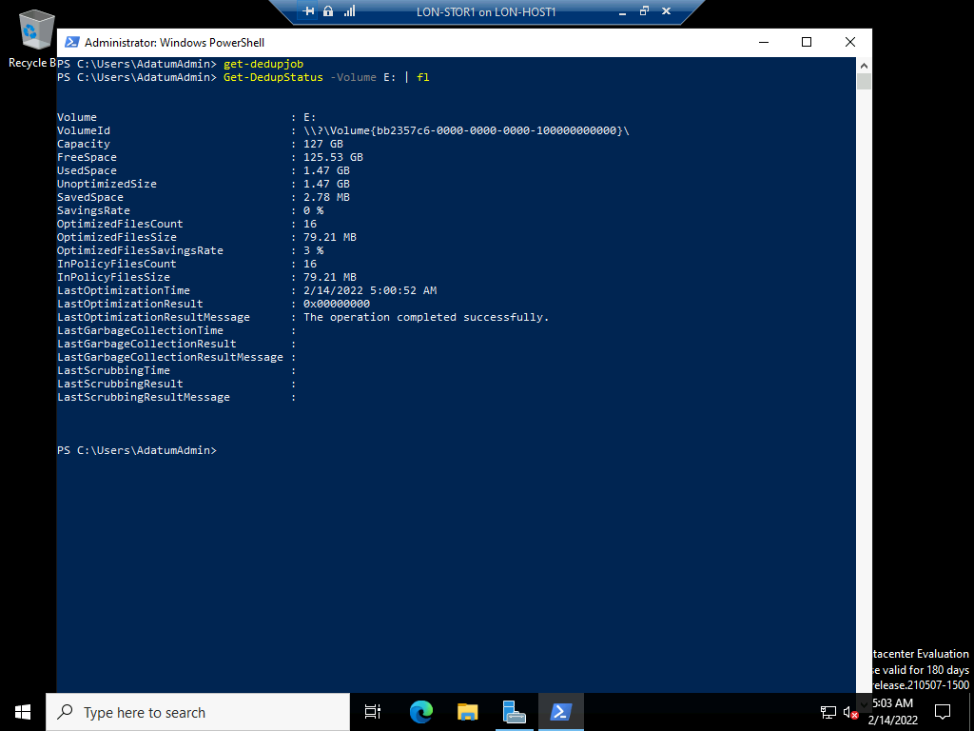

1. In the **Windows PowerShell command prompt** window, type the following command, and then press Enter:
2. Get-DedupVolume -Volume E: | fl

**Note:** Observe the number of optimized files.

1. In **Server Manager**, in the navigation pane, click **File and Storage Services** , and then click **Disks**.
2. Beneath **VOLUMES**, click **E**.
3. Click **Refresh** and observe the values for **Deduplication Rate** and **Deduplication Savings**.

**Note:** Because most of the files on drive E are small, you may not notice a significant amount of saved space.

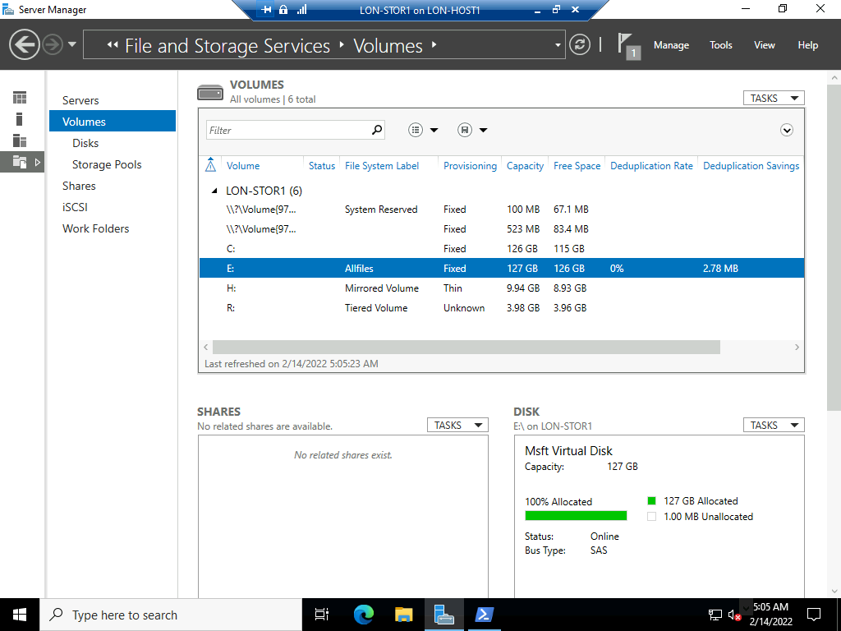

Task 4: Verify VM performance again

1. In the **Windows PowerShell** window, type the following command, and then press Enter:
2. Measure-Command -Expression {Get-ChildItem -Path E:\ -Recurse}

**Note:** Compare the values returned from the previous command with the value of the same command earlier in the lab to assess if system performance has changed.

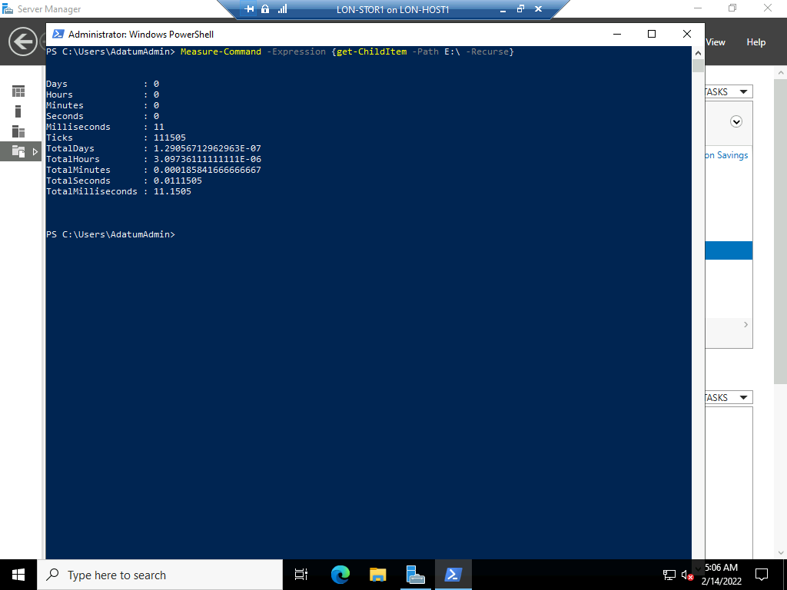

**Results**: After completing this exercise, you should have successfully configured Data Deduplication for the appropriate data volume on **LON-STOR1**.

**Congratulations!** You have now completed this lab. To continue to the next lab click End Lab in the Tools Menu . If you wish to contiue with this lab at a later date ensure you save the lab environment rather than ending it.